Bleiksøya Island, Vesterålen, Norway
A steep, cone-shaped bird rock rising from the Norwegian Sea, Bleiksøya is home to 80,000 pairs of Atlantic puffins. Ships anchor off Bleik village — one of Norway's most spectacular Arctic beaches — and tender passengers ashore for wildlife safaris unlike anything else in Europe.
⚓ Tender port · 🕒 Typical call: 5–7 hrs · 💵 Norwegian Krone (NOK) · 🗣️ Norwegian · 🐦 Wildlife & nature focus
✍️ MY DAY IN PORT (FILL IN)
Ship / Date
In port | arrive ______ · all aboard ______
Booked excursion
Notes / meeting point
GETTING ASHORE
- Docking: Anchor & tender — ships anchor offshore; tenders land at Bleik village harbour (~400 m from anchorage)
- Walk to center: Bleik village is tiny — café, shop, and beach are within 5–10 min on foot from the tender pier
- Best For: Puffin & seabird safaris, whale watching, Arctic beach walks, midnight sun
- Don't Miss: A boat puffin safari around Bleiksøya (April–August): 80,000 breeding puffin pairs on the cliffs
GETTING AROUND
- 🚕 Taxi: 280–340 NOK (~$25–$32 USD) — Taxis run between Bleik and Andenes (the nearest town with shops and services), about 10 km away and a 10-minute ride. P
TOP THINGS TO DO
- Puffin Safari Around Bleiksøya — Small boats circle the protected cone-shaped island while 80,000 pairs of Atlantic puffins wheel overhead and perch on sea-level…
- Sperm Whale Safari — Bleik Canyon — The Bleik Canyon, a deep submarine trench roughly 10 nautical miles (~17 km) offshore, draws sperm whales year-round.
- Bleik Beach Walk (Bleiksstranda) — One of Norway's longest white-sand beaches stretches along the village, backed by dramatic dunes — an extraordinary sight in the…
- Hike Måtinden — Vesterålen's signature hike (405 m) above Bleik rewards with panoramic views over Bleiksstranda beach, Bleiksøya bird island, and…
BEST WALKS
- Bleik Village & Beach Stroll: 1–2 hrs | Easy | Free — From the tender pier, walk through the small village to Bleiksstranda — one of Norway's most…
WEATHER · DAYLIGHT · MONEY
Month | High °F | Low °F | Rainy days
May | 45 | 38 | 16
Jul | 57 | 50 | 10
Sep | 52 | 46 | 15
Daylight: Sep 6:11AM–7:29PM
cruiseports.org/bleiksoya-island · Confirm terminal & all-aboard time with your ship

Bleiksøya Island, Vesterålen, Norway — Port Map
Red = walkable sights · Amber = excursions farther out · P = cruise terminal
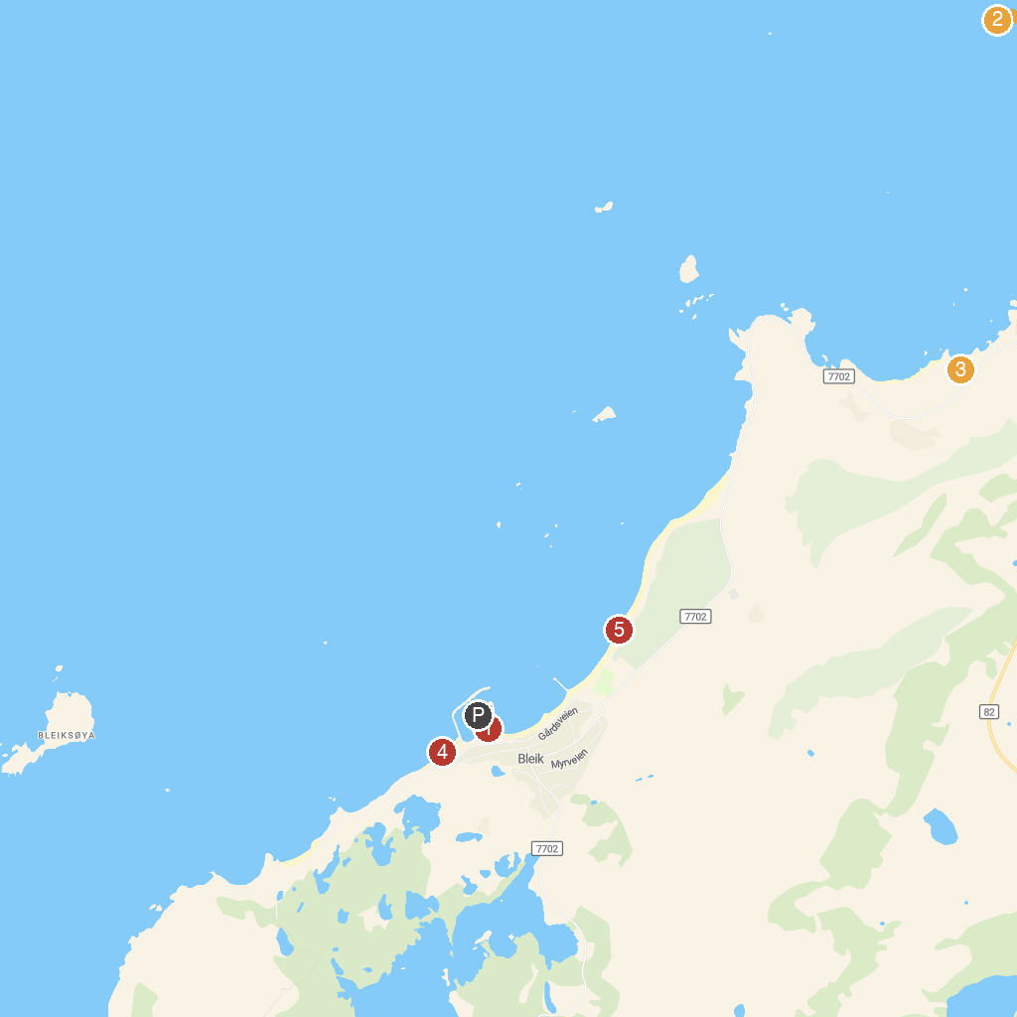
MAP KEY
1. Puffin Safari AS | 4. Bleik, Vesteralen
2. Andøymuseet | 5. Bleik sandstrand
3. Spaceship Aurora
P. Cruise port / terminal
Map © MapTiler © OpenStreetMap contributors · cruiseports.org

