Bleckede, Lower Saxony, Germany
A quiet Elbe riverside town where a baroque castle hides live beavers, and meadow cycling paths stretch endlessly through a UNESCO biosphere. Blink and you might miss it — that's the point.
⚓ Docked (river pier) · 🕒 Typical call: 4–6 hrs · 💶 Euro (€) · 🗣️ German
✍️ MY DAY IN PORT (FILL IN)
Ship / Date
In port | arrive ______ · all aboard ______
Booked excursion
Notes / meeting point
GETTING ASHORE
- Docking: River pier at Bleckeder Hafen; ships moor directly, 5-min walk to town
- Walk to center: ~5 min from harbor to Schlossstraße and the castle
- Best For: Nature lovers, cyclists, biosphere wildlife, and castle history
- Don't Miss: Biosphaerium Elbtalaue — live beavers and a tower with Elbe valley panorama
GETTING AROUND
- 🚕 Taxi: €8–€15 — Autoruf Bleckede (tel: 05852 95846 46) offers port transfers (Hafentransfer). Short rides to town are inexpensive given
- 📱 Rideshare: ❌ not available
TOP THINGS TO DO
- Biosphaerium Elbtalaue & Castle Tower — The star attraction: a baroque half-timbered building at Schloss Bleckede housing live beavers, native Elbe fish, and an…
- Elbe Cycle Path Ride — Rent a bike and join the famous Elbe Cycle Route as it passes through Bleckede.
- Bleckede Old Town Walk — Stroll the compact old town to see the St.
- Old Elbe Backwater & Bird Watching — A short ride or walk from town leads to the Alte Elbe (Old Elbe) near Vitico and Achterholz — a silted-up river arm with brackish…
BEST WALKS
- Harbour to Castle Walk: ~1 km • 15 min one-way • flat — From the Bleckeder Hafen, walk north along Hafenstraße into town.
- Elbe Dyke Stroll to Mahnkenwerder Tower: ~3 km • 45 min one-way • flat dyke path — Head to the Elbe dyke south of town for open meadow views.
WEATHER · DAYLIGHT · MONEY
Month | High °F | Low °F | Rainy days
May | 64 | 48 | 10
Jul | 74 | 58 | 13
Sep | 67 | 53 | 10
Daylight: May 5:17AM–9:10PM · Jul 5:08AM–9:36PM · Sep 6:51AM–7:32PM
cruiseports.org/bleckede · Confirm terminal & all-aboard time with your ship

Bleckede, Lower Saxony, Germany — Port Map
Red = walkable sights · Amber = excursions farther out · P = cruise terminal
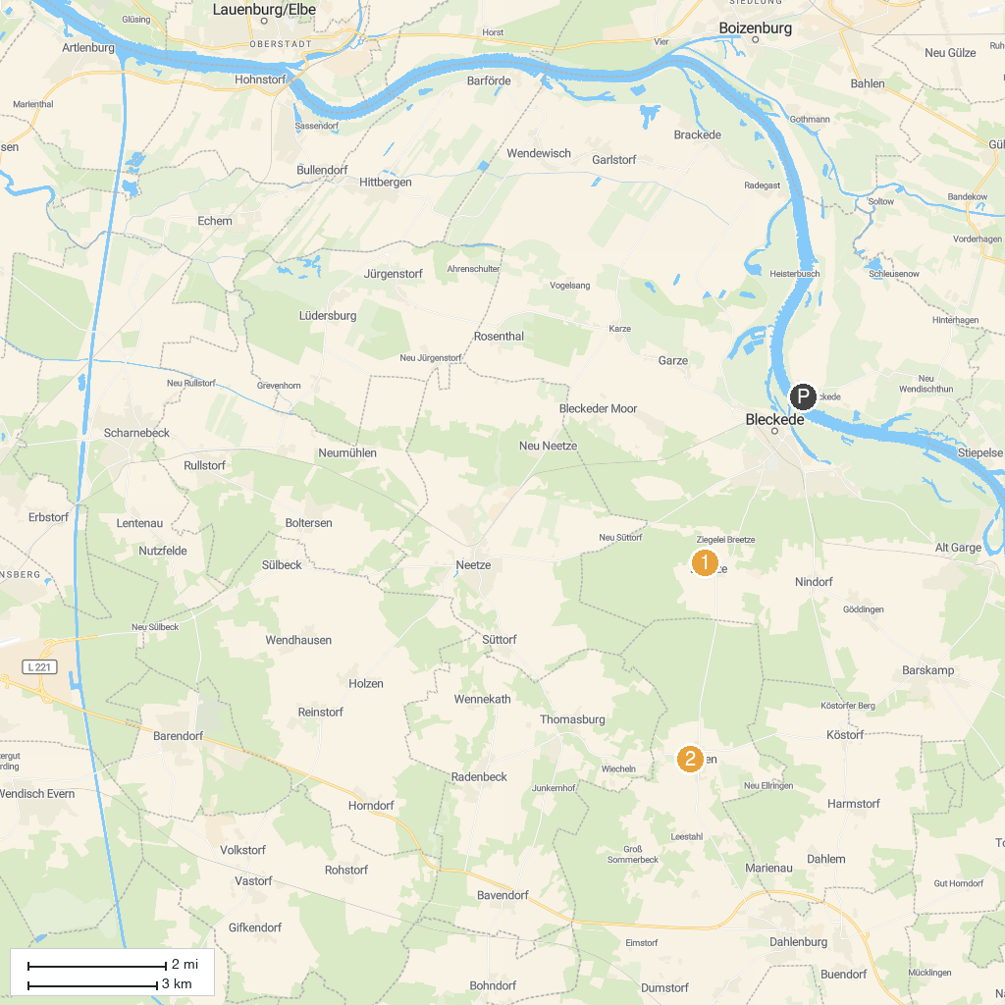
MAP KEY
1. Findlingsgarten Breetze | 2. Oldtimertreffen Ellringen
P. Cruise port / terminal
Map © MapTiler © OpenStreetMap contributors · cruiseports.org

