Blaye, Gironde, France
A fortified river town on the Gironde Estuary, Blaye pairs a sprawling free-entry UNESCO citadel with rolling Bordeaux vineyards — all within easy walking distance of the dock.
⚓ Docked (river quay) · 🕒 Typical call: 6-8 hrs · 💶 Euro · 🗣️ French
✍️ MY DAY IN PORT (FILL IN)
Ship / Date
In port | arrive ______ · all aboard ______
Booked excursion
Notes / meeting point
GETTING ASHORE
- Docking: River quay at Blaye waterfront, ~300 m from citadel entrance — no tender
- Walk to center: 5 min to Citadel gates; 10 min to town center
- Best For: History, wine tasting, estuary views, relaxed walking
- Don't Miss: Free entry to Vauban Citadel ramparts and underground passages
GETTING AROUND
- 🚕 Taxi: €5–€15 within town — Local taxis serve Blaye. Transfers to Bordeaux city center run €69–€117. Short in-town trips are inexpensive but no publ
- 📱 Rideshare: ✅ Uber
TOP THINGS TO DO
- Vauban Citadel Self-Guided Tour — Roam 38 hectares of 17th-century military engineering — ramparts, underground passages, ruined Château des Rudel, and a fortified…
- Blaye Côtes de Bordeaux Wine Tasting — The Blaye appellation produces excellent Merlot-dominant reds at prices well below Médoc grands crus.
- Ferry to Fort Médoc & the Médoc Vineyards — A short ferry crossing from Blaye to Lamarque puts you in the heart of the Médoc.
- Corniche Road to Bourg — The Route des Capitaines winds along limestone cliffs from Blaye to the medieval river town of Bourg, passing troglodyte…
- Plassac Gallo-Roman Villa — Just 5 km from Blaye, Plassac preserves the foundations of a substantial Gallo-Roman villa occupied from the 1st to 5th centuries…
BEST WALKS
- Citadel Ramparts Loop: 3.7 km · Easy · 1 hr — Enter via Porte Royale from the quay path, walk the full perimeter of the ramparts for sweeping…
- Quay to Town Center Stroll: 1 km · Easy · 20 min — From the river quay, walk up through the lower town to Cours Vauban, stopping at the Maison du Vin…
WEATHER · DAYLIGHT · MONEY
Month | High °F | Low °F | Rainy days
May | 69 | 54 | 11
Jul | 79 | 63 | 7
Sep | 76 | 59 | 8
Daylight: May 6:33AM–9:25PM · Jul 6:30AM–9:46PM · Sep 7:41AM–8:13PM
cruiseports.org/blaye · Confirm terminal & all-aboard time with your ship

Blaye, Gironde, France — Port Map
Red = walkable sights · Amber = excursions farther out · P = cruise terminal
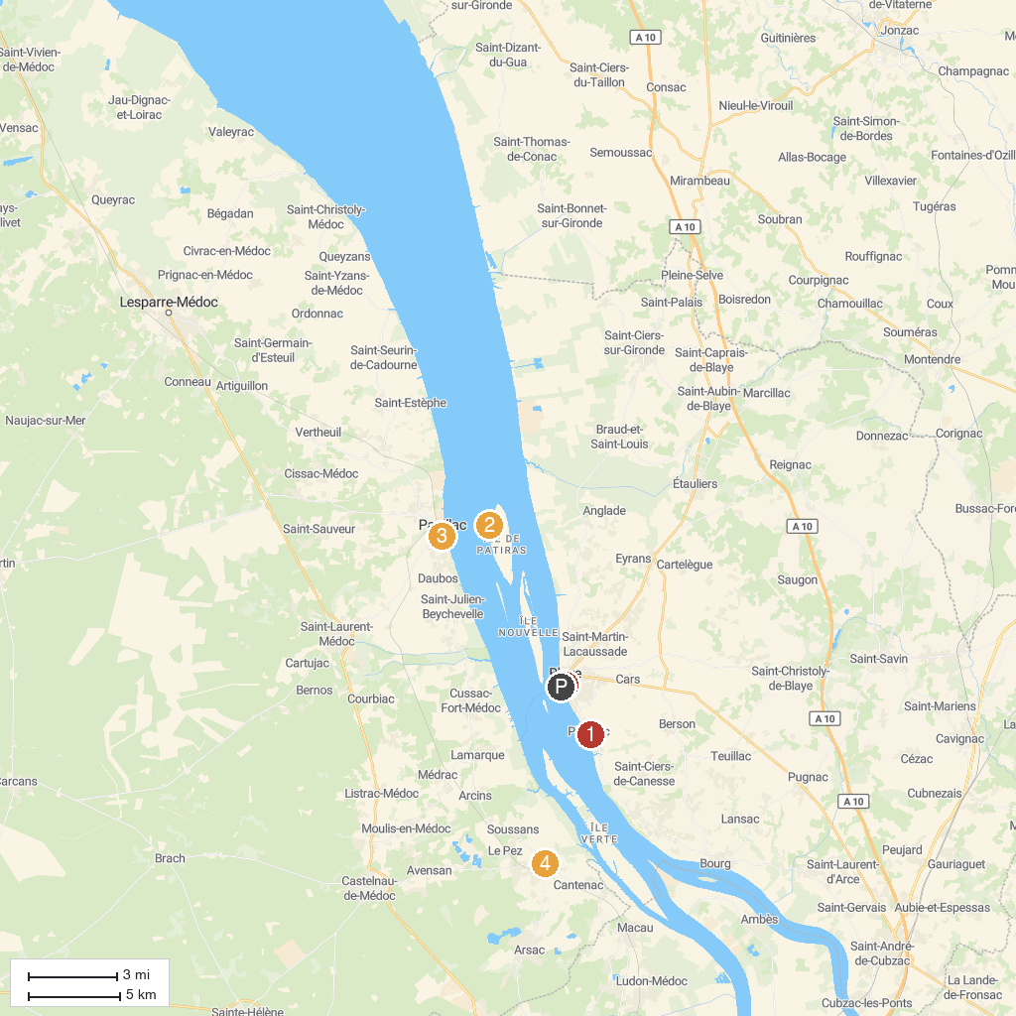
MAP KEY
1. Villa Gallo Romaine de Plassac | 4. Château Marquis de Terme Tourisme
2. Lighthouse Patiras | 5. Tourist Office of Blaye
3. Église Saint-Martin
P. Cruise port / terminal
Map © MapTiler © OpenStreetMap contributors · cruiseports.org

