Bjørnøya, Svalbard, Norway
Halfway between mainland Norway and Spitsbergen, Bear Island is one of the North Atlantic's great seabird kingdoms — a protected wilderness of plunging cliffs, fog-shrouded plateaus, and millions of nesting guillemots.
⚓ Expedition Zodiac only (no pier) · 🕒 Typical call: 3-6 hrs (weather-dependent) · 💵 Norwegian Krone (NOK) · 🗣️ Norwegian · 🐦 Wildlife focus
✍️ MY DAY IN PORT (FILL IN)
Ship / Date
In port | arrive ______ · all aboard ______
Booked excursion
Notes / meeting point
GETTING ASHORE
- Docking: Zodiac/tender only — no pier; landings weather-dependent
- Location: Barents Sea, 74°N — 178 km² nature reserve
- Best For: Seabird cliffs, Arctic wildlife, expedition photography
- Don't Miss: The guillemot cliffs of Stappen and Fuglefjella
GETTING AROUND
TOP THINGS TO DO
- Seabird Cliff Zodiac Cruise — Zodiac along the dramatic southern cliffs — collectively known as Fuglefjella, including the towering Stappen pillar — where over…
- Herwighamna Landing & Meteorological Station — Land at the only inhabited spot on the island — the Norwegian meteorological station, continuously staffed since 1947 (an earlier…
- Kvalrossbukta Whaling Ruins — Visit the remains of the old whaling and walrus-hunting outpost on the island's coast — a stark reminder of Bear Island's brutal…
- Miseryfjellet Hike — For fit expedition travellers, hike toward Miseryfjellet (536 m), the island's highest peak, for panoramic views of the Barents…
BEST WALKS
- Herwighamna Northern Plain: Easy · 1-3 km · Flat tundra — Wander the boggy Arctic tundra around the met station, with around 1,200 shallow freshwater lakes…
- Southern Cliff Viewpoints: Moderate · variable · Rugged coastal path — If a southern landing is permitted, approach the cliff tops above Fuglefjella to look down on the…
WEATHER · DAYLIGHT · MONEY
Month | High °F | Low °F | Rainy days
May | 58 | 44 | 11
Jul | 69 | 56 | 13
Sep | 61 | 50 | 12
Daylight: May 4:48AM–9:45PM · Jul 4:32AM–10:18PM · Sep 6:49AM–7:39PM
cruiseports.org/bjornoya-bear-island · Confirm terminal & all-aboard time with your ship

Bjørnøya, Svalbard, Norway — Port Map
Red = walkable sights · Amber = excursions farther out · P = cruise terminal
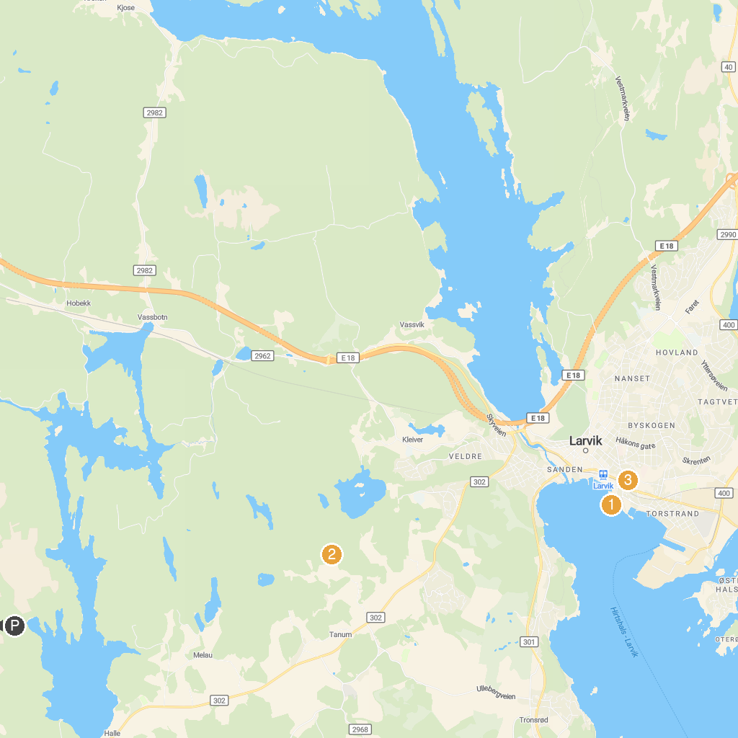
MAP KEY
1. Tollerodden | 4. Salsås
2. Istrehågan, Iron age Cemetery | 5. Herregården i Larvik
3. Brevik church
P. Cruise port / terminal
Map © MapTiler © OpenStreetMap contributors · cruiseports.org

