Bitetos, Douro Valley, Portugal
A sleepy Douro riverside hamlet where river cruise ships linger overnight — Baroque churches, an 11th-century monastery-restaurant, Roman ruins, and some of Portugal's finest wines within easy reach.
⚓ Docked (river pier) · 🕒 Typical call: overnight (~14 hrs) · 💶 Currency: Euro (€) · 🗣️ Language: Portuguese · 🍷 Wine country stop
✍️ MY DAY IN PORT (FILL IN)
Ship / Date
In port | arrive ______ · all aboard ______
Booked excursion
Notes / meeting point
GETTING ASHORE
- Docking: River cruise ships dock directly at the village pier; no tendering required.
- Walk to centre: The village centre is steps from the pier — under 5 min on foot.
- Best For: Wine lovers, history buffs, and travellers who want a relaxed evening ashore.
- Don't Miss: Mosteiro de Alpendurada — an 11th-century Benedictine monastery, now a hotel with a restaurant.
GETTING AROUND
- 🚕 Taxi: ~€10–15 each way — Marco de Canaveses, the nearest town with cafés, shops, and an ATM, is about 5 km away. Ask your ship's reception or cru
TOP THINGS TO DO
- Mosteiro de Alpendurada — This 11th-century Benedictine monastery (founded c.
- Douro Wine Tasting — The Douro Valley produces some of Portugal's finest table wines alongside Port.
- Roman Bridge & Baroque Churches — Bitetos is home to a Roman-era bridge (Ponte Romana de Bitetos) over the nearby Tâmega.
- Douro River Boat Trip — Local operators offer pontoon boat excursions, kayak tours, and motorboat trips along the Douro, Paiva, and Tâmega rivers — a…
- Day Trip to Porto — Porto is roughly 55 km west (about an hour by road).
BEST WALKS
- Village & Riverside Stroll: 1.5 km loop | 30 min | Easy — From the pier, walk along the Douro quay, turn into the village lanes to the Baroque parish church…
- Pier to Alpendurada Monastery: 2 km return | 45 min | Easy — A straightforward walk from the ship along the riverside road to the Mosteiro de Alpendurada.
WEATHER · DAYLIGHT · MONEY
Month | High °F | Low °F | Rainy days
May | 71 | 53 | 10
Jul | 83 | 62 | 4
Sep | 78 | 59 | 8
Daylight: May 6:14AM–8:44PM · Jul 6:13AM–9:03PM · Sep 7:13AM–7:41PM
cruiseports.org/bitetos · Confirm terminal & all-aboard time with your ship

Bitetos, Douro Valley, Portugal — Port Map
Red = walkable sights · Amber = excursions farther out · P = cruise terminal
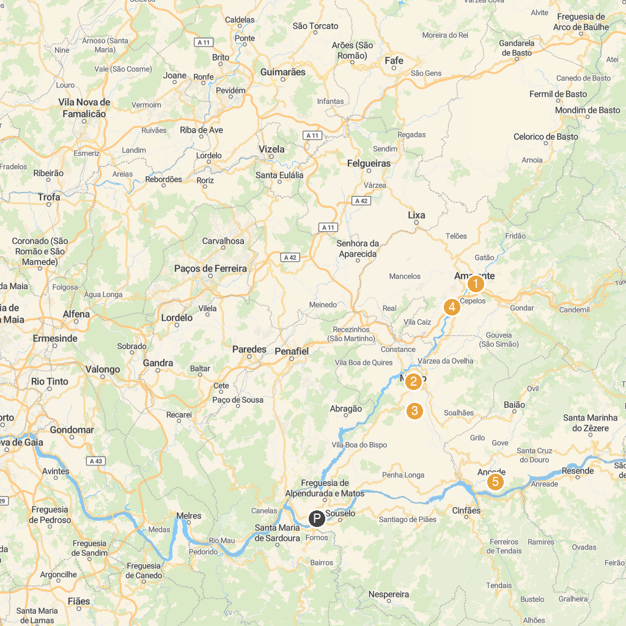
MAP KEY
1. Igreja de São Gonçalo | 5. Mosteiro de Santo André de Ancede e Capela do Bom Despacho (Centro Cultural)
2. Municipal Museum Carmen Miranda | 6. Dolmen Chã de Parada
3. Tongobriga - Freixo Archaeological Area | 7. Parque de Lazer de Pias
4. Amarante Water Park | 8. Caldas de aregos
P. Cruise port / terminal
Map © MapTiler © OpenStreetMap contributors · cruiseports.org

