Binz, Rügen, Germany
A grand Baltic seaside resort where chalk-white cliffs rise from the sea and Wilhelminian spa villas line a sweeping sandy beach. Binz is Rügen's most elegant town — compact, walkable, and surprisingly rich for a half-day ashore.
⚓ Tender port · 🕒 Typical call: 6-8 hrs · 💶 Euro (EUR) · 🗣️ German
✍️ MY DAY IN PORT (FILL IN)
Ship / Date
In port | arrive ______ · all aboard ______
Booked excursion
Notes / meeting point
GETTING ASHORE
- Docking: Tender — ships anchor offshore; boats drop at the Seebrücke pier
- Walk to center: Immediate — tender lands at the pier head, town is right there
- Best For: Beach walks, chalk cliff excursions, historic steam railway
- Don't Miss: Königsstuhl chalk cliffs at Jasmund National Park
GETTING AROUND
- 🚕 Taxi: €4 base + meter — Local taxis serve the Rügen area. Short hops within Binz run about €10; transfers to Bergen auf Rügen or Sassnitz cost m
TOP THINGS TO DO
- Königsstuhl Chalk Cliffs & Jasmund National Park — The 118-metre chalk headland is Germany's most iconic coastal scenery.
- Prora — Nazi Megastructure on the Beach — The 4.5-kilometre seafront complex built by the Third Reich as a 'Strength through Joy' resort was never used for its intended…
- Rasender Roland Steam Railway — Board the narrow-gauge steam train that has puffed across Rügen since 1895.
- Jagdschloss Granitz Hunting Lodge — A romantic 19th-century neo-Gothic castle set in forest above Binz, built for Prince Wilhelm Malte I.
- Hiddensee Island Day Trip — The car-free island west of Rügen rewards visitors with wild heathland, the white Dornbusch lighthouse, and utter quiet.
BEST WALKS
- Strandpromenade Beach Walk: 2 km · 30 min · Easy · Flat seafront — Walk the full length of Binz's beachfront promenade from the Seebrücke pier northward past ornate…
- Forest Path to Jagdschloss Granitz: 4 km one-way · 1 hr · Moderate · Forest trail — From the Binz Kleinbahnhof (narrow-gauge railway station), a marked trail leads through the Granitz…
WEATHER · DAYLIGHT · MONEY
Month | High °F | Low °F | Rainy days
May | 62 | 45 | 18
Jul | 74 | 58 | 16
Sep | 66 | 51 | 12
Daylight: May 5:49AM–8:55PM · Jul 5:44AM–9:17PM · Sep 7:03AM–7:37PM
cruiseports.org/binz-rugen · Confirm terminal & all-aboard time with your ship

Binz, Rügen, Germany — Port Map
Red = walkable sights · Amber = excursions farther out · P = cruise terminal
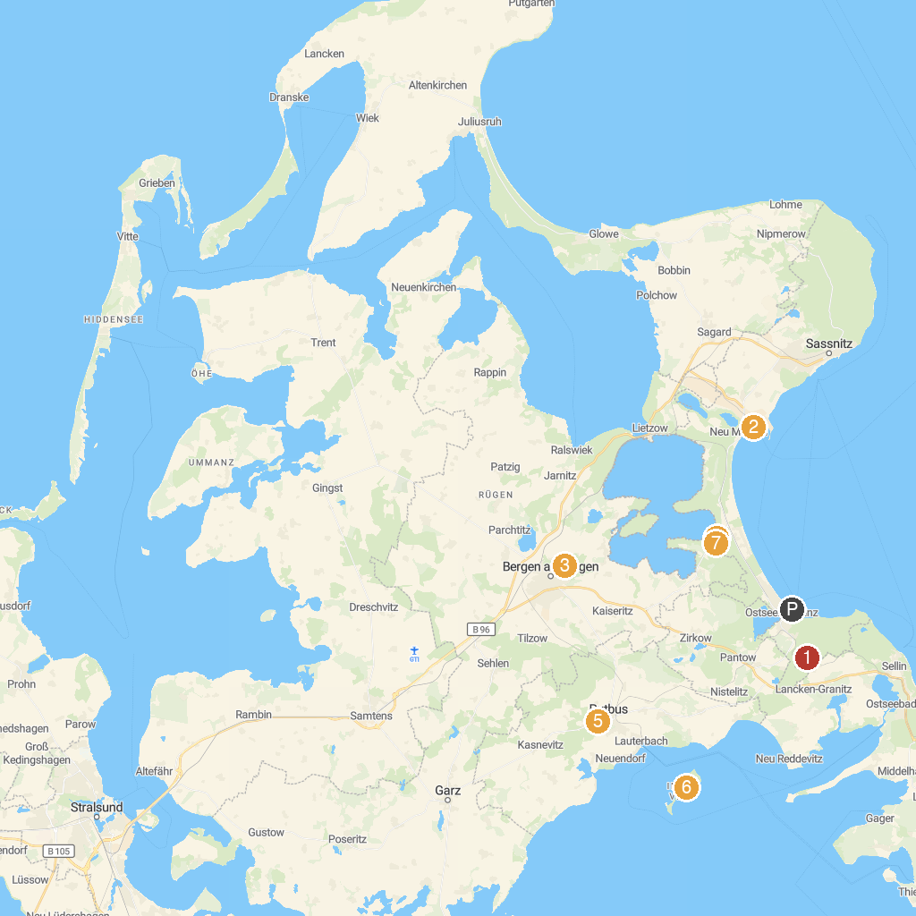
MAP KEY
1. Granitz Hunting Castle | 5. Baumwipfelpfad im Naturerbe Zentrum Rügen
2. Sassnitz Ferry Port GmbH | 6. Uhren- und Musikgerätemuseum
3. Erlebniswelt U-Boot | 7. Insel Vilm
4. Inselrodelbahn | 8. Aussichtplattform Adlerhorst - Baumwipfelpfad Rügen Naturerbezentrum Rügen
P. Cruise port / terminal
Map © MapTiler © OpenStreetMap contributors · cruiseports.org

