Bintulu, Sarawak, Malaysia
A Borneo port where dense rainforest meets the South China Sea — Similajau's wild beaches, the Kemena riverfront, and markets piled with belacan and kek lapis await on a shore day.
⚓ Docked (deepwater berth) · 🕒 Typical call: 7-9 hrs · 💵 Malaysian Ringgit (MYR) · 🗣️ Malay; English widely understood
✍️ MY DAY IN PORT (FILL IN)
Ship / Date
In port | arrive ______ · all aboard ______
Booked excursion
Notes / meeting point
GETTING ASHORE
- Docking: Deepwater berth at Bintulu Port — ships dock directly, no tender
- Walk to centre: ~2 km from port to Bintulu Waterfront Promenade; taxi 5–10 min
- Best For: Rainforest trekking, wildlife, local markets, Sarawakian food
- Don't Miss: Similajau National Park beaches and Council Negeri Monument
GETTING AROUND
- 🚕 Taxi: RM 30–40 — Local taxis available at the port. Sarawak meter rates start at RM 4 plus RM 2/km; negotiate or confirm fare before boar
- 📱 Rideshare: ✅ Grab, Maxim
TOP THINGS TO DO
- Similajau National Park — About 30 km north of town, Similajau protects 7,000 ha of coastal rainforest and some of Sarawak's most untouched beaches.
- Bintulu Waterfront & Markets — Stroll the Kemena River promenade past the Council Negeri Monument — the spot where Sarawak's first State Legislative Assembly…
- Sebauh River Wildlife Cruise — A motorboat cruise up the Sebauh River, inland from Bintulu, offers chances to spot long-tailed macaques, kingfishers, hornbills…
- Kampung Jepak Fishing Village — A short drive across the Kemena River estuary, this traditional Malay fishing village is where Bintulu's famous belacan shrimp…
- Taman Tumbina Botanical & Zoo Park — Bintulu's hilltop botanical and zoological park overlooks the South China Sea.
BEST WALKS
- Kemena Waterfront Promenade Walk: 2 km one-way | Easy | 30-45 min — Follow the paved promenade along the Kemena River from the Council Negeri Monument past colourful…
- Tanjung Batu Beach Stroll: 1.5 km beach | Easy | 20-30 min — A short taxi ride south of town, Tanjung Batu is Bintulu's main public beach — a mix of rocky…
WEATHER · DAYLIGHT · MONEY
Month | High °F | Low °F | Rainy days
May | 87 | 76 | 26
Jul | 86 | 75 | 23
Sep | 86 | 75 | 25
Daylight: May 6:16AM–6:31PM · Jul 6:25AM–6:42PM · Sep 6:19AM–6:26PM
cruiseports.org/bintulu · Confirm terminal & all-aboard time with your ship

Bintulu, Sarawak, Malaysia — Port Map
Red = walkable sights · Amber = excursions farther out · P = cruise terminal
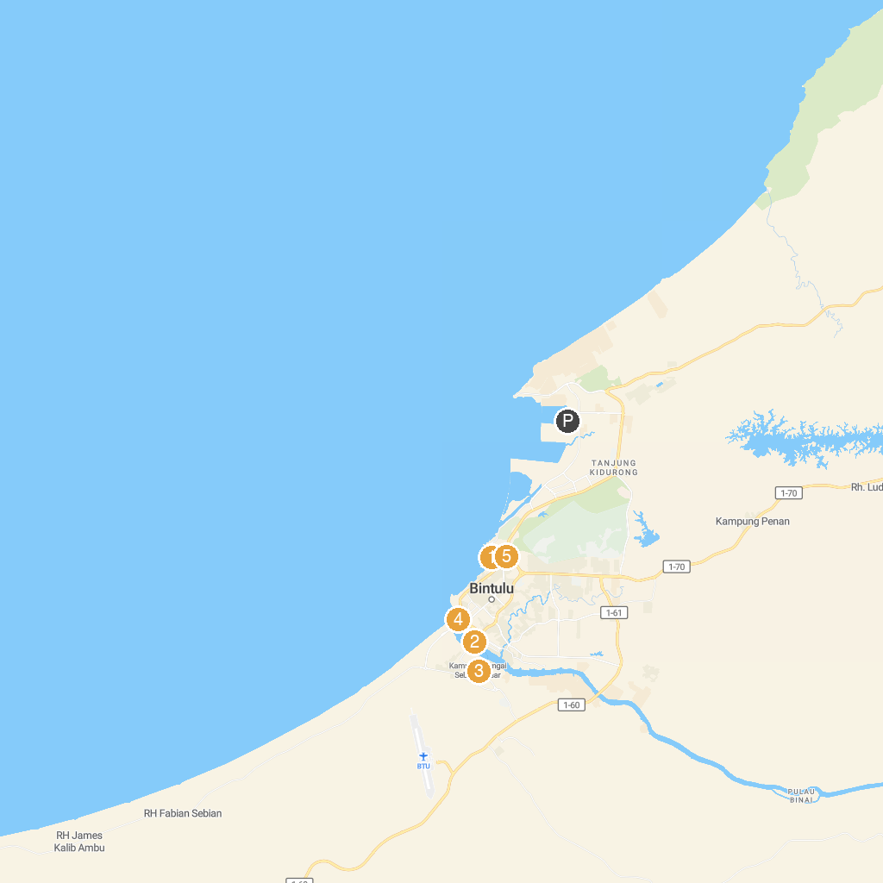
MAP KEY
1. Taman Tumbina Zoo | 4. Bintulu Waterfront
2. Pasar TAMU Bintulu | 5. Tumbina Hill Peak Point
3. Darul Makmur Mosque, Jepak Village
P. Cruise port / terminal
Map © MapTiler © OpenStreetMap contributors · cruiseports.org

