Bingen am Rhein, Rhineland-Palatinate, Germany
Perched at the confluence of the Rhine and Nahe rivers, Bingen is the southern gateway to a UNESCO World Heritage gorge lined with medieval castles and vineyard-draped hillsides. Ships dock steps from the old town — no tender, no transfer.
⚓ Docked (Rhine Promenade pier) · 🕒 Typical call: 6–8 hrs · 💶 Euro (€) · 🗣️ German · 🍷 Wine country
✍️ MY DAY IN PORT (FILL IN)
Ship / Date
In port | arrive ______ · all aboard ______
Booked excursion
Notes / meeting point
GETTING ASHORE
- Docking: Directly along the Rhine Promenade — town center is steps away
- Walk to centre: 2–5 min on foot from ship to old town and Klopp Castle
- Best For: Rhine Valley scenery, Riesling tasting, castle panoramas
- Don't Miss: Mouse Tower (Mäuseturm) from the promenade & ferry to Rüdesheim
GETTING AROUND
- 🚕 Taxi: €5–€10 — Taxis use the Mainz tariff: €4 base plus ~€1.80–€4/km. The port is so close to the center that most rides are short and
- 📱 Rideshare: ✅ Uber
TOP THINGS TO DO
- Rhine Gorge Boat Tour — Cruise the UNESCO-listed Upper Middle Rhine Valley from Bingen, passing the Mouse Tower, Ehrenfels, Rheinstein, and Reichenstein…
- Klopp Castle & Old Town Walk — Climb to Burg Klopp for sweeping views of the Rhine and Nahe confluence, then wander Bingen's old town streets, the Basilica of St.
- Riesling Wine Tasting — Bingen sits at the intersection of the Rheingau and Nahe wine regions.
- Ferry to Rüdesheim am Rhein — Hop the 5-minute ferry to Rüdesheim, explore the famous Drosselgasse, visit Siegfried's Mechanical Music Cabinet, or take the…
- Museum am Strom & Hildegard Heritage — Step inside the converted 19th-century waterfront power station for 2,000 years of Rhine history, including a dedicated wing on…
BEST WALKS
- Promenade to Klopp Castle Loop: 2.5 km · 40–50 min · some hills — From the dock, stroll north along the Rheinanlagen promenade past the Museum am Strom, then turn up…
- Mäuseturm Viewpoint Stroll: 1 km · 15 min · flat — A flat, easy walk along the promenade south of the dock to the best viewpoints of the Mouse Tower…
WEATHER · DAYLIGHT · MONEY
Month | High °F | Low °F | Rainy days
May | 66 | 50 | 11
Jul | 78 | 61 | 11
Sep | 70 | 54 | 8
Daylight: May 5:42AM–9:07PM · Jul 5:36AM–9:31PM · Sep 7:04AM–7:41PM
cruiseports.org/bingen-am-rhein · Confirm terminal & all-aboard time with your ship

Bingen am Rhein, Rhineland-Palatinate, Germany — Port Map
Red = walkable sights · Amber = excursions farther out · P = cruise terminal
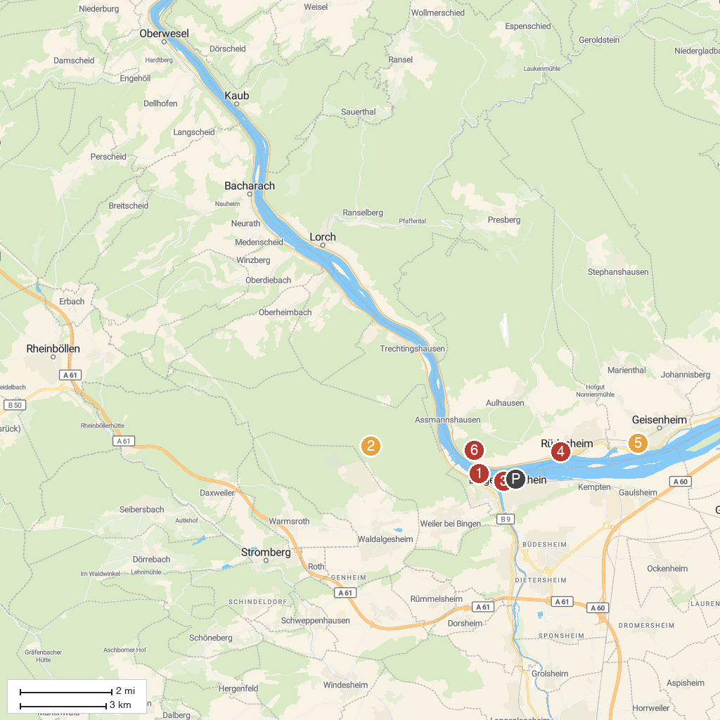
MAP KEY
1. Mouse Tower | 4. Rüdesheimer Besichtigungsfahrten GmbH (Winzerexpress)
2. Steckeschlääfer-Klamm | 5. Villa Monrepos
3. Museum am Strom | 6. Rossel Castle
P. Cruise port / terminal
Map © MapTiler © OpenStreetMap contributors · cruiseports.org

