Bimini Islands, Bahamas
Fifty miles off Miami but a world away, Bimini is pure Bahamas — crystal flats, friendly stingrays, and a casino-resort pier that Oasis-class ships call home.
⚓ Docked (dedicated pier) · 🕒 Typical call: 6–8 hrs · 💵 Bahamian Dollar / USD · 🗣️ English
✍️ MY DAY IN PORT (FILL IN)
Ship / Date
In port | arrive ______ · all aboard ______
Booked excursion
Notes / meeting point
GETTING ASHORE
- Docking: Resorts World Bimini Cruise Port (North Bimini); all major lines dock directly — no tender
- Walk to center: Resort amenities 5–15 min on foot; Alice Town ~2 miles south, taxi/golf cart needed
- Best For: Snorkeling, beaches, stingray encounters, relaxed Bahamian vibe
- Don't Miss: Stingray Safari at Honeymoon Harbor and the SS Sapona shipwreck snorkel
GETTING AROUND
- 🚕 Taxi: $5–$10 USD per person — Local taxis wait at the pier and can take you to Alice Town (~2 miles away) or Radio Beach. Fares are roughly $5 per per
- 📱 Rideshare: ❌ not available
TOP THINGS TO DO
- Stingray Safari at Honeymoon Harbor — Boat out to Honeymoon Harbor Beach to swim alongside friendly southern stingrays in shallow, crystal-clear water.
- SS Sapona Shipwreck Snorkel — The SS Sapona — a WWI-era concrete-hulled freighter — partially sank in the 1920s and now sits in shallow water teeming with…
- Reef Shark Snorkeling Adventure — Snorkel alongside Caribbean reef sharks and blacknose sharks at a managed reef site.
- Bimini Road (Road to Atlantis) Snorkel — Explore the mysterious underwater rock formation off North Bimini — a natural geological feature that sparked legends of Atlantis.
- Bimini Heritage & Island Bike Tour — Cycle through Alice Town and Bailey Town past Ernest Hemingway's old haunts, the Dolphin House Museum, and local conch shacks.
BEST WALKS
- Pier to Fisherman's Village Loop: 1 mile · Flat · 20–30 min — From the cruise pier, walk south along the resort path past Kayak Beach to Fisherman's Village — a…
- Alice Town Historical Stroll: ~1 mile · Flat · 45 min (golf cart or taxi from pier) — Alice Town is Bimini's original settlement.
WEATHER · DAYLIGHT · MONEY
Month | High °F | Low °F | Rainy days
May | 84 | 68 | 11
Jul | 89 | 75 | 24
Sep | 86 | 73 | 20
Daylight: May 6:33AM–8:10PM · Jul 6:36AM–8:26PM · Sep 7:10AM–7:29PM
cruiseports.org/bimini-islands · Confirm terminal & all-aboard time with your ship

Bimini Islands, Bahamas — Port Map
Red = walkable sights · Amber = excursions farther out · P = cruise terminal
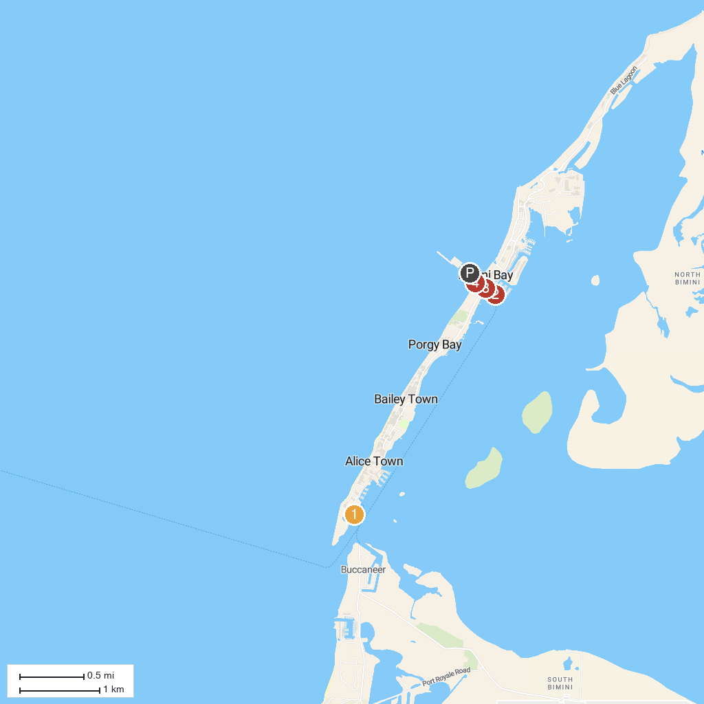
MAP KEY
1. Browns Marina | 3. Kayak Beach
2. Bimini Blue Adventures | 4. Bimini Public Beach
P. Cruise port / terminal
Map © MapTiler © OpenStreetMap contributors · cruiseports.org

