Biloxi, Mississippi, USA
The 'Gulf Coast Riviera' rolls out miles of white-sand beach, a skyline of casino towers, and a seafood heritage stretching back to the Biloxi oyster schooners. American Cruise Lines' intimate Gulf Coast itinerary makes this sun-drenched city a natural stop.
⚓ Docked (Small Craft Harbor) · 🕒 Typical call: 6–8 hrs · 💵 USD · 🗣️ English · 🎰 Casino city
✍️ MY DAY IN PORT (FILL IN)
Ship / Date
In port | arrive ______ · all aboard ______
Booked excursion
Notes / meeting point
GETTING ASHORE
- Docking: Small Craft Harbor, Biloxi waterfront — served by American Cruise Lines small ships
- Walk to center: Waterfront attractions within 5–10 min walk; casinos & beach along Highway 90
- Best For: Casinos, Gulf seafood, maritime history, beach strolls
- Don't Miss: Biloxi Lighthouse (1848), Maritime & Seafood Industry Museum, a real shrimping trip
GETTING AROUND
- 🚕 Taxi: $10–25 (metered) — zTrip offers 24/7 metered taxi service in Biloxi. Available on demand or by reservation; fares vary by distance.
- 📱 Rideshare: ✅ Uber, Lyft
TOP THINGS TO DO
- Biloxi Lighthouse & Beach Boulevard Stroll — The 1848 Biloxi Lighthouse is one of the Gulf Coast's most photographed landmarks.
- Biloxi Shrimping Trip — Climb aboard a working shrimp boat for a 70-minute 'Living Marine Adventure' cruise.
- Maritime & Seafood Industry Museum — Traces the Gulf Coast's shrimping, oystering, and boat-building heritage.
- Ohr-O'Keefe Museum of Art — Designed by Frank Gehry, this striking campus celebrates George E.
- Beauvoir — Jefferson Davis Estate — The beachfront antebellum mansion where Confederate President Jefferson Davis spent his final years.
BEST WALKS
- Beach Boulevard Lighthouse Walk: 2.5 km · Flat · 30–45 min — A classic Biloxi stroll along the Gulf-facing promenade.
- Ohr-O'Keefe Museum to Beauvoir: By trolley or taxi · 20 min — Take the Casino Hopper west to the Ohr-O'Keefe Museum of Art, then continue a short ride to…
WEATHER · DAYLIGHT · MONEY
Month | High °F | Low °F | Rainy days
May | 82 | 68 | 12
Jul | 88 | 76 | 20
Sep | 86 | 72 | 14
Daylight: May 6:01AM–7:42PM · Jul 6:04AM–7:58PM · Sep 6:40AM–7:00PM
cruiseports.org/biloxi-ms · Confirm terminal & all-aboard time with your ship

Biloxi, Mississippi, USA — Port Map
Red = walkable sights · Amber = excursions farther out · P = cruise terminal
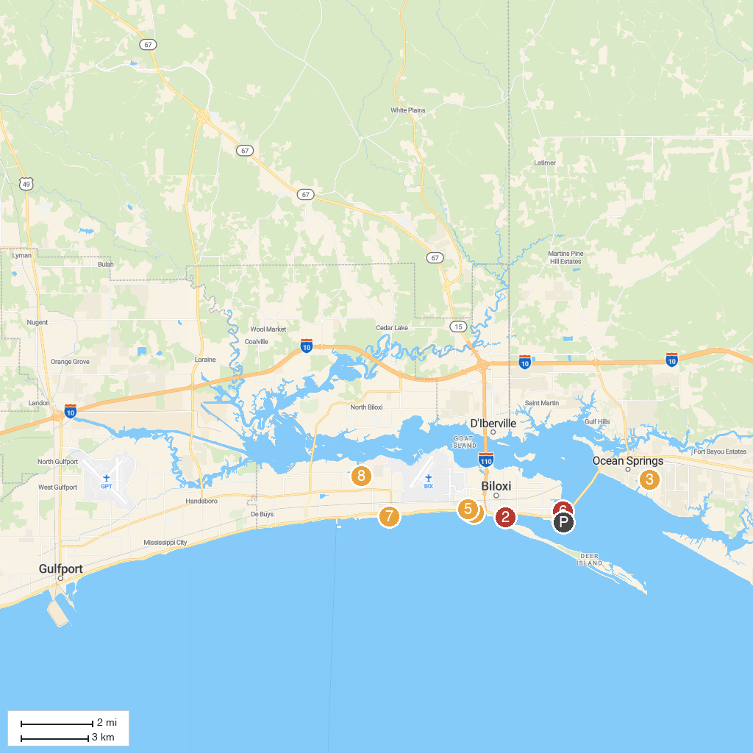
MAP KEY
1. Biloxi Lighthouse | 5. Lighthouse Park
2. Biloxi Shrimping Trip | 6. Point Cadet Plaza
3. Inner Harbor Park | 7. Mississippi Gulf Coast
4. Biloxi Beach | 8. Hiller Park
P. Cruise port / terminal
Map © MapTiler © OpenStreetMap contributors · cruiseports.org

