Bilbao, Basque Country, Spain
Where a titanium museum transformed an industrial city into one of Europe's great cultural destinations — and the pintxos alone are worth the detour.
⚓ Docked (pier) · 🕒 Typical call: 8–10 hrs · 💶 Euro (€) · 🗣️ Spanish / Basque (Euskera) · 🚌 Shuttle to city center
✍️ MY DAY IN PORT (FILL IN)
Ship / Date
In port | arrive ______ · all aboard ______
Booked excursion
Notes / meeting point
GETTING ASHORE
- Docking: Berth at Santurtzi cruise terminal, ~14 km from city center
- Walk to center: Not walkable — shuttle or taxi required
- Best For: Art, Basque food, architecture, old town wandering
- Don't Miss: Guggenheim Museum Bilbao and pintxos in the Casco Viejo
GETTING AROUND
- 🚕 Taxi: €30–40 each way — Taxis are metered; the ~20km ride to Bilbao city center takes about 25–30 min. Fares updated January 2025: €4.85 base +
- 📱 Rideshare: ✅ Uber
- 🚌 Hop-on hop-off: ✅ Bilbao City View
TOP THINGS TO DO
- Guggenheim Museum Bilbao — Frank Gehry's 1997 titanium masterpiece is one of the most celebrated buildings on Earth.
- Casco Viejo (Old Town) Walk — The 'Siete Calles' (Seven Streets) are Bilbao's medieval core — tight lanes packed with pintxos bars, independent shops, and the…
- Pintxos Bar Crawl — Pintxos (Basque tapas) are taken seriously here.
- Zubizuri & Riverfront Walk — Santiago Calatrava's white arched footbridge (Zubizuri) is one of several striking bridges spanning the Ría de Bilbao.
- San Juan de Gaztelugatxe Day Trip — A 45-minute drive from Bilbao brings you to this dramatic hermitage perched on a sea stack — the 'Dragonstone' filming location…
BEST WALKS
- Guggenheim to Casco Viejo Riverside Walk: 2 km · 25 min · Flat — Start at the Guggenheim's Puppy sculpture and walk east along the Ría de Bilbao riverbank.
- Casco Viejo Lanes & Cathedral: 1 km loop · 1 hr · Easy — Wander the Siete Calles from Plaza Nueva, peek into the Santiago Cathedral, browse the covered…
WEATHER · DAYLIGHT · MONEY
Month | High °F | Low °F | Rainy days
May | 67 | 53 | 14
Jul | 76 | 62 | 10
Sep | 75 | 60 | 11
Daylight: May 6:47AM–9:28PM · Jul 6:45AM–9:49PM · Sep 7:51AM–8:21PM
cruiseports.org/bilbao · Confirm terminal & all-aboard time with your ship

Bilbao, Basque Country, Spain — Port Map
Red = walkable sights · Amber = excursions farther out · P = cruise terminal
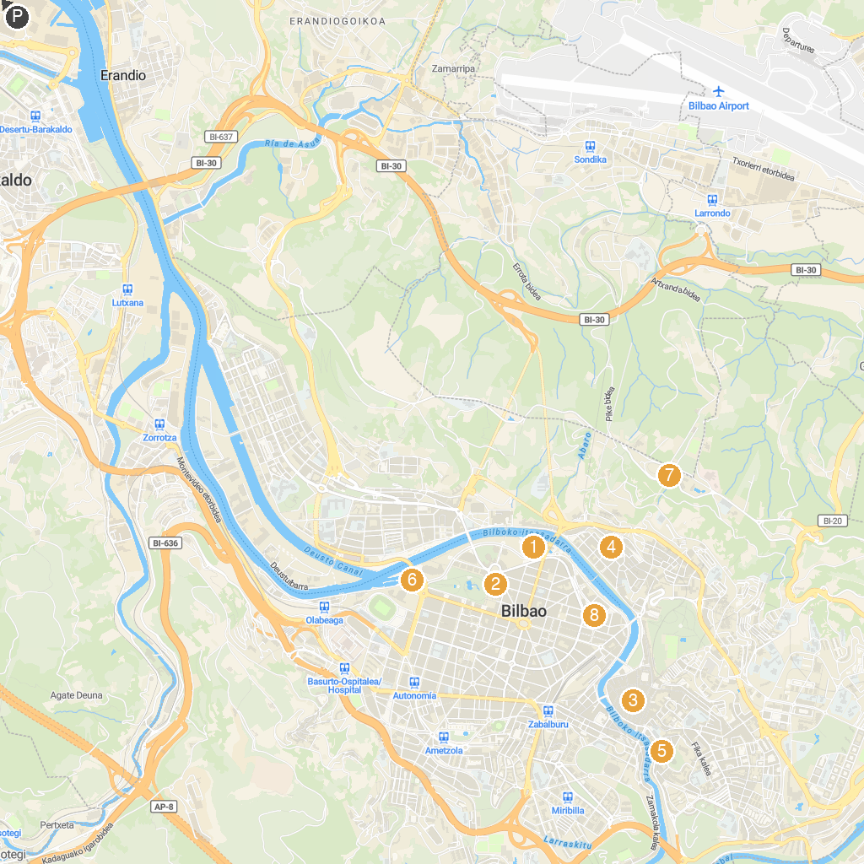
MAP KEY
1. Guggenheim Museum Bilbao | 5. Museum of Sacred Art of Bilbao
2. Museum of Fine Arts of Bilbao | 6. Itsasmuseum Bilbao
3. Bilboko Donejakue Katedrala | 7. Artxanda Funicular
4. Funicular bottom station | 8. Church of San Vicente de Abando
P. Cruise port / terminal
Map © MapTiler © OpenStreetMap contributors · cruiseports.org

