Biarritz, Basque Country, France
The glamour capital of France's Atlantic coast — where Belle Époque grandeur meets world-class surf breaks and vibrant Basque character. Most cruise ships anchor offshore and tender into this dramatic clifftop resort.
⚓ Tender port (no cruise pier) · 🕒 Typical call: 6–8 hrs · 💶 Euro (€) · 🗣️ French / Basque
✍️ MY DAY IN PORT (FILL IN)
Ship / Date
In port | arrive ______ · all aboard ______
Booked excursion
Notes / meeting point
GETTING ASHORE
- Docking: Tender only — ships anchor offshore; tender to Port des Pêcheurs or Grande Plage area
- Walk to centre: 5 min from tender landing to Grande Plage and town core
- Best For: Beach walks, surf culture, Belle Époque architecture, Basque food
- Don't Miss: Rocher de la Vierge — the rock bridge with sweeping Atlantic views
GETTING AROUND
- 🚕 Taxi: €20–€25 to city center — Taxis are available near the tender landing and town. Fixed-rate private transfers can be pre-booked; minivans for group
- 📱 Rideshare: ✅ Uber, Bolt
TOP THINGS TO DO
- Rocher de la Vierge & Grande Plage Walk — The signature Biarritz experience: cross Gustave Eiffel's metal bridge to the Virgin's Rock for dramatic Atlantic views, then…
- Surf Lesson on Côte des Basques — Biarritz is the birthplace of European surfing.
- Biarritz Town History Tour — A guided walk covering the Belle Époque heyday — Hôtel du Palais (the former Villa Eugénie, built by Napoleon III for Empress…
- Basque Country Day Trip: Saint-Jean-de-Luz & Bayonne — Visit the elegant fishing port of Saint-Jean-de-Luz (where Louis XIV was married) and the medieval city of Bayonne, famous for…
- San Sebastián Pintxos & Bay of La Concha — A longer full-day excursion across the Spanish border to San Sebastián — arguably Europe's greatest food city — for a pintxos…
BEST WALKS
- Coastal Icons Loop: 3.5 km · 60–90 min · Moderate (some steps and inclines) — From the fishing port, follow the clifftop path south past Villa Belza to Côte des Basques beach…
- Lighthouse Panorama Walk: 2 km · 45 min · Easy to moderate — Head north from Grande Plage along the Avenue de l'Impératrice to the Phare de Biarritz on Pointe…
WEATHER · DAYLIGHT · MONEY
Month | High °F | Low °F | Rainy days
May | 66 | 54 | 14
Jul | 75 | 64 | 10
Sep | 74 | 61 | 11
Daylight: May 6:41AM–9:24PM · Jul 6:39AM–9:44PM · Sep 7:46AM–8:15PM
cruiseports.org/biarritz · Confirm terminal & all-aboard time with your ship

Biarritz, Basque Country, France — Port Map
Red = walkable sights · Amber = excursions farther out · P = cruise terminal
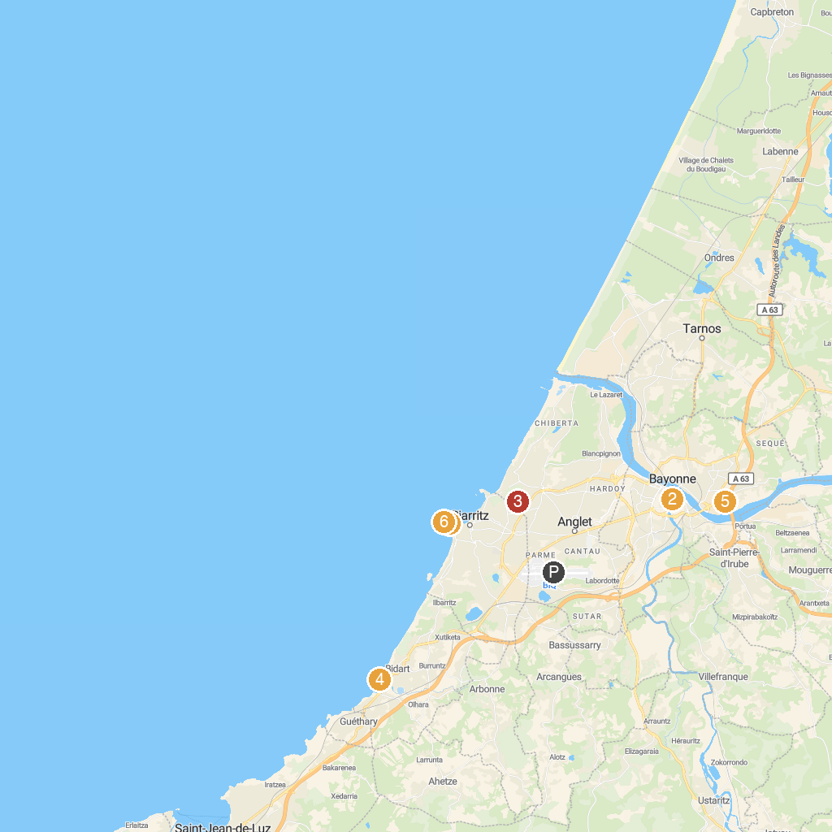
MAP KEY
1. Biarritz Aquarium | 5. TOO LATE Escape Game Bayonne - Pays basque
2. Musée Basque | 6. Parc Ducontenia
3. Fabrique de Chistera | 7. Socoa Fort
4. Plage de Bidart | 8. Rocher de la Vierge
P. Cruise port / terminal
Map © MapTiler © OpenStreetMap contributors · cruiseports.org

