Besançon, Bourgogne-Franche-Comté, France
Wrapped in a horseshoe bend of the Doubs River and crowned by a Vauban citadel, Besançon is one of eastern France's most rewarding river stops — Roman ruins, Renaissance palaces, and a watchmaking legacy all within easy walking distance of the quay.
⚓ River port (docked) · 🕒 Typical call: 6-8 hrs · 💶 Euro (€) · 🗣️ French
✍️ MY DAY IN PORT (FILL IN)
Ship / Date
In port | arrive ______ · all aboard ______
Booked excursion
Notes / meeting point
GETTING ASHORE
- Docking: Docked at Besançon river port on the Doubs, 30 berths, seasonal (Apr 15–Oct 15)
- Walk to centre: 5-10 min walk from river quay to La Boucle old town
- Best For: UNESCO Citadel, Roman history, watchmaking museums, local Comté cheese
- Don't Miss: Citadelle de Besançon (UNESCO) and the underground canal boat tour
GETTING AROUND
- 🚕 Taxi: €5–10 — Metered taxis available; short rides within the city center are inexpensive given the compact layout. Base fare ~€2.30 p
- 📱 Rideshare: ✅ Uber, Bolt
TOP THINGS TO DO
- Citadelle de Besançon — UNESCO Fortress — Vauban's 17th-century masterpiece crowns Mont Saint-Étienne with 11 hectares of ramparts, three museums (Comtois, Natural…
- La Boucle Old Town Walk — Stroll the pedestrianised horseshoe of streets past the Porte Noire Roman arch, Saint-Jean Cathedral with its astronomical clock…
- Underground Canal Boat Tour — Board 'Le Vauban' or 'Le Battant' for a scenic river loop that passes through the impressive 375-metre tunnel carved beneath the…
- Royal Saltworks of Arc-et-Senans — A second UNESCO World Heritage site 35 km southwest: Claude-Nicolas Ledoux's 18th-century 'ideal industrial city' is an…
- Musée du Temps — Museum of Time — Besançon was France's watchmaking capital.
BEST WALKS
- La Boucle Historic Loop: 2.5 km · ~1 hr · easy (flat) — From the quay follow the river past Quai Vauban, turn into the old town at Pont Battant, pass the…
- Up to the Citadel: 1 km · ~20 min · steep uphill — From the old town, climb Rue de la Convention steeply uphill to the Citadel main gate.
WEATHER · DAYLIGHT · MONEY
Month | High °F | Low °F | Rainy days
May | 65 | 49 | 15
Jul | 78 | 61 | 12
Sep | 71 | 55 | 10
Daylight: May 5:59AM–9:05PM · Jul 5:55AM–9:27PM · Sep 7:13AM–7:47PM
cruiseports.org/besancon · Confirm terminal & all-aboard time with your ship

Besançon, Bourgogne-Franche-Comté, France — Port Map
Red = walkable sights · Amber = excursions farther out · P = cruise terminal
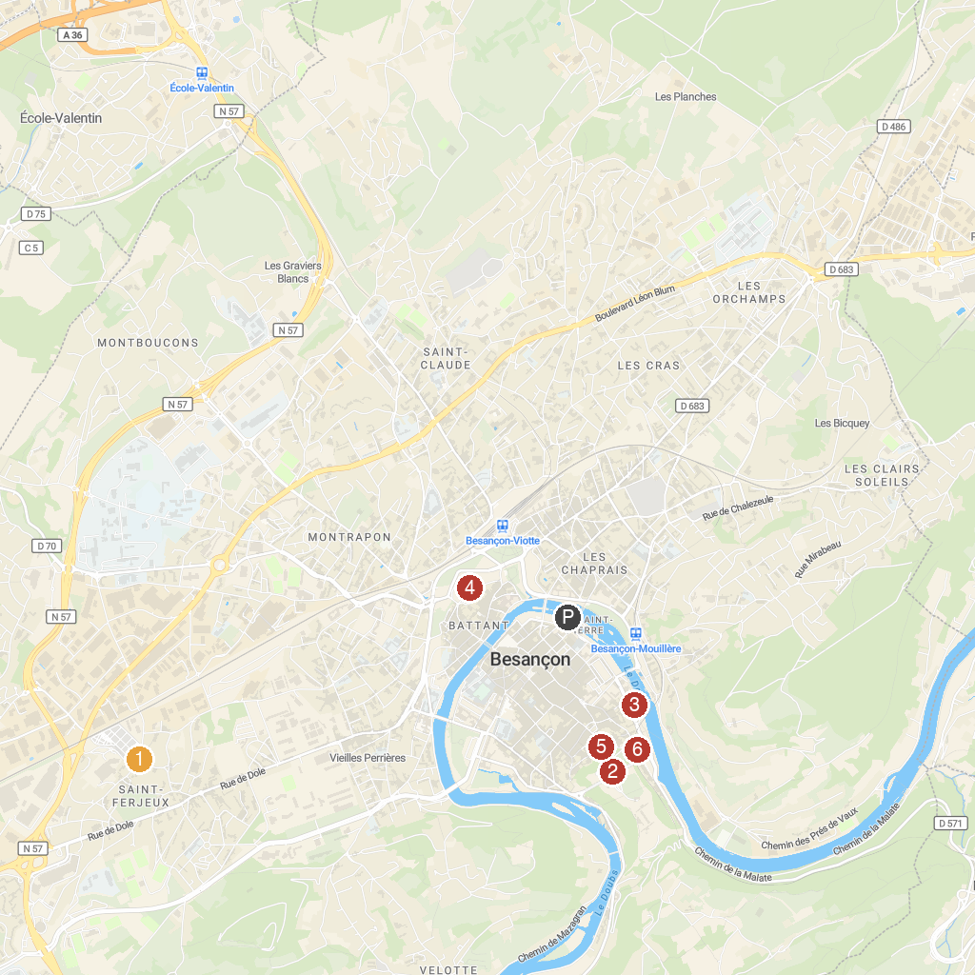
MAP KEY
1. Basilica of Saint-Ferjeux | 5. Astronomical clock
2. Besançon Citadel | 6. The Little Train of Besançon
3. Frac Franche-Comté | 7. Lama Loisir Mamirolle
4. Griffin Fort | 8. Fromagerie - Musée de TREPOT
P. Cruise port / terminal
Map © MapTiler © OpenStreetMap contributors · cruiseports.org

