Bernkastel-Kues, Moselle Valley, Germany
The 'Pearl of the Moselle' packs a medieval market square, world-class Riesling cellars, and sweeping vineyard views into a remarkably walkable town. Most ships dock steps from the Marktplatz — so you can be sipping wine within five minutes of stepping off.
⚓ Docked (riverside promenade) · 🕒 Typical call: 6–8 hrs · 💶 Euro (€) · 🗣️ German · 🍷 Wine country
✍️ MY DAY IN PORT (FILL IN)
Ship / Date
In port | arrive ______ · all aboard ______
Booked excursion
Notes / meeting point
GETTING ASHORE
- Docking: Ships moor along the Moselle promenade; town center is a 5-min walk.
- Walk to center: 5 min to Marktplatz; Kues side is 10 min across the bridge.
- Best For: Wine tasting, medieval architecture, easy walking, photography.
- Don't Miss: The Spitzhäuschen (Pointed House) and Landshut Castle ruins.
GETTING AROUND
- 🚕 Taxi: ~€8–15 — Local taxis (Taxi Edringer, Taxi Priwitzer, Taxi Reitz) are available 24/7. Stands are on the Bernkastel waterfront and
- 📱 Rideshare: ❌ not available
TOP THINGS TO DO
- Marktplatz & Old Town Walk — Wander the UNESCO-quality market square lined with 15th–17th century half-timbered buildings.
- Landshut Castle Ruins — Hike 30 min up vine-covered slopes to the medieval ruins of Burg Landshut for sweeping panoramas of the Moselle valley and the…
- Moselle Riesling Wine Tasting — Bernkastel sits at the heart of one of Germany's finest Riesling regions.
- Cusanusstift (St. Nikolaus Hospital), Kues — Founded in 1458 by philosopher-cardinal Nicholas of Cusa, this remarkably intact Gothic complex holds a church, medieval library…
- Moselle River Boat Tour — One-hour panoramic cruises depart from Bernkastel and glide past vine-clad hills toward Lieser and Mülheim, offering different…
BEST WALKS
- Old Town & Market Square Loop: 1.5 km · 30–45 min · Easy — From the dock, walk inland along Gestade to the Marktplatz.
- River Promenade to Kues & Cusanusstift: 2.5 km round-trip · 45–60 min · Easy — Walk north along the promenade, cross the Moselle bridge into Kues, and continue a few minutes to…
- Vineyard Hike to Landshut Castle: 3 km round-trip · 1.5–2 hrs · Moderate (steep) — Follow signs from the Marktplatz up through the Doctor vineyard (one of Germany's most famous…
WEATHER · DAYLIGHT · MONEY
Month | High °F | Low °F | Rainy days
May | 66 | 49 | 12
Jul | 77 | 60 | 11
Sep | 69 | 54 | 9
Daylight: May 5:46AM–9:10PM · Jul 5:40AM–9:34PM · Sep 7:08AM–7:44PM
cruiseports.org/bernkastel-kues · Confirm terminal & all-aboard time with your ship

Bernkastel-Kues, Moselle Valley, Germany — Port Map
Red = walkable sights · Amber = excursions farther out · P = cruise terminal
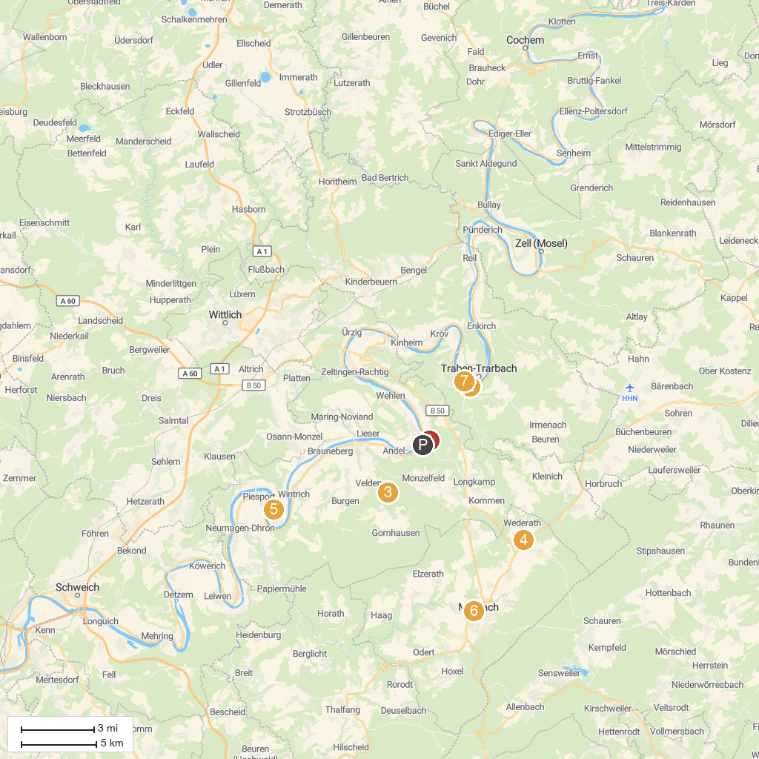
MAP KEY
1. Historische Bonbonmacherei | 5. Aussichtspunkt Pestkapelle
2. Grevenburg Castle Ruins | 6. Deutsches Telefon-Museum
3. Schloss Veldenz | 7. Historische Ölmühle Morbach
4. Kulturzentrum Archäologiepark BELGINUM | 8. Buddha-Museum
P. Cruise port / terminal
Map © MapTiler © OpenStreetMap contributors · cruiseports.org

