Berlevåg, Finnmark, Norway
One of Norway's most remote coastal stops, Berlevåg earns its reputation through sheer Barents Sea drama — colossal tetrapod breakwaters, a harbour museum that tells the story of fighting the sea, and Arctic wilderness that begins right at the pier.
⚓ Docked (small ships) / Tender (large ships) · 🕒 Typical call: 1-2 hrs (Hurtigruten stopover) · 💵 Norwegian Krone (NOK) · 🗣️ Norwegian
✍️ MY DAY IN PORT (FILL IN)
Ship / Date
In port | arrive ______ · all aboard ______
Booked excursion
Notes / meeting point
GETTING ASHORE
- Docking: Pier for vessels up to ~152m; larger cruise ships tender
- Walk to centre: 5 min from pier to village centre
- Best For: Arctic scenery, tetrapod breakwaters, Hurtigruten atmosphere
- Don't Miss: Berlevåg Harbour Museum and the Kjølnes Lighthouse
GETTING AROUND
- 🚕 Taxi: NOK 100–150 — Berlevåg Taxi serves the village. Fares are short given the compact size; airport transfers (3.6 km) run roughly NOK 100
TOP THINGS TO DO
- Berlevåg Harbour Museum — Housed in a restored waterfront warehouse, this museum chronicles Berlevåg's epic battle with the Barents Sea — including the…
- Tetrapod Breakwater Walk — Stroll the breakwaters protecting the harbour and marvel at the 11,000+ four-legged concrete tetrapods that keep the Barents Sea…
- Sandfjorden Beach & Dunes — A short drive west leads to Sandfjorden, a surprisingly wide white-sand Arctic beach backed by dunes.
- Tanahorn Peak Hike — A moderate 3.5 km hike starting 8 km west of Berlevåg leads to the Tanahorn summit with sweeping panoramas over the Barents Sea.
- Kjølnes Lighthouse — Built in 1916 and rebuilt after WWII, Kjølnes Fyr stands on the headland approach to Berlevåg with classic coastal views.
BEST WALKS
- Village Harbour Loop: 1 km · 20 min · flat — From the pier, walk past the tetrapod breakwaters to the Harbour Museum, then loop back through the…
- Kjølnes Lighthouse Drive & Walk: ~5 km by road · 45 min · easy coastal walk — Drive or take a taxi east along the coast to Kjølnes lighthouse.
WEATHER · DAYLIGHT · MONEY
Month | High °F | Low °F | Rainy days
May | 42 | 34 | 17
Jul | 59 | 49 | 12
Sep | 50 | 42 | 14
Daylight: Sep 5:14AM–6:40PM
cruiseports.org/berlevag · Confirm terminal & all-aboard time with your ship

Berlevåg, Finnmark, Norway — Port Map
Red = walkable sights · Amber = excursions farther out · P = cruise terminal
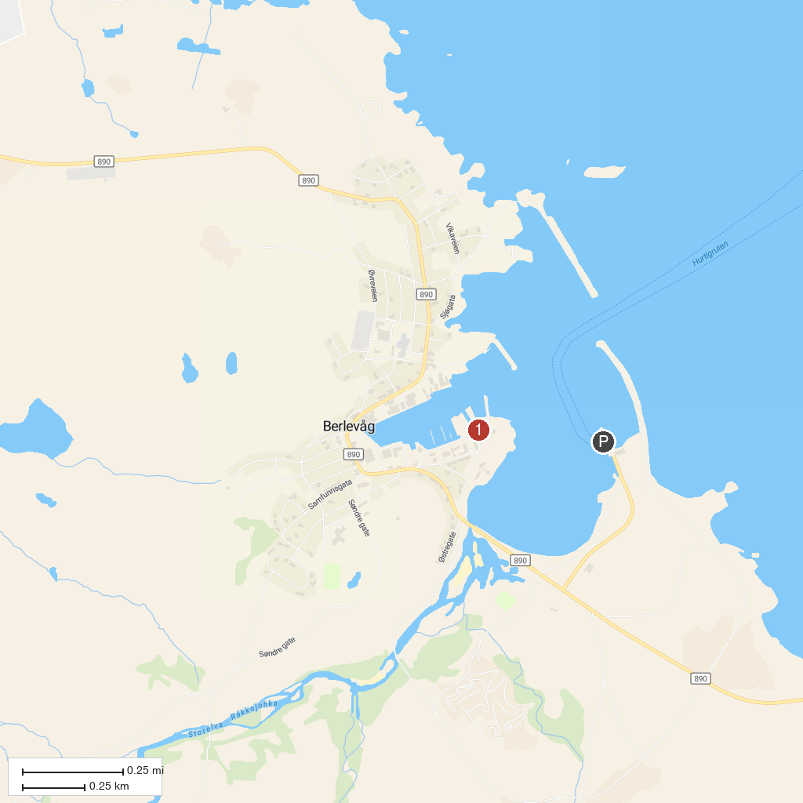
MAP KEY
1. Berlevåg Harbor Museum | 2. Veinesodden batteri
P. Cruise port / terminal
Map © MapTiler © OpenStreetMap contributors · cruiseports.org

