Bergen, Vestland, Norway
Norway's second city sits wrapped in seven mountains and a harbor that's been busy since the Vikings. Bryggen's painted wooden facades are a UNESCO icon, the fjords begin just outside town, and you can ride a funicular to the clouds before lunch.
⚓ Docked (multiple central piers) · 🕒 Typical call: 8-12 hrs · 💵 Norwegian Krone (NOK) · 🗣️ Norwegian (English widely spoken)
✍️ MY DAY IN PORT (FILL IN)
Ship / Date
In port | arrive ______ · all aboard ______
Booked excursion
Notes / meeting point
GETTING ASHORE
- Docking: Central piers (Skolten, Festningskaien, Bontelabo) — 5-10 min walk to Bryggen. Large ships may dock at Dokken/Jekteviken, 2.5 km from center.
- Walk to center: 5 min from Skolten/Festningskaien; free shuttle from Dokken terminal
- Best For: Fjord day trips, UNESCO heritage, hiking, seafood
- Don't Miss: Fløibanen funicular ride + Flåm Railway day excursion
GETTING AROUND
- 🚕 Taxi: 150–300 NOK (~$15–$28) — Taxis are readily available at the cruise terminals. Short ride to city center; Norway taxis are metered and on the pric
- 📱 Rideshare: ✅ Uber, Bolt
- 🚌 Hop-on hop-off: ✅
TOP THINGS TO DO
- Flåm Railway & Nærøyfjord Cruise — The classic full-day 'Norway in a Nutshell' circuit: coach to Voss or Myrdal, then the scenic Flåmsbana railway descending 864…
- Fløibanen Funicular & Mount Fløyen — A six-minute funicular ride from the city center delivers panoramic views of Bergen, its seven mountains, and the harbor.
- Bryggen Wharf & Hanseatic Museum — Wander the narrow alleys of Bergen's UNESCO-listed medieval wharf, then step into the Hanseatic Museum to understand how German…
- Hardangerfjord Day Trip — Coach east to the Hardangerfjord — Norway's 'Queen of Fjords' — famed for fruit orchards in bloom, and the Steinsdalsfossen…
- Bergen Fish Market (Fisketorget) — The covered Fish Market on the wharf is Bergen's most atmospheric food stop — fresh shrimp, smoked salmon, fish soup, and local…
BEST WALKS
- Harbor & Bryggen Loop: 2 km · 45-60 min · Flat, easy — Start at the Fish Market, walk north along the quay to Bryggen Wharf, duck into the alleyways…
- Fløibanen to Fløyen Summit Walk: 0.5 km walk up + 6-min funicular · 1.5-2 hrs return · Easy-moderate — Walk from the harbor to the Fløibanen station at the base of the hill, ride the funicular to the…
WEATHER · DAYLIGHT · MONEY
Month | High °F | Low °F | Rainy days
May | 55 | 42 | 15
Jul | 63 | 52 | 18
Sep | 59 | 49 | 17
Daylight: May 4:58AM–10:13PM · Jul 4:39AM–10:48PM · Sep 7:06AM–7:59PM
cruiseports.org/bergen · Confirm terminal & all-aboard time with your ship

Bergen, Vestland, Norway — Port Map
Red = walkable sights · Amber = excursions farther out · P = cruise terminal
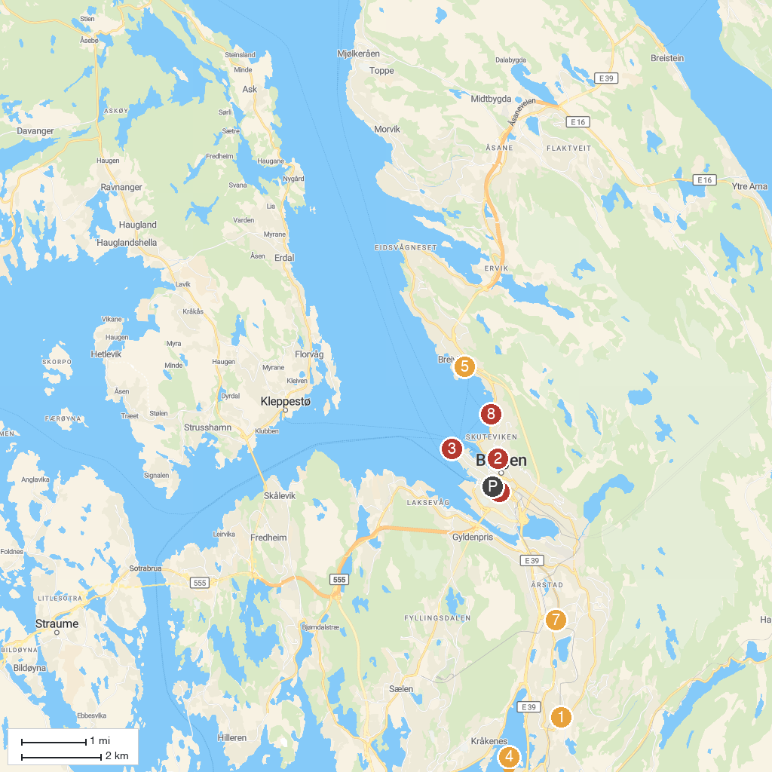
MAP KEY
1. Fantoft Stave Church | 5. Gamle Bergen Museum - Bymuseet i Bergen
2. Bryggen | 6. Kode - Stenersen building
3. Akvariet i Bergen - The National Aquarium | 7. Hindu Sabha Bergen
4. Troldhaugen | 8. Sandviksboder Kystkultursenter
P. Cruise port / terminal
Map © MapTiler © OpenStreetMap contributors · cruiseports.org

