Benoa (Bali), Indonesia
Bali from the sea — ancient clifftop temples, emerald rice terraces, vibrant art villages, and sacred ceremony all within reach of a single shore day, if you plan smart and start early.
⚓ Docked (Benoa harbour) · 🕒 Typical call: 8–10 hrs · 💵 Indonesian Rupiah (IDR) · 🗣️ Indonesian / Balinese
✍️ MY DAY IN PORT (FILL IN)
Ship / Date
In port | arrive ______ · all aboard ______
Booked excursion
Notes / meeting point
GETTING ASHORE
- Docking: Port of Benoa, near Denpasar
- Walk to center: Transfer or taxi needed
- Best For: Temples · Rice terraces · Culture
- Don't Miss: Uluwatu sunset Kecak dance
GETTING AROUND
- 🚕 Taxi: $17–$25 USD — Metered and negotiated taxis wait at the cruise terminal. Agree on a fare before departing — typical rates are Kuta/Semi
- 📱 Rideshare: ✅ Grab, Gojek
- 🚌 Hop-on hop-off: ✅ Kura-Kura Bus · from Rp 100,000 (~$6 USD) one-way
TOP THINGS TO DO
- Uluwatu Temple & Kecak Fire Dance — The crown jewel of a Bali port day.
- Ubud: Monkey Forest, Art Market & Rice Terraces — Bali's cultural heart — the Sacred Monkey Forest Sanctuary, the bustling Ubud Art Market, Tegallalang rice terraces, and craft…
- Tanah Lot Temple — One of Bali's most photographed sights — a Hindu sea temple perched on a rocky islet offshore, accessible on foot at low tide.
- Garuda Wisnu Kencana Cultural Park — A vast hilltop cultural park on the Bukit Peninsula — home to a towering 121-metre statue of Vishnu astride Garuda, Balinese…
- Nusa Dua & Seminyak Beaches — Nusa Dua's manicured resort beach is 15 minutes from the port — an easy half-day for sun and sand.
BEST WALKS
- Ubud town & Monkey Forest loop: ~3 km · 2 hrs · easy — From the Ubud Art Market, walk south through the village to the Sacred Monkey Forest Sanctuary…
- Tegallalang Rice Terrace walk: ~1.5 km · 1 hr · easy–moderate — Walk the stepped paths through the iconic Tegallalang terraces north of Ubud — lush, photogenic…
WEATHER · DAYLIGHT · MONEY
Month | High °F | Low °F | Rainy days
May | 84 | 76 | 19
Jul | 80 | 74 | 17
Sep | 82 | 73 | 16
Daylight: May 6:24AM–6:06PM · Jul 6:35AM–6:14PM · Sep 6:13AM–6:15PM
cruiseports.org/benoa · Confirm terminal & all-aboard time with your ship

Benoa (Bali), Indonesia — Port Map
Red = walkable sights · Amber = excursions farther out · P = cruise terminal
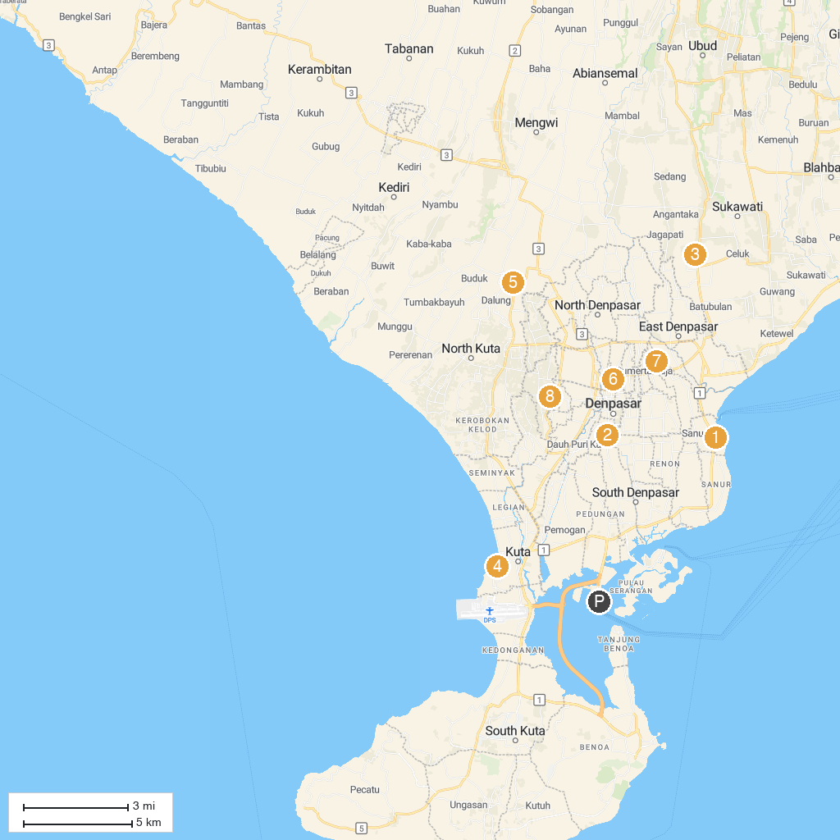
MAP KEY
1. Masjid Al-Ihsaan - Sanur | 5. Monumen Perjuangan Bangsal Bali
2. Masjid An-Nur - Denpasar | 6. Puri Agung Denpasar
3. Bali Bird Park | 7. Taman Wisata Tukad Bindu
4. Waterbom Bali | 8. Bali SUN Tours
P. Cruise port / terminal
Map © MapTiler © OpenStreetMap contributors · cruiseports.org

