Benidorm, Costa Blanca, Spain
A skyscraper skyline rising from golden Mediterranean beaches — Benidorm is Spain's brash, fun resort city with a surprisingly charming old quarter and easy access to inland villages and waterfalls.
⚓ Tender port · 🕒 Typical call: 6-8 hrs · 💶 Euro (EUR) · 🗣️ Spanish
✍️ MY DAY IN PORT (FILL IN)
Ship / Date
In port | arrive ______ · all aboard ______
Booked excursion
Notes / meeting point
GETTING ASHORE
- Docking: Tender — ships anchor offshore; boats run to the port quay
- Walk to centre: 5 min from tender dock to Playa de Levante
- Best For: Beach days, Old Town tapas, day trips to Guadalest
- Don't Miss: Balcón del Mediterráneo viewpoint in the Old Town
GETTING AROUND
- 🚕 Taxi: €6–€12 — Taxis are metered and readily available at ranks near the port quay, beaches, and hotels. Short rides within Benidorm ty
- 📱 Rideshare: ✅ Uber
- 🚌 Hop-on hop-off: ✅ · from €9.50
TOP THINGS TO DO
- Guadalest & Algar Waterfalls — The hilltop village of El Castell de Guadalest — perched on a rocky outcrop with a medieval castle — is Benidorm's most iconic…
- Benidorm Old Town & Balcón del Mediterráneo — The Casco Antiguo sits on a rocky promontory dividing Levante and Poniente beaches.
- Aqualandia or Aqua Natura Water Park — Benidorm hosts two big water parks: Aqualandia in Rincón de Loix (beside the Mundomar marine park), with towering slides and wave…
- Sierra Helada Natural Park Hike — The limestone ridge behind Benidorm's Rincon de Loix district is a protected natural park.
- Benidorm Island Boat Trip — Illa de Benidorm sits just 3 km offshore and is a marine reserve with clear water for snorkelling.
BEST WALKS
- Old Town & Balcón del Mediterráneo: 1.5 km · 30 min · Easy — From the port quay, head uphill into the Casco Antiguo.
- Levante Promenade Beach Walk: 3 km return · 45 min · Flat — Stroll north along the full length of Playa de Levante — one of Spain's longest urban beaches…
WEATHER · DAYLIGHT · MONEY
Month | High °F | Low °F | Rainy days
May | 72 | 60 | 4
Jul | 86 | 73 | 1
Sep | 80 | 69 | 7
Daylight: May 6:49AM–9:05PM · Jul 6:48AM–9:23PM · Sep 7:42AM–8:08PM
cruiseports.org/benidorm · Confirm terminal & all-aboard time with your ship

Benidorm, Costa Blanca, Spain — Port Map
Red = walkable sights · Amber = excursions farther out · P = cruise terminal
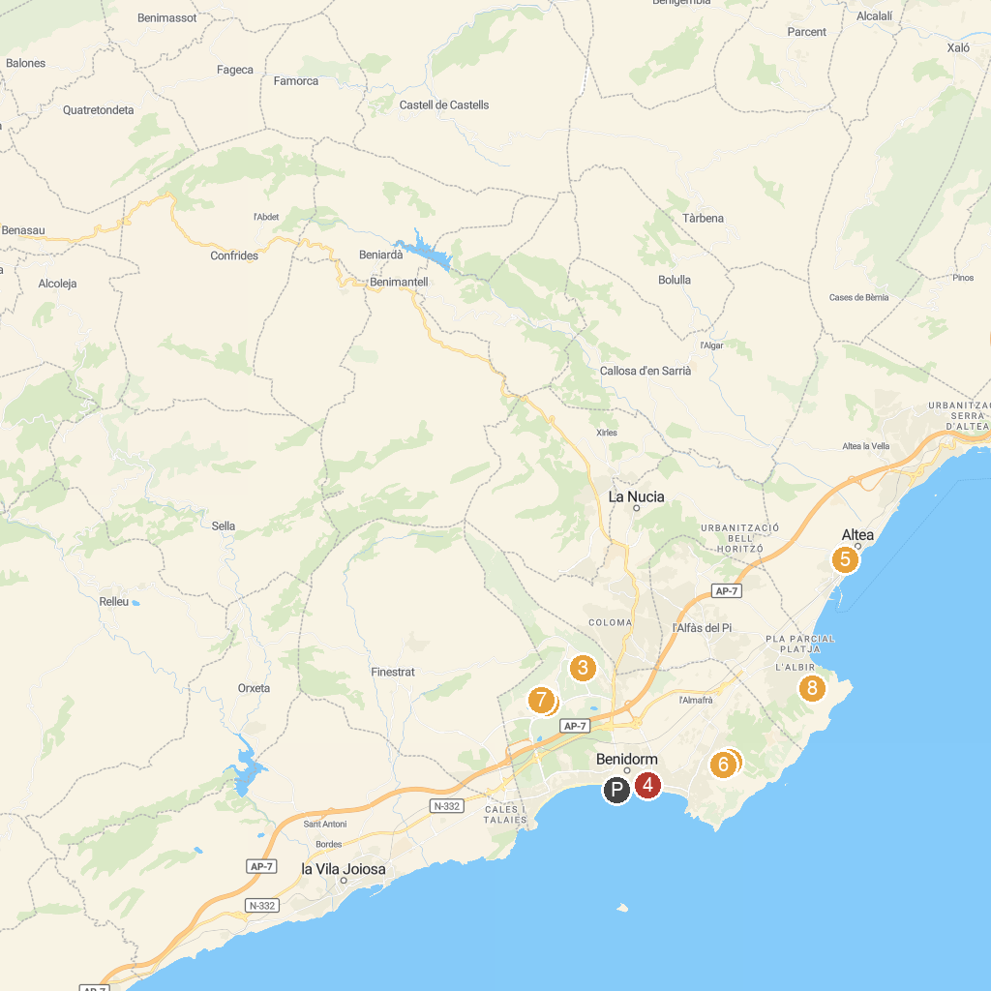
MAP KEY
1. Terra Mítica | 5. The Virgin of the Consol
2. Mundomar | 6. Aqualandia
3. Terra Natura | 7. Puerto de Alejandría
4. Sould Park Festilandia Benidorm - Parc Infantil i d'Atraccions | 8. Via ferrata de l'Albir
P. Cruise port / terminal
Map © MapTiler © OpenStreetMap contributors · cruiseports.org

