Belle-Île-en-Mer, Brittany, France
Brittany's 'beautiful island' rewards a shore day with wild sea-stack coastline, pastel-shuttered fishing villages, and the dramatic cliffs that captivated Claude Monet. Ships tender into the charming harbour of Le Palais — everything starts from the quayside.
⚓ Tender port (Le Palais harbour) · 🕒 Typical call: 7–9 hrs · 💶 Euro (€) · 🗣️ French
✍️ MY DAY IN PORT (FILL IN)
Ship / Date
In port | arrive ______ · all aboard ______
Booked excursion
Notes / meeting point
GETTING ASHORE
- Docking: Tender only — ships anchor offshore; tenders land at Le Palais quay
- Walk to centre: Instant — Le Palais town begins at the tender dock
- Best for: Dramatic coastal hikes, cycling, Monet landmarks, Breton seafood
- Don't miss: Aiguilles de Port-Coton (Monet's needle rocks) & Sauzon harbour village
GETTING AROUND
- 🚕 Taxi: EUR 15-20 typical short trip — Local taxis and licensed VTC drivers available island-wide; booking 24-48 hours ahead is recommended, especially in summ
TOP THINGS TO DO
- Aiguilles de Port-Coton & Côte Sauvage — The jagged sea stacks on the wild south-western coast — famously painted by Claude Monet in 1886 — are Belle-Île's signature view.
- Pointe des Poulains Walk — A 2-hour circular walk to the island's northern tip takes in a lighthouse, sweeping Atlantic panoramas, and the fort once owned…
- Island Cycling — Rent a standard or electric bike at Le Palais and follow waymarked lanes to Sauzon, Plage des Grands Sables, or sections of the…
- Vauban Citadel & Belle-Île Museum — The 16th-century fortress above Le Palais harbour, reinforced by Vauban, now houses the Belle-Île Museum of Art and History.
- Sauzon Village & Goulphar Lighthouse — Sauzon — Belle-Île's prettiest harbour, with pastel shutters and bobbing fishing boats — pairs perfectly with a stop at the Grand…
BEST WALKS
- Le Palais Harbour & Citadel Loop: 1.5 km · 40 min · Easy — From the tender dock, stroll the waterfront promenade, browse the market streets of Le Palais, then…
- Port-Coton Needles Coastal Path: 5 km loop · 2 hrs · Moderate — Take a bus or hire car to Port-Coton, then walk the clifftop path above the iconic needle rocks…
WEATHER · DAYLIGHT · MONEY
Month | High °F | Low °F | Rainy days
May | 65 | 49 | 13
Jul | 77 | 59 | 9
Sep | 72 | 55 | 9
Daylight: May 6:23AM–9:19PM · Jul 6:19AM–9:41PM · Sep 7:33AM–8:05PM
cruiseports.org/belle-ile-en-mer · Confirm terminal & all-aboard time with your ship

Belle-Île-en-Mer, Brittany, France — Port Map
Red = walkable sights · Amber = excursions farther out · P = cruise terminal
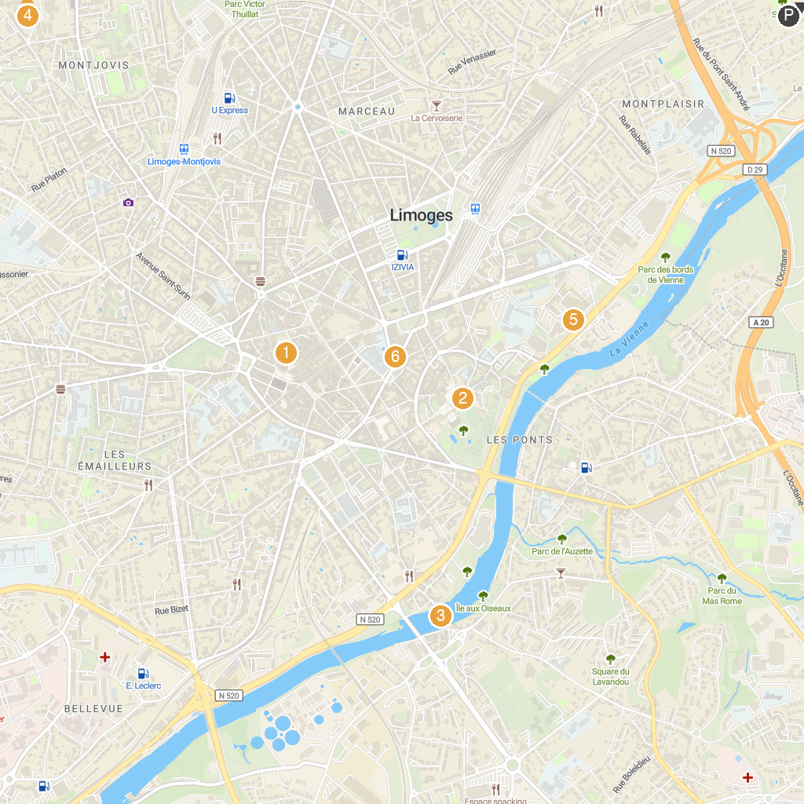
MAP KEY
1. Basilique Saint Michel des Lions | 5. HistoRail, musée du chemin de fer
2. Cathédrale Saint-Étienne de Limoges | 6. Castle of Nieul
3. Pont Saint-Martial | 7. Four à porcelaine des Casseaux
4. Parc des Sports de Beaublanc | 8. Petit Train
P. Cruise port / terminal
Map © MapTiler © OpenStreetMap contributors · cruiseports.org

