Belize City, Belize District, Belize
Belize City is a tender-only port — no cruise ship has ever docked at a pier here. That 15-minute boat ride unlocks the planet's second-largest barrier reef, towering Mayan temples, and cave tubing through the ancient Maya underworld.
⚓ Tender port (no pier for cruise ships) · 🕒 Typical call: 7-9 hrs · 💵 USD & Belize Dollar (2 BZD = 1 USD) · 🗣️ English-speaking (also Creole, Spanish) · 🌊 Barrier reef, jungle & Mayan ruins
✍️ MY DAY IN PORT (FILL IN)
Ship / Date
In port | arrive ______ · all aboard ______
Booked excursion
Notes / meeting point
GETTING ASHORE
- Docking: Tender only — ships anchor offshore, high-speed tenders run ~15-20 min to Fort Street Tourism Village pier
- Walk to center: Fort Street pier to Swing Bridge ~0.6 mi / 15 min; to Baron Bliss Lighthouse ~0.5 mi / 10 min
- Best For: Cave tubing, Mayan ruins (Altun Ha, Lamanai), barrier reef snorkeling, zip-lining
- Don't Miss: Cave tubing at Nohoch Che'en Caves Branch or Lamanai ruins by river boat — book before you sail
GETTING AROUND
- 🚕 Taxi: $10–15 USD — Taxis are readily available at Fort Street Tourism Village. Fares are not metered — agree on a price before departing; e
- 📱 Rideshare: ❌ not available
TOP THINGS TO DO
- Cave Tubing at Nohoch Che'en Caves Branch — Float on inner tubes through ancient Mayan ceremonial caves lit only by headlamps, stalactites hanging overhead.
- Lamanai Mayan Ruins by River Boat — Drive an hour to Tower Hill, then ride 26 miles up the New River — crocodiles sunning on the banks, howler monkeys crashing…
- Altun Ha Mayan Ruins — Belize's most visited Mayan site is about an hour's drive from the pier.
- Barrier Reef Snorkeling — Hol Chan & Shark Ray Alley — Snorkel the protected Hol Chan Marine Reserve cut in the UNESCO World Heritage barrier reef, then drift over Shark Ray Alley…
- Goff's Caye Beach & Snorkel — A tiny uninhabited sand island sitting right on the barrier reef — postcard-perfect, uncrowded, and reachable in under an hour by…
BEST WALKS
- Fort Street to Baron Bliss Lighthouse: 0.5 mi · Flat · ~15 min one-way — A flat waterfront walk from the Tourism Village pier south along the harbor esplanade to the Baron…
- Swing Bridge & Downtown Stroll: ~0.75 mi loop · Easy · 45-60 min — Walk north from the pier into the historic downtown.
WEATHER · DAYLIGHT · MONEY
Month | High °F | Low °F | Rainy days
May | 85 | 79 | 20
Jul | 85 | 79 | 24
Sep | 85 | 78 | 28
Daylight: May 5:20AM–6:17PM · Jul 5:26AM–6:30PM · Sep 5:41AM–5:54PM
cruiseports.org/belize-city · Confirm terminal & all-aboard time with your ship

Belize City, Belize District, Belize — Port Map
Red = walkable sights · Amber = excursions farther out · P = cruise terminal
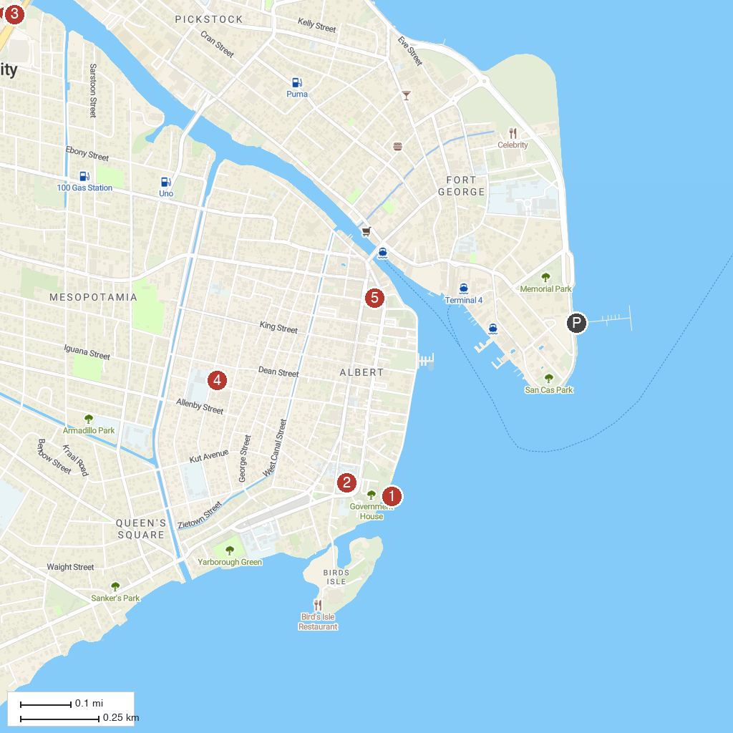
MAP KEY
1. Government House | 4. Saint Ignatius of Loyola Catholic Church, Basra
2. St John Anglican Cathedral service | 5. Battlefield Park
3. Luba Garifuna Museum
P. Cruise port / terminal
Map © MapTiler © OpenStreetMap contributors · cruiseports.org

