Belgrade, Serbia
Where the Sava meets the Danube, Belgrade rises on a cliff crowned by a medieval fortress — a capital that has been rebuilt more than any other city on earth and wears every scar proudly.
⚓ Docked (Sava River pier) · 🕒 Typical call: 8-10 hrs · 💵 Serbian Dinar (RSD) · 🗣️ Serbian
✍️ MY DAY IN PORT (FILL IN)
Ship / Date
In port | arrive ______ · all aboard ______
Booked excursion
Notes / meeting point
GETTING ASHORE
- Docking: Alongside on Sava River, near Beton Hala waterfront
- Walk to center: ~25-30 min uphill to Knez Mihailova St; taxi 5 min
- Best For: History, Orthodox architecture, Balkan food & nightlife
- Don't Miss: Kalemegdan Fortress at sunset over the two rivers
GETTING AROUND
- 🚕 Taxi: €5–8 — Metered taxis run about 600–800 RSD (€5–8) to most city center destinations. Use city-regulated cabs with the Belgrade c
- 📱 Rideshare: ❌ not available
- 🚌 Hop-on hop-off: ✅
TOP THINGS TO DO
- Kalemegdan Fortress & Old Belgrade Walk — Belgrade Fortress sits on a cliff at the confluence of the Sava and Danube — 2,000 years of layered history in one hilltop park.
- City Highlights & Nikola Tesla Museum — A guided loop taking in Republic Square, Knez Mihailova Street, the Church of Saint Sava (one of the world's largest Orthodox…
- Novi Sad & Petrovaradin Fortress Day Trip — Ninety kilometres north, Novi Sad's baroque old town and the dramatic Petrovaradin Fortress — nicknamed 'Gibraltar on the Danube'…
- Iron Gate Gorge & Golubac Fortress — Drive east along the Danube to the dramatic Iron Gate canyon.
- Skadarlija Bohemian Quarter & Serbian Food — Belgrade's cobblestoned Skadarlija district is lined with traditional kafanas (taverns) serving ćevapi, burek, and local wines.
BEST WALKS
- Sava Quay to Kalemegdan Fortress: 2.5 km · 30-35 min · Moderate (uphill) — From the pier, walk north along the Sava embankment past Beton Hala's cafes, then climb…
- Knez Mihailova Street to Skadarlija: 1.8 km · 20-25 min · Easy — Stroll Belgrade's main pedestrian boulevard from Republic Square past boutiques, galleries, and…
WEATHER · DAYLIGHT · MONEY
Month | High °F | Low °F | Rainy days
May | 72 | 55 | 13
Jul | 84 | 66 | 10
Sep | 75 | 59 | 9
Daylight: May 5:09AM–7:59PM · Jul 5:06AM–8:20PM · Sep 6:17AM–6:48PM
cruiseports.org/belgrade · Confirm terminal & all-aboard time with your ship

Belgrade, Serbia — Port Map
Red = walkable sights · Amber = excursions farther out · P = cruise terminal
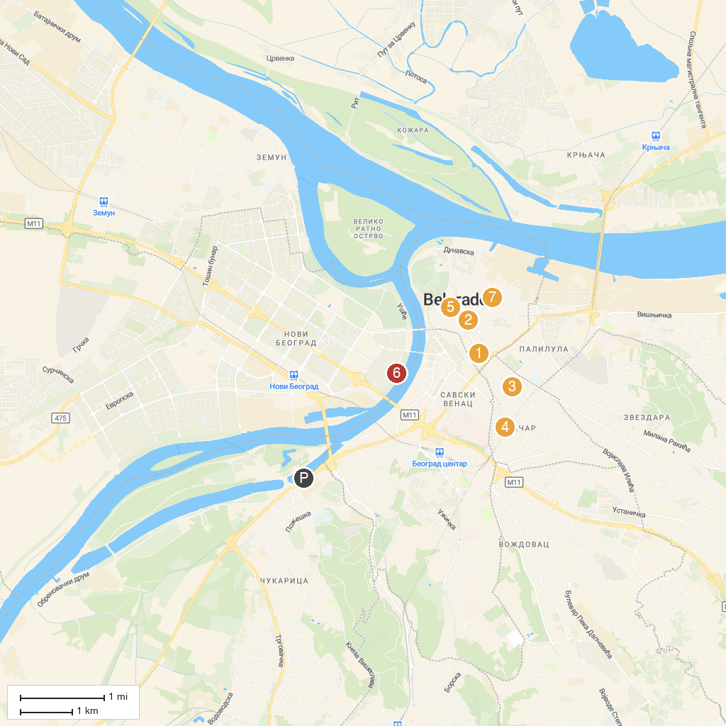
MAP KEY
1. The Old Palace | 5. Monument to the Unknown Hero
2. Prince Mihailo Monument | 6. Zepter Museum
3. Nikola Tesla Museum | 7. Republika Srpska Park
4. Church of Saint Sava | 8. St. Alexandar Nevsky Serbian Orthodox Church
P. Cruise port / terminal
Map © MapTiler © OpenStreetMap contributors · cruiseports.org

