Belfast, Maine, USA
A postcard-pretty Maine harbor town where lobster boats bob at the dock and a brick-fronted Main Street spills right down to the water. Belfast rewards slow exploration on foot — and rewards it well.
⚓ Docked (City Landing pier) · 🚢 Small ships only (≤50 passengers) · 🕒 Typical call: 6–8 hrs · 💵 US Dollar · 🗣️ English
✍️ MY DAY IN PORT (FILL IN)
Ship / Date
In port | arrive ______ · all aboard ______
Booked excursion
Notes / meeting point
GETTING ASHORE
- Docking: City Landing floating dock, mouth of Passagassawakeag River
- Walk to center: 2–5 min stroll up Main Street
- Best For: Walking, lobster lunch, historic architecture, harbor cruises
- Don't Miss: The Harbor Walk to Armistice Bridge and a lobster roll at the waterfront
GETTING AROUND
- 🚕 Taxi: From $10 — Local taxi companies serve the port area; Flagship Taxi (207-222-3108) and Bayside Taxi (207-338-1993) are established o
- 📱 Rideshare: ✅ Uber
TOP THINGS TO DO
- Lobster Boat Experience — Head out on a working lobster boat with a local lobsterman for a live trap-hauling demonstration on Penobscot Bay.
- Historic Downtown Walking Tour — Follow the Hawthorne Hike or Museum in the Streets trail past pre-Civil War brick storefronts, Victorian sea-captain homes, and…
- Schooner Sail on Penobscot Bay — Sail Belfast Bay aboard Schooner Charm or similar vessels for panoramic views of the Penobscot Bay islands, Camden Hills, and the…
- Sea Kayak the Penobscot Shoreline — Paddle Belfast Bay with Water Walker Sea Kayak Tours, exploring the rocky coastline, tidal flats, and quiet coves just outside…
- Belfast Historical Society & Museum — Compact museum at 10 Market Street (corner of Church Street) covering Belfast's maritime heritage, industrial boom years, and the…
BEST WALKS
- Harbor Walk to Armistice Bridge: 1 mile each way · Paved · Easy · 30–45 min — Follow the paved Belfast Harbor Walk from City Landing along the shore, past Heritage Park, to the…
- Main Street Historic District Loop: 1.5 miles · Sidewalk · Easy · 45–60 min — From the dock walk up Main Street past brick storefronts, then detour along Church Street to see…
WEATHER · DAYLIGHT · MONEY
Month | High °F | Low °F | Rainy days
May | 58 | 46 | 14
Jul | 65 | 54 | 17
Sep | 61 | 51 | 13
Daylight: May 5:18AM–9:23PM · Jul 5:08AM–9:50PM · Sep 6:57AM–7:39PM
cruiseports.org/belfast-me · Confirm terminal & all-aboard time with your ship

Belfast, Maine, USA — Port Map
Red = walkable sights · Amber = excursions farther out · P = cruise terminal
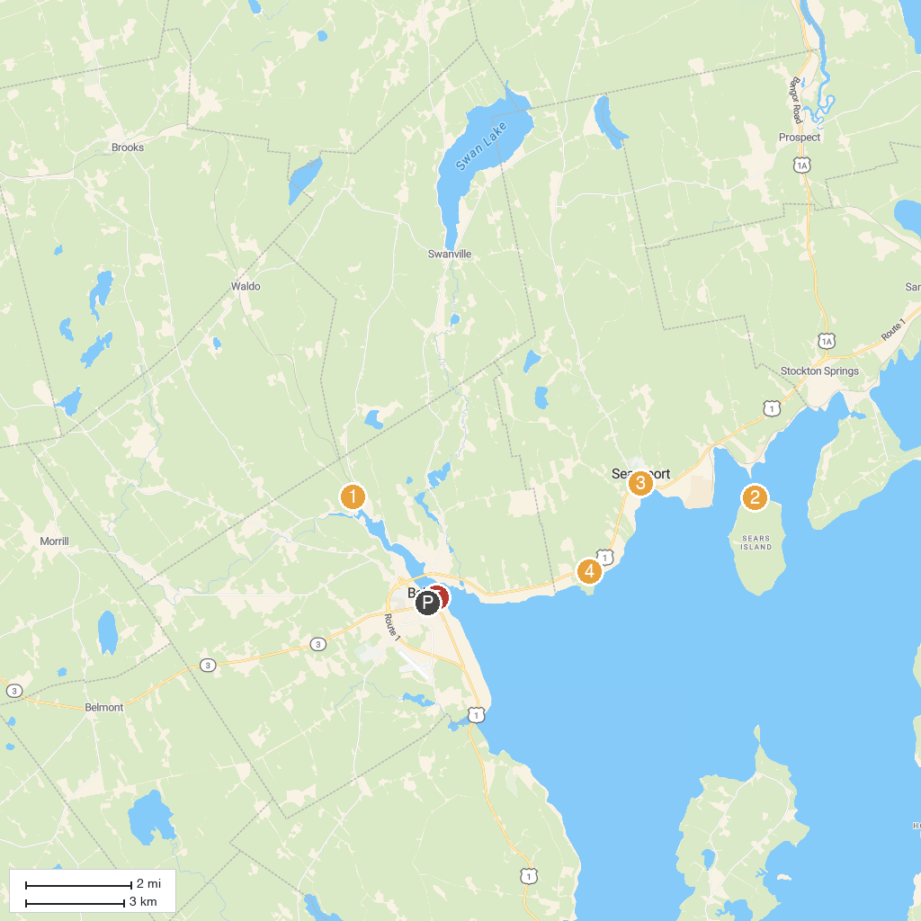
MAP KEY
1. Belfast and Moosehead Lake Railroad | 4. Moose Point State Park
2. Friends of Sears Island | 5. Heritage Park
3. Penobscot Marine Museum
P. Cruise port / terminal
Map © MapTiler © OpenStreetMap contributors · cruiseports.org

