Belém, Pará, Brazil
Gateway to the world's greatest rainforest, Belém blends Amazonian energy with Portuguese colonial grandeur — from the sprawling Ver-o-Peso waterfront market to stilt-house river islands just minutes away.
⚓ Docked (Terminal de Outeiro or city pier) · 🕒 Typical call: 8-10 hrs · 💵 Brazilian Real (BRL) · 🗣️ Portuguese
✍️ MY DAY IN PORT (FILL IN)
Ship / Date
In port | arrive ______ · all aboard ______
Booked excursion
Notes / meeting point
GETTING ASHORE
- Docking: Most ships dock at the new Terminal de Outeiro (2025) or the city-centre pier on Guajará Bay
- Walk to centre: City-pier berth is walkable to Ver-o-Peso (~5 min); Outeiro (on Caratateua Island) requires a shuttle or taxi (~27 km / ~40 min)
- Best For: Amazon river life, colonial history, exotic market food, nature
- Don't Miss: Ver-o-Peso market at dawn — the freshest açaí and fish in the Amazon
GETTING AROUND
- 🚕 Taxi: R$30–45 (~USD 6–9) — Metered taxis available outside the port. Base fare R$5 + R$3.25/km. A 5–8 km ride to the center runs roughly R$30–45.
- 📱 Rideshare: ✅ Uber
TOP THINGS TO DO
- Amazon River Boat Tour — Cruise the furos (natural channels) and igarapés around Belém, visiting Combu Island where locals harvest açaí from stilt houses…
- Ver-o-Peso Market Deep Dive — The largest open-air market in Latin America (commerce on this site dates to 1625; the iron market hall was built in 1901)…
- Forte do Presépio & Complexo Feliz Lusitânia — Founded in 1616, this Portuguese fort launched the colonisation of the Amazon.
- Basílica de Nossa Senhora de Nazaré — This rubber-boom masterpiece (begun 1909) is modelled on the Basilica of St Paul Outside the Walls in Rome — Carrara marble, gold…
- Mangal das Garças Ecological Park — Beautifully landscaped riverside park with walk-through aviaries, a butterfly house, and a lookout tower over the Guamá River — a…
BEST WALKS
- Waterfront Heritage Walk: 2-3 km · ~1.5 hrs · Easy — Start at Ver-o-Peso market at the water's edge, walk south along the bay to Forte do Presépio for…
- Mangal das Garças & Guamá Riverfront: 1.5 km · ~1 hr · Easy — Walk from Estação das Docas south along the Guamá riverbank to Mangal das Garças ecological park…
WEATHER · DAYLIGHT · MONEY
Month | High °F | Low °F | Rainy days
May | 86 | 76 | 28
Jul | 87 | 75 | 18
Sep | 90 | 75 | 11
Daylight: May 6:09AM–6:11PM · Jul 6:18AM–6:21PM · Sep 6:06AM–6:11PM
cruiseports.org/belem · Confirm terminal & all-aboard time with your ship

Belém, Pará, Brazil — Port Map
Red = walkable sights · Amber = excursions farther out · P = cruise terminal
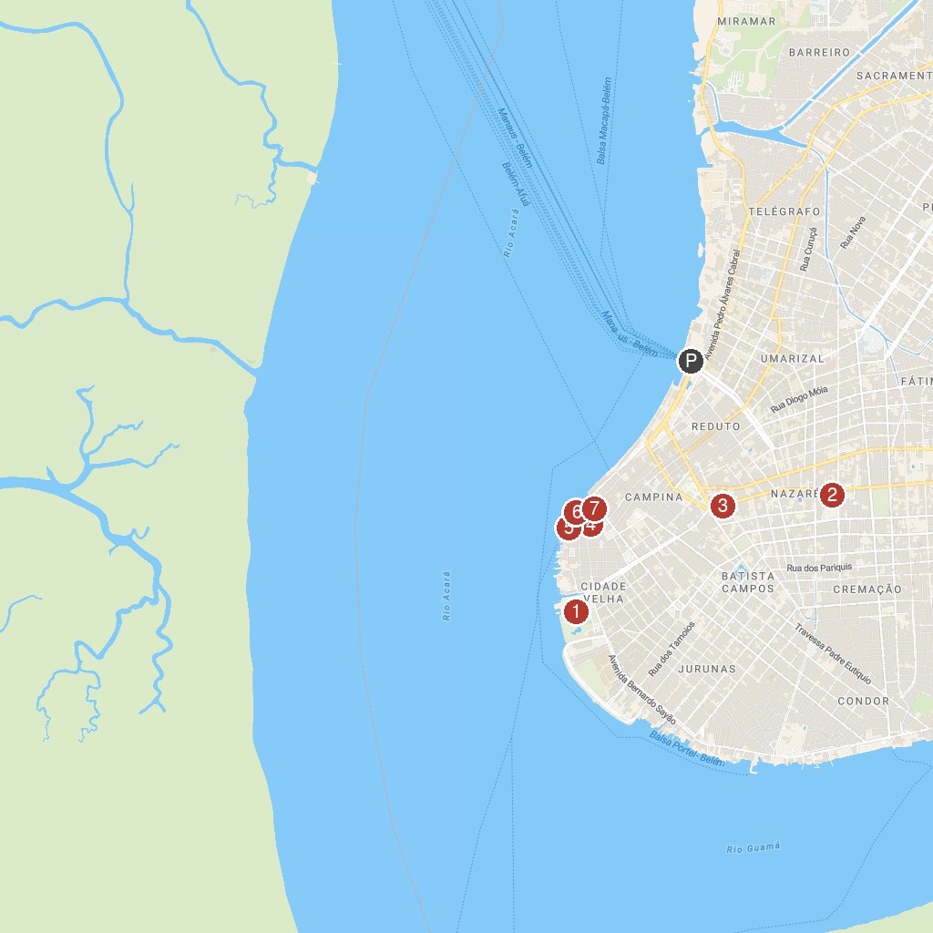
MAP KEY
1. Mangal das Garças | 5. Corveta-Museu Solimões
2. Basilica Sanctuary of Our Lady of Nazareth | 6. Presépio Fort
3. Museum of Image and Sound | 7. Clock Square
4. Instituto Histórico e Geográfico do Pará
P. Cruise port / terminal
Map © MapTiler © OpenStreetMap contributors · cruiseports.org

