Bejaia, Kabylie, Algeria
Where the Kabylie mountains tumble into the Mediterranean, Bejaia delivers dramatic sea cliffs, a UNESCO biosphere reserve full of wild macaques, and an old Casbah that few Western cruise passengers have ever explored.
⚓ Docked (commercial port) · 🕒 Typical call: 7-9 hrs · 💵 Algerian Dinar (DZD) — cash preferred · 🗣️ Tamazight / Arabic / French
✍️ MY DAY IN PORT (FILL IN)
Ship / Date
In port | arrive ______ · all aboard ______
Booked excursion
Notes / meeting point
GETTING ASHORE
- Docking: Ships berth at the commercial Port of Bejaia on Boulevard Frères Amrani; city center is a short walk or taxi ride away.
- Walk to Centre: ~15 min on foot from the port gate to Place Gueydon in the city centre.
- Best For: Off-the-beaten-path Mediterranean history, Gouraya National Park hikes, Barbary macaque sightings, and dramatic coastal scenery.
- Don't Miss: Cap Carbon lighthouse viewpoint and the trail through Gouraya Park to Pic des Singes.
GETTING AROUND
- 🚕 Taxi: $1–$3 — Taxis are plentiful at the port and the city center is only ~500m away — a very short and cheap ride. Agree on a fare be
- 📱 Rideshare: ❌ not available
TOP THINGS TO DO
- Gouraya National Park & Barbary Macaques — A UNESCO biosphere reserve draped over the hillside above the city.
- Cap Carbon & the Lighthouse — The clifftop path to Cap Carbon's lighthouse is carved into sheer rock above the sea.
- Casbah & Saracen Gate Walking Tour — Wander the narrow lanes of Bejaia's old Casbah, passing the medieval Bab el Bahr (Porte Sarrasine / Saracen Gate) — one of the…
- Yemma Gouraya Summit & Fort — The pyramid-shaped peak anchoring Bejaia's skyline holds an ancient fort and a marabout shrine at its summit.
- Tichy Beach & Coastal Corniche — East of downtown, Tichy's crescent of golden sand is backed by red-soil cliffs and eucalyptus trees.
BEST WALKS
- Port to Casbah & Place Gueydon: 2 km · ~45 min · Easy — A flat stroll from the port gate through the lower town to the main square and Casbah entrance.
- Gouraya Park Lower Trail to Pic des Singes: 4 km round-trip · ~2 hrs · Moderate — From the park entrance above the city, follow the shaded forest trail up to Monkey Peak.
WEATHER · DAYLIGHT · MONEY
Month | High °F | Low °F | Rainy days
May | 71 | 58 | 7
Jul | 85 | 71 | 1
Sep | 81 | 69 | 7
Daylight: May 5:32AM–7:40PM · Jul 5:32AM–7:58PM · Sep 6:22AM–6:46PM
cruiseports.org/bejaia · Confirm terminal & all-aboard time with your ship

Bejaia, Kabylie, Algeria — Port Map
Red = walkable sights · Amber = excursions farther out · P = cruise terminal
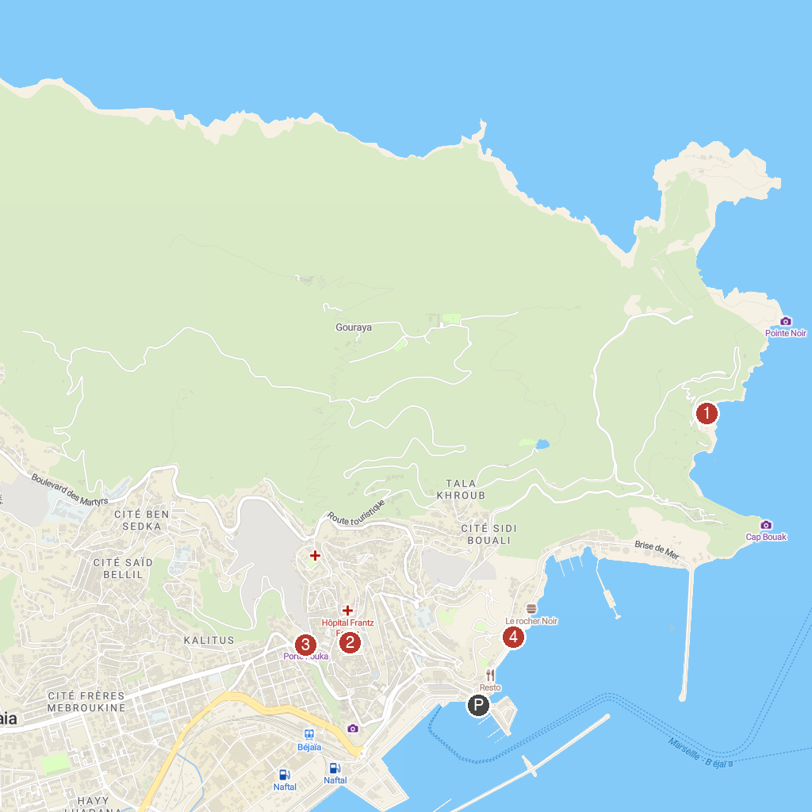
MAP KEY
1. Plage Les Aiguades | 3. Bab El Fouka
2. متحف برج موسى | 4. Brise de mer
P. Cruise port / terminal
Map © MapTiler © OpenStreetMap contributors · cruiseports.org

