Beirut, Lebanon
A city of layered history — Phoenician, Roman, Ottoman, and bullet-scarred modern — Beirut rewards curious visitors with ancient ruins, spectacular coastal scenery, and some of the finest food in the Mediterranean.
⚓ Docked (Quay 5) · 🕒 Typical call: 8–10 hrs · 💵 USD widely accepted; carry cash · 🗣️ Arabic / French / English
✍️ MY DAY IN PORT (FILL IN)
Ship / Date
In port | arrive ______ · all aboard ______
Booked excursion
Notes / meeting point
GETTING ASHORE
- Docking: Berthed at Quay 5, Port of Beirut — ~10-min walk to downtown
- Walk to center: 10 min to Martyrs' Square / Place de l'Étoile on foot
- Best For: Ancient history, Lebanese cuisine, day trips to Byblos & Jeita Grotto
- Don't Miss: Pigeon Rocks at Raouché, National Museum of Beirut, Byblos old harbor
GETTING AROUND
- 🚕 Taxi: $10–$20 — Metered taxis are rare in Beirut — always negotiate and agree on the fare before getting in. Expect roughly $10–$20 to c
- 📱 Rideshare: ✅ Uber, Bolt
- 🚌 Hop-on hop-off: ✅ City Sightseeing Beirut
TOP THINGS TO DO
- Downtown Beirut & Roman Ruins — Walk from the port to Place de l'Étoile, the restored Ottoman-era parliament square, then explore the Roman baths and…
- National Museum of Beirut — Lebanon's principal archaeology museum traces 6,000 years of civilization — Phoenician sarcophagi, Bronze Age artifacts, and…
- Jeita Grotto & Harissa — Jeita Grotto is one of the world's great cave systems — two interconnected limestone chambers with a boat ride on an underground…
- Byblos (Jbeil) — Ancient Phoenician City — One of the oldest continuously inhabited cities on earth, Byblos is a UNESCO World Heritage Site 40 km north of Beirut.
- Beirut Food & Neighborhood Walk — Lebanese cuisine is justifiably famous.
BEST WALKS
- Port to Place de l'Étoile & the Souks: 1.5 km • ~25 min • Flat — Leave the cruise terminal and walk west along the waterfront, then turn inland toward Martyrs'…
- Corniche Promenade to Pigeon Rocks: 4 km one way • ~50 min • Flat — From the port take a taxi to the start of the Corniche at Ain El-Mreisseh, then walk the seaside…
WEATHER · DAYLIGHT · MONEY
Month | High °F | Low °F | Rainy days
May | 79 | 65 | 4
Jul | 87 | 75 | 0
Sep | 86 | 74 | 2
Daylight: May 5:37AM–7:32PM · Jul 5:38AM–7:49PM · Sep 6:21AM–6:44PM
cruiseports.org/beirut · Confirm terminal & all-aboard time with your ship

Beirut, Lebanon — Port Map
Red = walkable sights · Amber = excursions farther out · P = cruise terminal
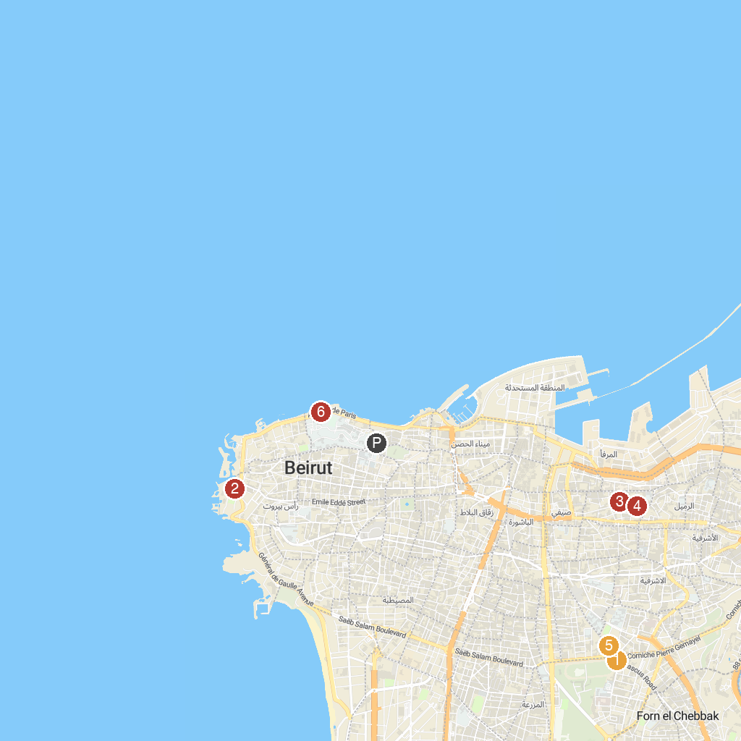
MAP KEY
1. National Museum of Beirut | 5. MIM Mineral Museum
2. Beirut Amusement Park | 6. Hall Of Fame
3. St. Nicolas Stairs | 7. Animal City
4. Sursock Palace | 8. Corniche El Manara
P. Cruise port / terminal
Map © MapTiler © OpenStreetMap contributors · cruiseports.org

