Beilstein, Rhineland-Palatinate, Germany
Barely a village — fewer than 150 souls — yet Beilstein packs medieval lanes, Baroque monastery steps, looming castle ruins, and some of the Mosel's finest Riesling cellars into a single glorious bend of the river.
⚓ Docked (river quay) · 🕒 Typical call: 5–7 hrs · 💶 Euro (€) · 🗣️ German
✍️ MY DAY IN PORT (FILL IN)
Ship / Date
In port | arrive ______ · all aboard ______
Booked excursion
Notes / meeting point
GETTING ASHORE
- Docking: Alongside the Mosel quay (Moselstrasse), steps from the old town
- Walk to center: 2 minutes — one of the most walkable ports on the Mosel
- Best For: Medieval atmosphere, Riesling tastings, and castle views
- Don't Miss: Burg Metternich ruins and the Klostertreppe monastery steps
GETTING AROUND
- 🚕 Taxi: €5–€15 within village area — Local taxis are available with a base fare of around €4.90. A taxi to nearby Cochem (approx. 10 km) typically costs €29–
TOP THINGS TO DO
- Burg Metternich Castle Ruins — A steep 10-minute climb above the village leads to the 12th-century ruins of Burg Metternich, with sweeping panoramic views of…
- Carmelite Monastery & Black Madonna — Climb the Klostertreppe — considered one of Germany's most picturesque staircases — past half-timbered houses to the 17th-century…
- Riesling Wine Tasting at Weingut Otto Görgen — Beilstein's most acclaimed winery offers cellar tours and tastings of Mosel Rieslings ranging from bone-dry Schoppen wines to…
- Vineyard Walk Above Beilstein — Trails from the village wind through steeply terraced Riesling vineyards above the Mosel, part of the long-distance Moselsteig…
- Boat Cruise to Cochem — Hop a scenic river cruise from Beilstein to the nearby town of Cochem (approx.
BEST WALKS
- Old Town & Klostertreppe Loop: 1.5 km · 45–60 min · Easy–moderate — Start at the river quay, walk into the Marktplatz, then follow the Klostertreppe up to the…
- Castle Ruin Climb: 1 km · 30–40 min · Moderate (steep) — From the Marktplatz, follow signs uphill to Burg Metternich.
WEATHER · DAYLIGHT · MONEY
Month | High °F | Low °F | Rainy days
May | 63 | 46 | 11
Jul | 74 | 57 | 11
Sep | 67 | 51 | 9
Daylight: May 5:44AM–9:10PM · Jul 5:38AM–9:34PM · Sep 7:07AM–7:44PM
cruiseports.org/beilstein-mosel · Confirm terminal & all-aboard time with your ship

Beilstein, Rhineland-Palatinate, Germany — Port Map
Red = walkable sights · Amber = excursions farther out · P = cruise terminal
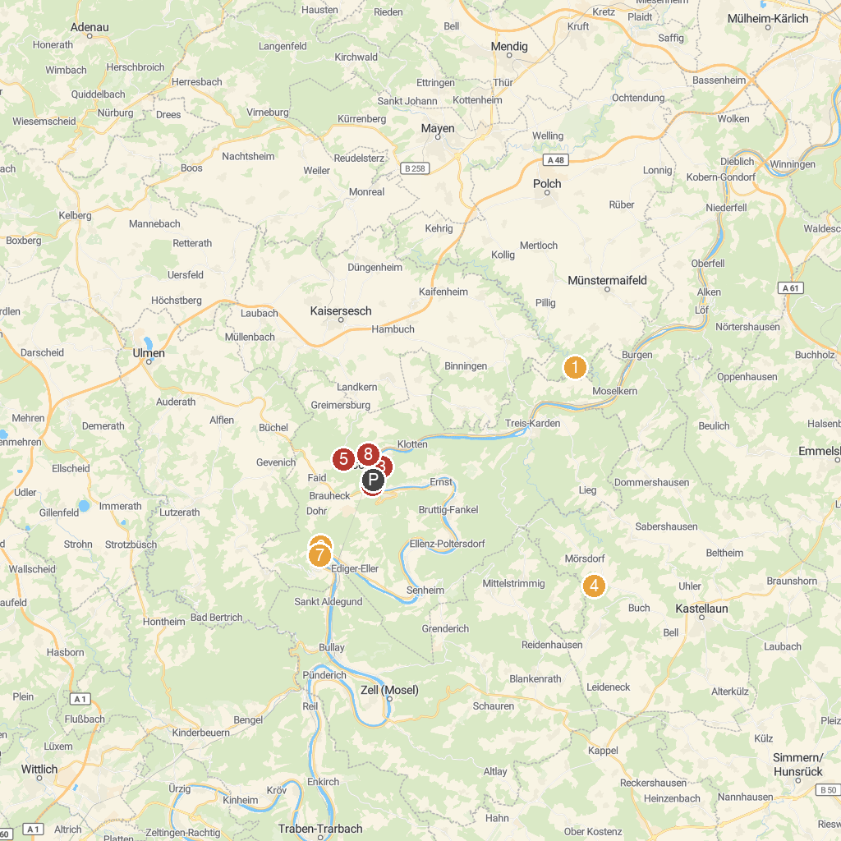
MAP KEY
1. Eltz Castle | 5. Burgruine Winneburg
2. Cochem Castle | 6. Mountain sanctuary on the Calmont
3. Bundesbank Bunker Cochem | 7. Kloster Ruine Stuben
4. Walderlebnis HUNSRUECK | 8. Wild- und Freizeitpark Klotten
P. Cruise port / terminal
Map © MapTiler © OpenStreetMap contributors · cruiseports.org

