Beaver Island, Michigan, USA
Lake Michigan's largest island offers a rare step off the grid — wild beaches, deep Irish roots, and a quirky past that saw a self-proclaimed Mormon king rule these shores in the 1850s.
⚓ Tender (St. James Harbor) · 🕒 Typical call: 6–8 hrs · 💵 US Dollar · 🗣️ English · 🌿 Small-ship itineraries
✍️ MY DAY IN PORT (FILL IN)
Ship / Date
In port | arrive ______ · all aboard ______
Booked excursion
Notes / meeting point
GETTING ASHORE
- Docking: Tender to St. James Harbor municipal dock
- Walk to center: 0–2 min from tender dock to St. James village
- Best For: Nature, history, cycling, beaches, stargazing
- Don't Miss: Mormon Print Shop Museum & Beaver Head Lighthouse
GETTING AROUND
- 🚕 Taxi: Varies by distance — B's Taxi & Delivery Services offers seasonal rides anywhere on the island. Call (989) 239-9292 for rates — no app bookin
TOP THINGS TO DO
- Mormon Print Shop Museum — Explore the island's remarkable past: Native American life, 19th-century Irish settlement, and the story of James Strang…
- Beaver Head Lighthouse Hike — A scenic drive or bike ride to the island's southern tip leads to the 1851 Beaver Head Lighthouse.
- Kayaking & Paddleboarding — Rentals in St.
- Birding Trail — Beaver Island sits on a major migratory flyway.
- Marine Museum & Heritage Park — The Marine Museum — housed in a former net shed — documents Beaver Island's Great Lakes fishing and shipbuilding heritage.
BEST WALKS
- St. James Village Stroll: 0.5 mi · Easy · 20–30 min — Walk the compact waterfront village from the municipal dock past the Marine Museum, Mormon Print…
- Big Sand Bay Trail: 2 mi round trip · Easy · 1 hr — A quiet forest trail leading to one of Beaver Island's most remote and pristine beaches on Lake…
WEATHER · DAYLIGHT · MONEY
Month | High °F | Low °F | Rainy days
May | 60 | 43 | 10
Jul | 76 | 57 | 9
Sep | 68 | 50 | 10
Daylight: May 6:13AM–8:19PM · Jul 6:14AM–8:37PM · Sep 7:02AM–7:26PM
cruiseports.org/beaver-island · Confirm terminal & all-aboard time with your ship

Beaver Island, Michigan, USA — Port Map
Red = walkable sights · Amber = excursions farther out · P = cruise terminal
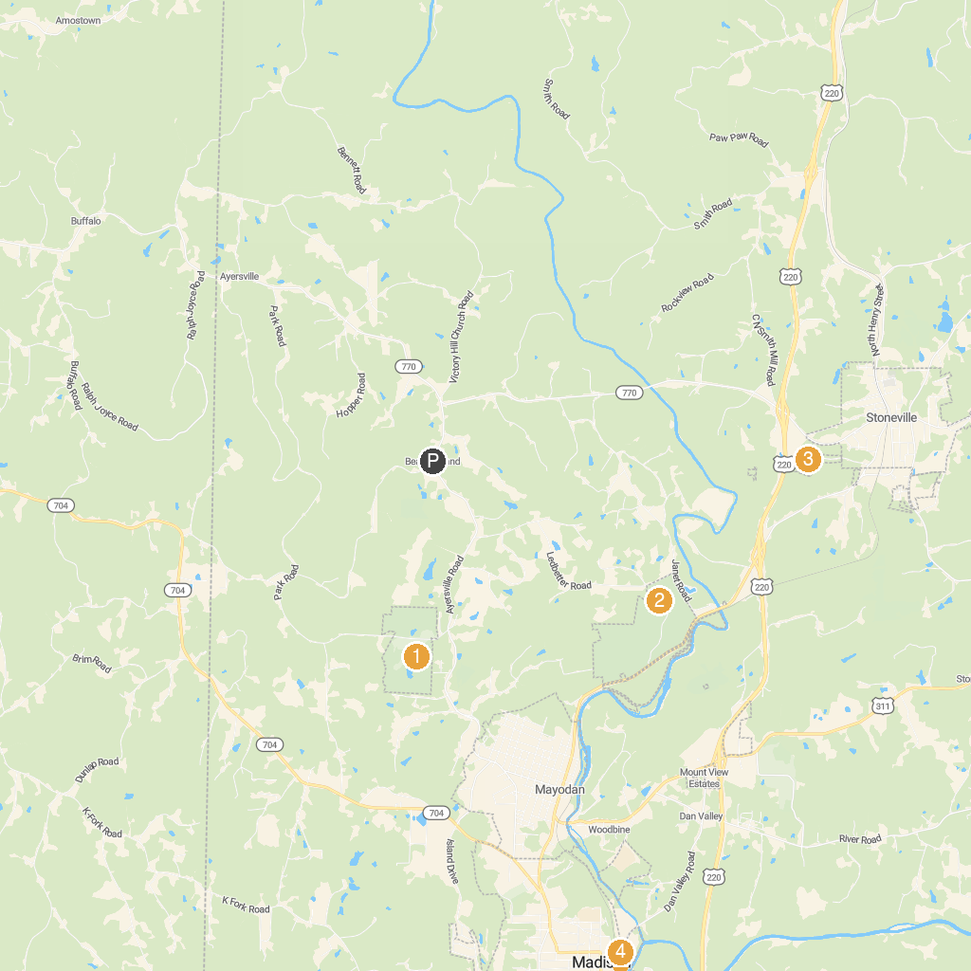
MAP KEY
1. Farris Memorial Park | 3. Stoneville Memorial Park
2. Mayo River State Park | 4. Mad Town Tubing
P. Cruise port / terminal
Map © MapTiler © OpenStreetMap contributors · cruiseports.org

