Beauty Point, Tasmania, Australia
A tranquil deep-water port on the Tamar River, Beauty Point punches above its weight — world-first seahorse aquariums, guaranteed platypus sightings, and one of Australia's finest cool-climate wine valleys all start right at the wharf.
⚓ Docked (Inspection Head Wharf) · 🕒 Typical call: 8–10 hrs · 💵 Australian Dollar (AUD) · 🗣️ English
✍️ MY DAY IN PORT (FILL IN)
Ship / Date
In port | arrive ______ · all aboard ______
Booked excursion
Notes / meeting point
GETTING ASHORE
- Docking: Alongside at Inspection Head Wharf; small to mid-size ships only
- Walk to Seahorse World: Steps from the wharf — Seahorse World and Platypus House are right at the pier
- Best For: Wildlife encounters, Tamar Valley wineries, day trip to Launceston
- Don't Miss: Platypus House — guaranteed daytime platypus sightings in a natural indoor setting
GETTING AROUND
- 🚕 Taxi: A–160 — Taxis are available from Beauty Point to Launceston city centre (~41 min). Surcharges apply evenings, weekends, and publ
- 📱 Rideshare: ✅ Uber
TOP THINGS TO DO
- Seahorse World & Platypus House — Two world-class wildlife encounters a short walk from the gangway.
- Cataract Gorge, Launceston — A dramatic river gorge carved into the edge of the city.
- Tamar Valley Wine Route — The valley surrounding Beauty Point hosts over 20 cellar doors producing cool-climate Pinot Noir, Riesling, and sparkling wines.
- Beaconsfield Mine & Heritage Centre — Site of Australia's famous 2006 mine rescue, now a heritage museum chronicling the gold-mining era and the dramatic 14-day rescue…
- Low Head Penguin Tour — Low Head, 15 km north of Beauty Point at the mouth of the Tamar, hosts one of Tasmania's oldest and largest fairy penguin colonies.
BEST WALKS
- Inspection Head Wharf Foreshore Stroll: 1 km · 20 min · Flat — An easy waterfront walk connecting the wharf to Beauty Point Foreshore Park, with river views…
- Cataract Gorge Cliff Walk, Launceston: 2 km loop · 45 min · Easy–moderate — Follow the cliff-face path from the First Basin to Alexandra Suspension Bridge, cross over, and…
WEATHER · DAYLIGHT · MONEY
Month | High °F | Low °F | Rainy days
May | 58 | 45 | 11
Jul | 53 | 41 | 13
Sep | 57 | 43 | 11
Daylight: May 7:13AM–5:03PM · Jul 7:34AM–5:03PM · Sep 6:14AM–6:02PM
cruiseports.org/beauty-point-launceston · Confirm terminal & all-aboard time with your ship

Beauty Point, Tasmania, Australia — Port Map
Red = walkable sights · Amber = excursions farther out · P = cruise terminal
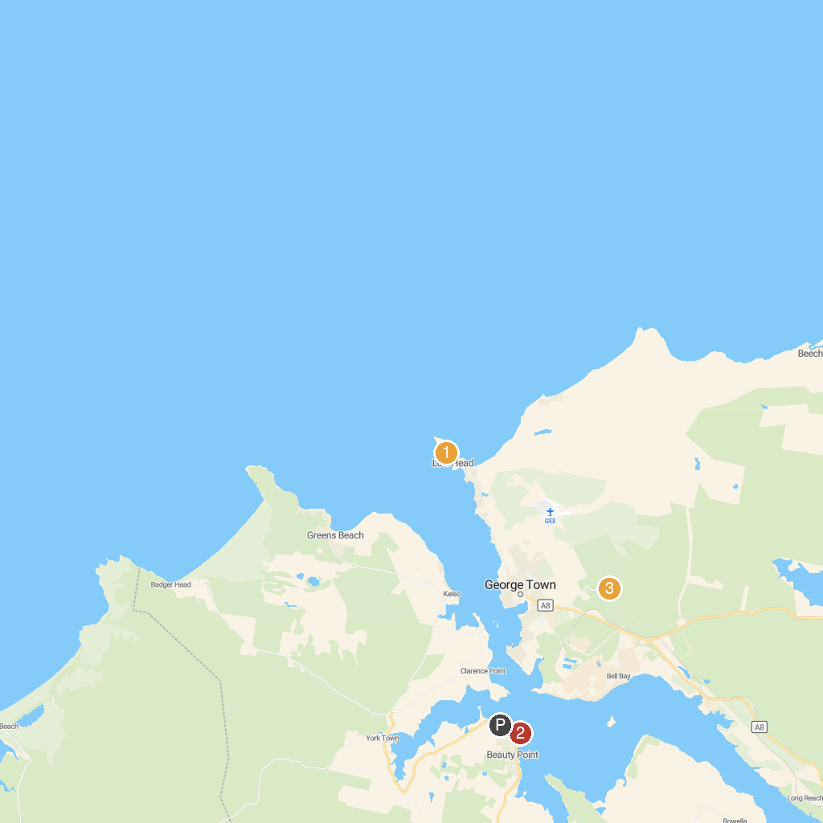
MAP KEY
1. Low Head Coastal Reserve | 3. Mount George Lookout
2. Seahorse World
P. Cruise port / terminal
Map © MapTiler © OpenStreetMap contributors · cruiseports.org

