Beaune, Burgundy, France
The undisputed capital of Burgundy wines, Beaune rewards cruisers with a perfectly preserved medieval old town, magnificent Gothic architecture, and some of the world's most celebrated wine cellars — all within easy walking distance of the coach drop-off.
🚌 Coach transfer from dock (~30-45 min) · 🕒 Typical call: 6-8 hrs · 💶 Euro (€) · 🗣️ French · 🍷 Wine country
✍️ MY DAY IN PORT (FILL IN)
Ship / Date
In port | arrive ______ · all aboard ______
Booked excursion
Notes / meeting point
GETTING ASHORE
- Docking: No direct berth — ships dock at Chalon-sur-Saône or Tournus; coach transfer to Beaune
- Walk to center: Town center is compact and walkable once the coach drops you at Place Carnot
- Best For: Wine tasting, medieval architecture, Burgundy gastronomy
- Don't Miss: Hospices de Beaune (Hôtel-Dieu) — the multicolored tiled roof is iconic
GETTING AROUND
- 🚕 Taxi: €8–€20 — Metered taxis available from the dock area into the city center. Base fare €8 includes first 2.4 km; €2.24/km thereafter
- 📱 Rideshare: ✅ Uber
TOP THINGS TO DO
- Hospices de Beaune — Hôtel-Dieu Museum — The crown jewel of Beaune: a 15th-century Gothic charity hospital with a breathtaking polychrome tiled roof, preserved…
- Burgundy Wine Cellar Tour & Tasting — Beaune is lined with historic wine houses.
- Cité des Climats & Vins de Bourgogne — A modern wine interpretation center celebrating Burgundy's UNESCO-listed 'Climats' vineyard system.
- Cycling the Voie des Vignes — Pedal a flat, well-marked cycle path through the famous Côte de Beaune vineyards, passing villages like Pommard and Meursault.
- Ramparts Walk — A 2.5 km circuit around Beaune's intact medieval walls, passing towers, bastions, and historic gates.
BEST WALKS
- Old Town & Hôtel-Dieu Loop: 1.5 km · 40 min · Easy — From Place Carnot, stroll to the Hospices de Beaune, then wind through Rue Carnot and Rue de…
- Ramparts Circuit: 2.5 km · 50 min · Easy — Circumnavigate the medieval town walls for a peaceful walk past towers, vine-covered bastions, and…
WEATHER · DAYLIGHT · MONEY
Month | High °F | Low °F | Rainy days
May | 66 | 50 | 12
Jul | 80 | 62 | 9
Sep | 72 | 55 | 8
Daylight: May 6:05AM–9:09PM · Jul 6:01AM–9:31PM · Sep 7:18AM–7:52PM
cruiseports.org/beaune · Confirm terminal & all-aboard time with your ship

Beaune, Burgundy, France — Port Map
Red = walkable sights · Amber = excursions farther out · P = cruise terminal
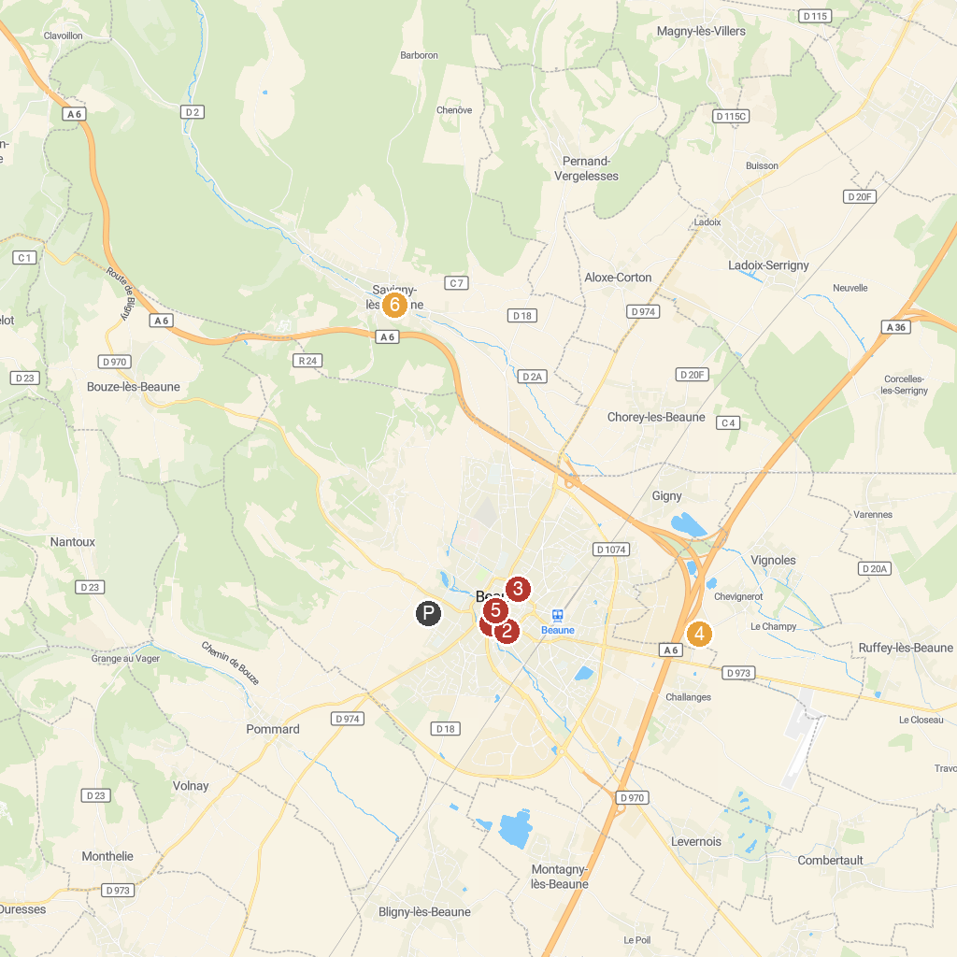
MAP KEY
1. Hôtel-Dieu Museum - Hospices de Beaune | 4. Art du Tonneau
2. Beaune Museum of Fine Arts | 5. Musée du Vin - Hôtel des Ducs de Bourgogne
3. Théâtre de Verdure | 6. Chateau de Savigny-les-Beaune
P. Cruise port / terminal
Map © MapTiler © OpenStreetMap contributors · cruiseports.org

