Beaufort, South Carolina, USA
One of America's oldest and best-preserved antebellum towns, Beaufort sits draped in Spanish moss on the South Carolina coast — a Lowcountry gem where the docks open straight onto 300 years of history.
⚓ Docked (Downtown Marina) · 🕒 Typical call: 6-8 hrs · 💵 US Dollar · 🗣️ English · 🌿 Lowcountry / Sea Islands
✍️ MY DAY IN PORT (FILL IN)
Ship / Date
In port | arrive ______ · all aboard ______
Booked excursion
Notes / meeting point
GETTING ASHORE
- Docking: Ships dock at Downtown Marina (Safe Harbor Beaufort) on Bay Street — steps from the historic district
- Walk to center: Immediate — Henry C. Chambers Waterfront Park and Bay Street shops begin at the marina exit
- Best For: History lovers, Gullah culture, antebellum architecture, and nature walks
- Don't Miss: Old Point neighborhood mansions and a boat tour spotting dolphins in the Beaufort River
GETTING AROUND
- 🚕 Taxi: $18–$22 — Local taxis (e.g. ADR Taxi Cab) run between Port Royal and downtown Beaufort, about 5 miles and 9 minutes. Fares are met
- 📱 Rideshare: ✅ Uber, Lyft
TOP THINGS TO DO
- Historic District Walking Tour — Guided 2-hour stroll through the National Historic District, past antebellum mansions in Old Point, the Verdier House, and Civil…
- Gullah-Geechee Sea Islands Tour — Motor-coach tour to St.
- Hunting Island State Park — Five miles of uncrowded barrier-island beach, maritime forest trails, and a climbable 19th-century lighthouse with panoramic…
- Dolphin & Boat Tour — Narrated open-water boat tour through the Beaufort River and tidal creeks searching for bottlenose dolphins, osprey, and great…
- Kayak the Sea Islands — Paddle through tidal creeks and salt marshes around the Sea Islands with a local guide — excellent for birdwatching and spotting…
BEST WALKS
- Bay Street & Waterfront Stroll: 1 mile | 30 min | Easy | Flat — Walk the length of Bay Street from the marina past antebellum storefronts, art galleries, and the…
- Old Point Neighborhood Loop: 2 miles | 45-60 min | Easy | Flat — From the marina, head east toward the Point to explore Beaufort's grandest antebellum mansions…
WEATHER · DAYLIGHT · MONEY
Month | High °F | Low °F | Rainy days
May | 82 | 67 | 11
Jul | 89 | 76 | 17
Sep | 84 | 71 | 14
Daylight: May 6:24AM–8:14PM · Jul 6:26AM–8:30PM · Sep 7:06AM–7:28PM
cruiseports.org/beaufort-sc · Confirm terminal & all-aboard time with your ship

Beaufort, South Carolina, USA — Port Map
Red = walkable sights · Amber = excursions farther out · P = cruise terminal
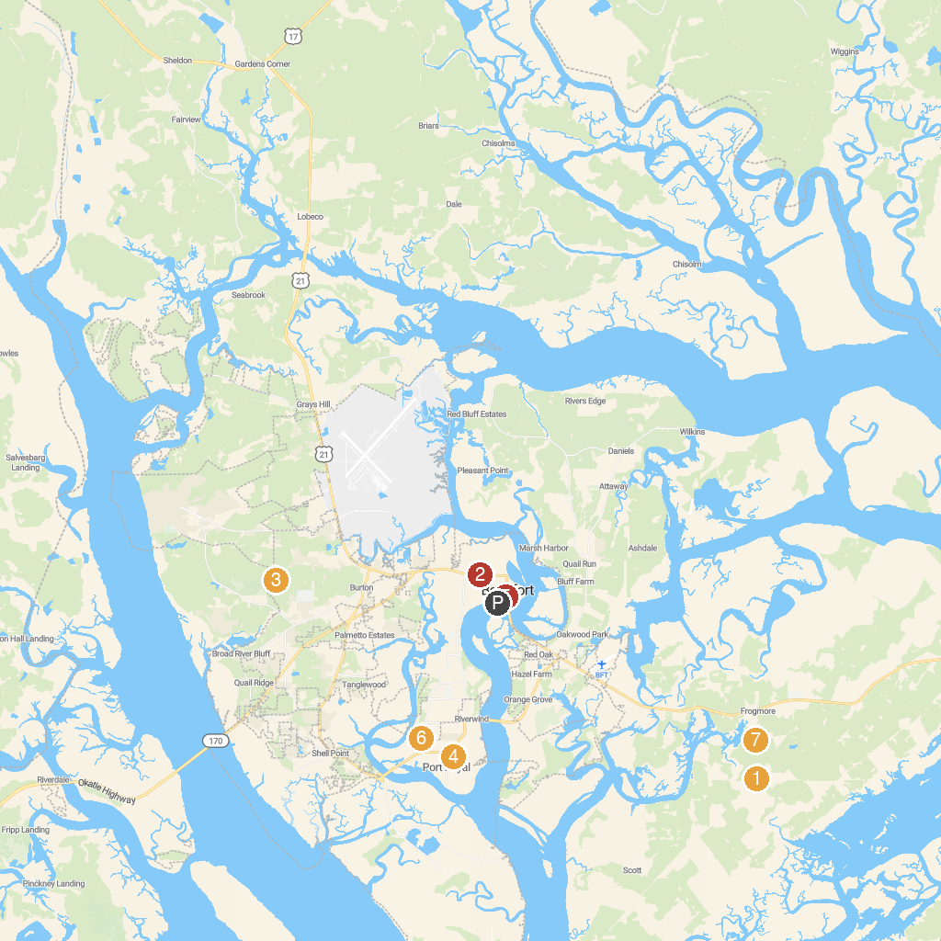
MAP KEY
1. Saint Helena Parish Chapel of Ease Ruins | 5. Beaufort History Museum
2. Beaufort National Cemetery | 6. Spanish Moss Trail Parking - Westvine
3. Burton Wells Dog Park | 7. Penn Center
4. Cypress Wetlands | 8. Widgeon Point Preserve
P. Cruise port / terminal
Map © MapTiler © OpenStreetMap contributors · cruiseports.org

