Beagle Channel, Tierra del Fuego, Chile/Argentina
One of the world's great scenic passages, the Beagle Channel threads between the jagged peaks of the Darwin Range and glacier-carved islands at the bottom of the Americas — a front-row seat from your deck as the ship glides through Glacier Alley.
⚓ Scenic cruising (no shore call) · 🕒 Typically 4-8 hrs transit · 🗣️ Spanish / Chilean territory · 🐧 Wildlife from the deck · 🌊 Expedition ships may zodiac
✍️ MY DAY IN PORT (FILL IN)
Ship / Date
In port | arrive ______ · all aboard ______
Booked excursion
Notes / meeting point
GETTING ASHORE
- Type: Scenic passage — ships transit, no standard port call
- Named After: HMS Beagle, which surveyed the area 1826–1830 (Darwin aboard 1831–36)
- Best For: Glaciers, Andean peaks, sea lions, cormorants, albatrosses
- Don't Miss: Glacier Alley (western Chilean section) — multiple glaciers calving to sea level
GETTING AROUND
- 🚕 Taxi: About US$3-10 short city rides; more for hourly touring — Taxis and remises are common for airport transfers, hotel runs, or reaching trailheads and viewpoints outside the center
- 🚌 Hop-on hop-off: ✅
TOP THINGS TO DO
- Glacier Alley Scenic Passage — The Chilean western section of the channel passes Alemania, Francia, Holanda, Italia, and Romanche glaciers — remnants of the…
- Sea Lions & Cormorants at Isla de los Lobos — Rocky outcrops in the eastern channel host large South American sea lion colonies and imperial cormorant rookeries.
- Les Éclaireurs Lighthouse — The red-and-white striped lighthouse often dubbed 'the Lighthouse at the End of the World' sits on a tiny island in the eastern…
- Martillo Island Penguin Colony — Home to the southernmost accessible penguin colony, with Magellanic and Gentoo penguins nesting from November through March.
- HMS Beagle Heritage Sailing — Darwin charted these waters in the 1830s aboard HMS Beagle — some operators offer guided narrative tours retracing his route…
BEST WALKS
- Bridges Island Expedition Landing: Short guided walk • Expedition ships only • ~1 hr — Expedition vessels occasionally land guests on Bridges Island for a guided walk through…
WEATHER · DAYLIGHT · MONEY
Month | High °F | Low °F | Rainy days
May | 44 | 37 | 18
Jul | 38 | 31 | 16
Sep | 43 | 35 | 18
Daylight: May 9:17AM–5:35PM · Jul 9:45AM–5:28PM · Sep 7:36AM–7:16PM
cruiseports.org/beagle-channel · Confirm terminal & all-aboard time with your ship

Beagle Channel, Tierra del Fuego, Chile/Argentina — Port Map
Red = walkable sights · Amber = excursions farther out · P = cruise terminal
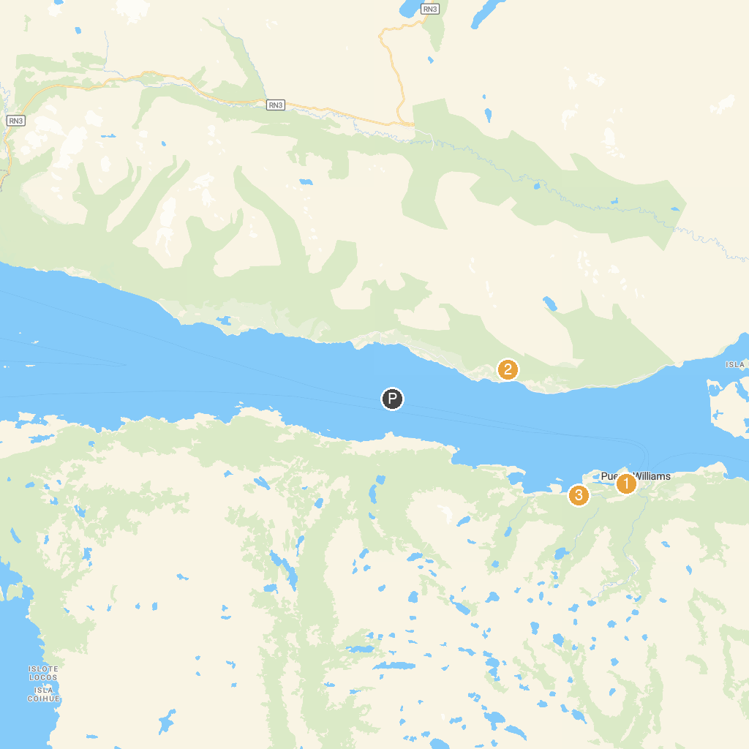
MAP KEY
1. Martin Gusinde Anthropological Museum | 3. Etnobotánico Omora Park
2. Cascada del Duende
P. Cruise port / terminal
Map © MapTiler © OpenStreetMap contributors · cruiseports.org

