Bayonne, New Jersey, USA
Cape Liberty sits on a former Navy base with the Manhattan skyline glittering across the water. Royal Caribbean and Celebrity ships home-port here, putting one of the world's great cities within a 25-minute ride.
⚓ Docked (pier) · 🕒 Homeport — full day · 💵 US Dollar · 🗣️ English
✍️ MY DAY IN PORT (FILL IN)
Ship / Date
In port | arrive ______ · all aboard ______
Booked excursion
Notes / meeting point
GETTING ASHORE
- Docking: Ships berth directly at Cape Liberty pier — no tender
- To Manhattan: ~25 min by taxi/rideshare; or Light Rail to Exchange Place + PATH train (~50 min)
- Best For: NYC sightseeing, Statue of Liberty, history, food
- Don't Miss: Ferry to Statue of Liberty & Ellis Island from Liberty State Park
GETTING AROUND
- 🚕 Taxi: $18–$25 — Taxis available at the terminal. Short ride (~5 min) to Bayonne city center around 34th Street Light Rail station.
- 📱 Rideshare: ✅ Uber, Lyft, Bolt
TOP THINGS TO DO
- Statue of Liberty & Ellis Island — Ferry from Liberty State Park to Liberty Island for close-up views of Lady Liberty, then on to Ellis Island's Immigration Museum…
- Manhattan Highlights — Times Square, the High Line, Central Park, Empire State Building, and the 9/11 Memorial & Museum — New York City rewards any…
- 9/11 Memorial & Museum — The twin reflecting pools and underground museum are among the most powerful memorial sites in the world.
- Liberty State Park Waterfront Walk — A 10-minute ride from the pier, this Jersey City park offers sweeping views of the Manhattan skyline and Statue of Liberty, the…
- Hoboken Food & Waterfront — A 15-minute drive, Hoboken offers a charming walkable main street scene with excellent restaurants, cafes, and Hudson River…
BEST WALKS
- Liberty State Park Promenade: 2–4 km · Easy · Free — Walk the waterfront promenade from the CRRNJ Terminal historic building south to Caven Point, with…
- Harbor View Park & Teardrop Memorial: 1–2 km · Easy — A short walk or ride from the pier on the same Military Ocean Terminal peninsula, Harbor View Park…
WEATHER · DAYLIGHT · MONEY
Month | High °F | Low °F | Rainy days
May | 67 | 54 | 14
Jul | 75 | 64 | 10
Sep | 74 | 61 | 11
Daylight: May 6:41AM–9:23PM · Jul 6:39AM–9:44PM · Sep 7:45AM–8:15PM
cruiseports.org/bayonne · Confirm terminal & all-aboard time with your ship

Bayonne, New Jersey, USA — Port Map
Red = walkable sights · Amber = excursions farther out · P = cruise terminal
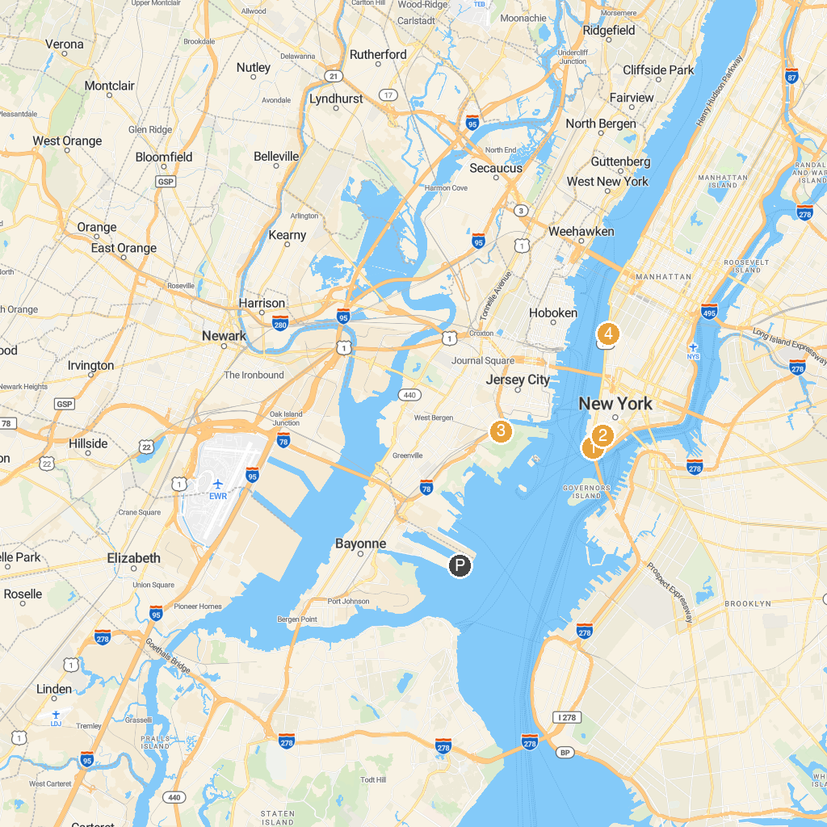
MAP KEY
1. Times Square | 5. Liberty Science Center
2. The Battery | 6. Washington Square Park
3. New York Stock Exchange | 7. Whitney Museum of American Art
4. Prospect Park | 8. Brooklyn Museum
P. Cruise port / terminal
Map © MapTiler © OpenStreetMap contributors · cruiseports.org

