Bay of Islands, Northland, New Zealand
Where New Zealand's founding document was signed and 144 islands spill into a sparkling blue bay — the Bay of Islands rewards every kind of curious cruiser, from history buffs to dolphin-chasers.
⚓ Tender port · 🕒 Typical call: 7-9 hrs · 💵 NZ Dollar (NZD) · 🗣️ English / Te Reo Māori
✍️ MY DAY IN PORT (FILL IN)
Ship / Date
In port | arrive ______ · all aboard ______
Booked excursion
Notes / meeting point
GETTING ASHORE
- Docking: Tender to Waitangi Wharf, near Paihia
- Walk to centre: 5-min shuttle or 20-min waterfront walk to Paihia
- Best For: Māori history, boat cruises, wildlife, scenic walks
- Don't Miss: Waitangi Treaty Grounds & Hole in the Rock cruise
GETTING AROUND
- 🚕 Taxi: NZD $30 minimum — Bay Cabs (metered) and Dial A Ride serve the Paihia and wider Bay of Islands area. Useful for reaching Kerikeri or other
TOP THINGS TO DO
- Waitangi Treaty Grounds — Walk a few hundred metres from the tender wharf to where the Treaty of Waitangi was signed in 1840 — NZ's founding document.
- Hole in the Rock Cruise — A classic Bay of Islands bucket-list trip — cruise out to Cape Brett and pass through the sea arch carved into Motukokako Island.
- Historic Russell — New Zealand's first European town and briefly its capital.
- Island Cruise & Snorkel — Half-day tours explore the bay's 144 islands, stopping at Urupukapuka or Motuarohia (Roberton Island) for swimming, snorkelling…
- Cape Reinga Day Trip — Long but spectacular: a guided coach tour to NZ's northernmost tip where the Tasman Sea meets the Pacific Ocean, often including…
BEST WALKS
- Waitangi Wharf to Waitangi Treaty Grounds: 1.2 km | 20 min | Easy | Flat waterfront — Walk north along the waterfront from Waitangi Wharf, cross the Waitangi Bridge over the Waitangi…
- Russell Historic Waterfront Walk: 1.5 km | 30 min | Easy | Ferry required — From Russell Wharf, stroll The Strand south past the Duke of Marlborough Hotel, Christ Church…
- Flagstaff Hill (Te Maiki), Russell: 2 km return | 45 min | Moderate | Some uphill — From near the boat ramp on The Strand, a short track climbs to Flagstaff Hill for panoramic views…
WEATHER · DAYLIGHT · MONEY
Month | High °F | Low °F | Rainy days
May | 65 | 55 | 9
Jul | 60 | 49 | 10
Sep | 62 | 50 | 12
Daylight: May 7:11AM–5:28PM · Jul 7:30AM–5:29PM · Sep 6:23AM–6:14PM
cruiseports.org/bay-of-islands · Confirm terminal & all-aboard time with your ship

Bay of Islands, Northland, New Zealand — Port Map
Red = walkable sights · Amber = excursions farther out · P = cruise terminal
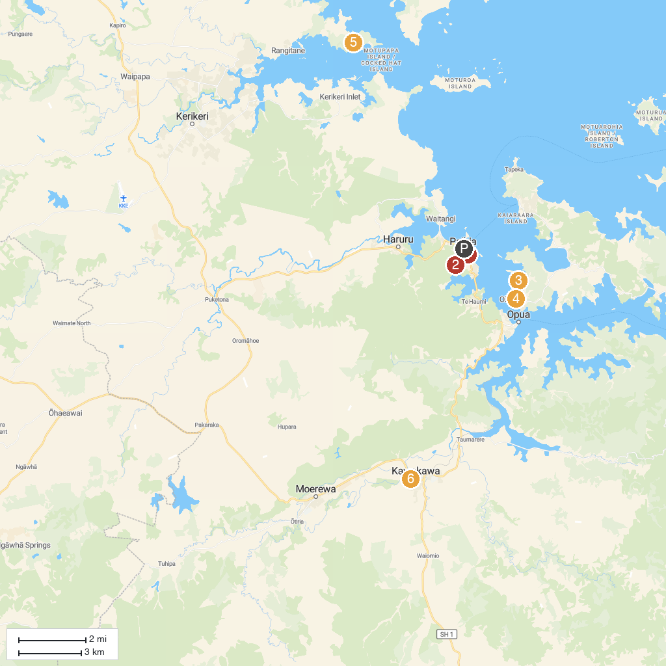
MAP KEY
1. Kawiti Glowworm Caves | 5. First New Zealand Capital
2. Barefoot Sailing Adventures | 6. Kerikeri Cruising Club & Marina
3. Opua Forest Paihia Lookout Track Entrance | 7. Bay of Islands Vintage Railway
4. Omata Estate Vineyard & Kitchen | 8. Te Wairere Waterfall
P. Cruise port / terminal
Map © MapTiler © OpenStreetMap contributors · cruiseports.org

