Baton Rouge, Louisiana, USA
Louisiana's capital city rises above the Mississippi River bend, blending Art Deco grandeur with Gothic Revival castles, a WWII destroyer at the levee, and sweeping plantation country just beyond the city limits.
⚓ Docked (river pier) · 🕒 Typical call: 6-8 hrs · 💵 USD · 🗣️ English · 🌊 Mississippi River cruise
✍️ MY DAY IN PORT (FILL IN)
Ship / Date
In port | arrive ______ · all aboard ______
Booked excursion
Notes / meeting point
GETTING ASHORE
- Docking: City Riverfront Dock ("Paperclip Dock"), downtown — step ashore directly
- Walk to center: Immediate — USS Kidd and Old State Capitol are steps from the dock
- Best For: History buffs, plantation tours, Southern food, river scenery
- Don't Miss: 27th-floor panorama from the Louisiana State Capitol (free)
GETTING AROUND
- 🚕 Taxi: $4 base + $2/mile — Traditional taxis are available in Baton Rouge. Official city rates are $4.00 base fare plus $2.01 per mile, with a $3.6
- 📱 Rideshare: ✅ Uber, Lyft
TOP THINGS TO DO
- Louisiana State Capitol & Observation Deck — At 450 feet, it's the tallest state capitol in the US.
- Old State Capitol (Castle of Baton Rouge) — This dramatic Gothic Revival castle served as the Louisiana statehouse from 1847 to 1932.
- USS Kidd Veterans Museum — A real Fletcher-class WWII destroyer moored on the Mississippi Riverfront.
- Antebellum Plantation Tours — Houmas House Plantation & Gardens and Oak Alley Plantation are among the grandest antebellum estates on the River Road, offering…
- Swamp & Bayou Tours — Operators like Red Stick Adventures offer guided airboat or pontoon tours into the cypress swamps surrounding Baton Rouge…
BEST WALKS
- Riverfront to Capitol Walk: 1.2 miles one way | Easy | ~25 min — A straightforward stroll from the dock northward along the levee and through downtown, taking in…
- Riverfront Plaza Stroll: 0.5 miles loop | Easy | ~15 min — A relaxed loop around Riverfront Plaza, past the USS Kidd berth, the Louisiana Art & Science…
WEATHER · DAYLIGHT · MONEY
Month | High °F | Low °F | Rainy days
May | 84 | 67 | 12
Jul | 90 | 76 | 18
Sep | 87 | 72 | 12
Daylight: May 6:10AM–7:52PM · Jul 6:13AM–8:07PM · Sep 6:49AM–7:09PM
cruiseports.org/baton-rouge · Confirm terminal & all-aboard time with your ship

Baton Rouge, Louisiana, USA — Port Map
Red = walkable sights · Amber = excursions farther out · P = cruise terminal
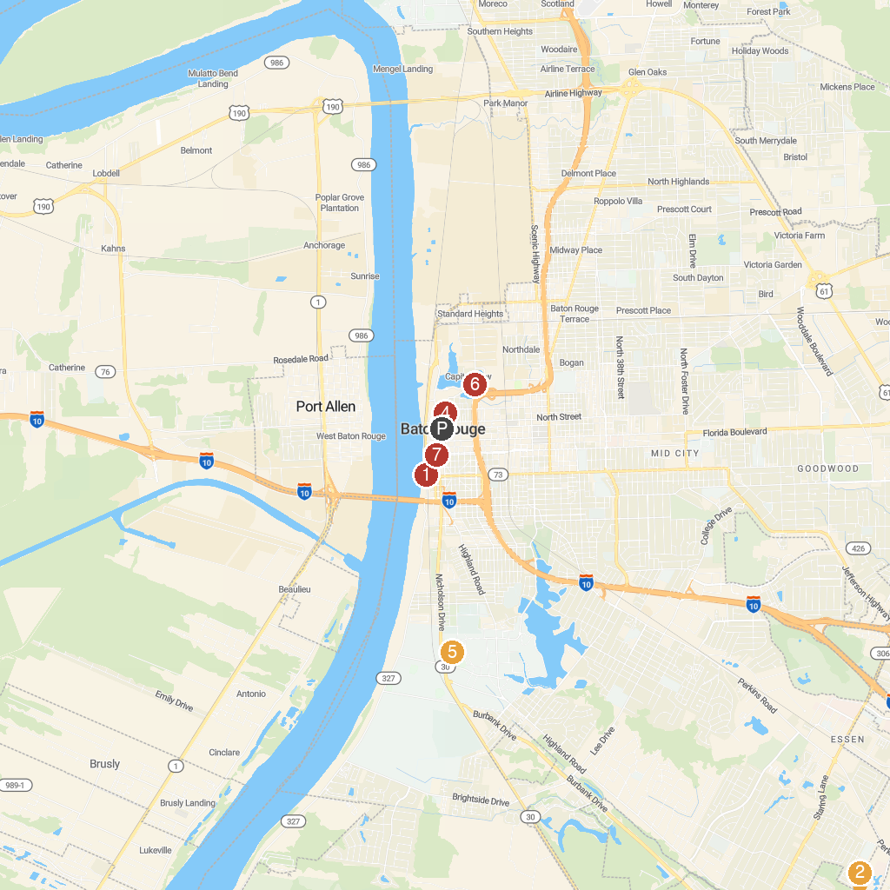
MAP KEY
1. BREC's Baton Rouge Zoo | 5. Capitol Park Museum
2. USS KIDD Veterans Museum | 6. Mike the Tiger's Habitat
3. BREC's Bluebonnet Swamp Nature Center | 7. Governor's Mansion
4. St. Joseph Cathedral | 8. North Boulevard Town Square
P. Cruise port / terminal
Map © MapTiler © OpenStreetMap contributors · cruiseports.org

