Batina, Baranja, Croatia
A sleepy Danube riverbank village where solemn WWII history meets lush wetlands — and a glass of Baranja wine caps off any shore day.
⚓ Docked (river pier) · 🕒 Typical call: 4–6 hrs · 💶 Euro (€) · 🗣️ Croatian
✍️ MY DAY IN PORT (FILL IN)
Ship / Date
In port | arrive ______ · all aboard ______
Booked excursion
Notes / meeting point
GETTING ASHORE
- Docking: Direct alongside at the village river pier
- Walk to centre: Steps from the pier — village is tiny
- Best For: WWII history, nature lovers, wine curious
- Don't Miss: Batina Memorial obelisk & Kopački Rit boat tour
GETTING AROUND
- 🚕 Taxi: €50–€60 — The nearest city is Osijek, ~42 km away. Pre-book a local taxi or transfer; metered cabs are available but not always wa
TOP THINGS TO DO
- Batina Memorial & War Cemetery — Climb to the striking obelisk that overlooks the Danube at the point where Soviet and Yugoslav forces crossed in the 1944 Battle…
- Kopački Rit Nature Park Boat Tour — Often called the 'Amazon of Europe,' this vast Danube floodplain wetland hosts herons, white-tailed eagles, cormorants, and deer.
- Osijek & Tvrđa Baroque Quarter — Croatia's fourth-largest city offers the well-preserved 18th-century fortress district of Tvrđa, with cobbled squares, St.
- Karanac Ethno Village — A beautifully preserved Baranja village functioning as a living museum of Croatian rural life, with traditional architecture…
- Baranja Wine & Cuisine Tasting — The Baranja region is known for its Graševina white wine and hearty Slavonian food — fish paprikash, kulen sausage, and fresh…
BEST WALKS
- Village & Memorial Hill Loop: 1.5 km · 30–45 min · Easy — From the pier, walk through the village centre, then follow the path up to the Batina Memorial…
WEATHER · DAYLIGHT · MONEY
Month | High °F | Low °F | Rainy days
May | 71 | 53 | 12
Jul | 83 | 65 | 8
Sep | 74 | 57 | 8
Daylight: May 5:13AM–8:09PM · Jul 5:09AM–8:31PM · Sep 6:23AM–6:55PM
cruiseports.org/batina · Confirm terminal & all-aboard time with your ship

Batina, Baranja, Croatia — Port Map
Red = walkable sights · Amber = excursions farther out · P = cruise terminal
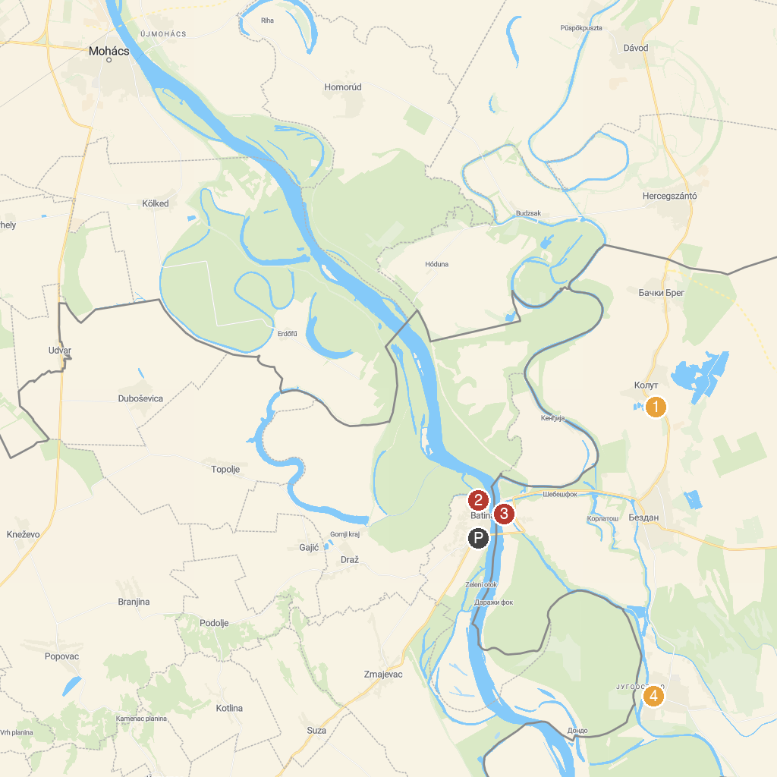
MAP KEY
1. Miki Zoo | 4. Monument of Batina Battle ("Julka")
2. Duna-Dráva National Park | 5. Batina Memorial House
3. Vinski podrum Vina Belje | 6. Etno Kuca Mali Bodrog
P. Cruise port / terminal
Map © MapTiler © OpenStreetMap contributors · cruiseports.org

