Bath, Maine, USA
A proud shipbuilding city on the Kennebec River, Bath wears its maritime soul on its sleeve — from the soaring Wyoming schooner sculpture to the working docks of Bath Iron Works just downstream.
⚓ Docked (river pier) · 🕒 Typical call: 6–8 hrs · 💵 USD · 🗣️ English · 🚢 Small ships only (max 250 ft)
✍️ MY DAY IN PORT (FILL IN)
Ship / Date
In port | arrive ______ · all aboard ______
Booked excursion
Notes / meeting point
GETTING ASHORE
- Docking: Alongside at Maine Maritime Museum's Deering Pier on the Kennebec River
- Walk to center: Downtown Bath is ~0.5 miles from the pier — easy flat walk
- Best For: Maritime history, river cruises, walkable New England downtown
- Don't Miss: Maine Maritime Museum — 20 acres with historic shipyard buildings and daily river cruises
GETTING AROUND
- 🚕 Taxi: $8–$15 — Local taxis (e.g. Bath Taxi / HI5) serve the port area. Fares to downtown are short — Bath is a compact city.
- 📱 Rideshare: ✅ Uber, Lyft
TOP THINGS TO DO
- Maine Maritime Museum — A 20-acre campus spanning the former Percy & Small Shipyard — the only surviving wooden shipbuilding yard in the US.
- Kennebec River Lighthouse Cruise — Board the museum's vessel Merrymeeting for a river cruise past Doubling Point Light, Squirrel Point Light, and Pond Island Light…
- Historic Downtown Bath Walking Tour — Bath's Front Street and surrounding blocks contain some of New England's finest intact 19th-century commercial architecture.
- Maine's First Ship — The Virginia — See a full reconstruction of the Virginia, the first English ocean-going ship built in the Americas in 1607.
- Popham Beach & Phippsburg — A 30-minute drive south leads to Popham Beach State Park, one of Maine's finest ocean beaches, and the ruins of Fort Popham at…
BEST WALKS
- Pier to Downtown Bath: 0.5 mi · 10–12 min · Flat — Walk north from Deering Pier along Washington Street past the museum grounds to downtown Bath.
- Downtown Historic Loop: 1 mi · 20–25 min · Flat — A short loop through Bath's historic core taking in the ornate City Hall, the Chocolate Church Arts…
WEATHER · DAYLIGHT · MONEY
Month | High °F | Low °F | Rainy days
May | 61 | 46 | 12
Jul | 70 | 56 | 12
Sep | 65 | 52 | 10
Daylight: May 5:18AM–8:54PM · Jul 5:11AM–9:19PM · Sep 6:44AM–7:23PM
cruiseports.org/bath-me · Confirm terminal & all-aboard time with your ship

Bath, Maine, USA — Port Map
Red = walkable sights · Amber = excursions farther out · P = cruise terminal
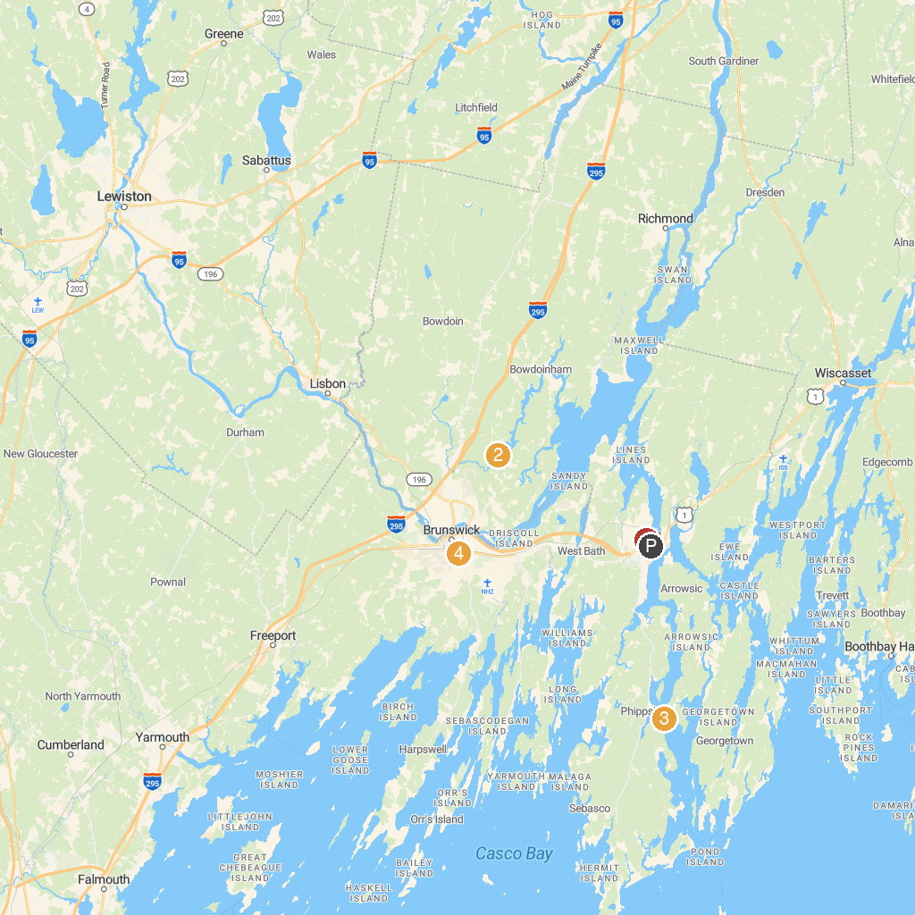
MAP KEY
1. Bowdoin College Museum of Art | 5. Squirrel Point Light
2. Coastal Maine Botanical Gardens | 6. Skolfield Shores Preserve
3. Patten Free Library | 7. Peary-MacMillan Arctic Museum
4. Head of Tide Park
P. Cruise port / terminal
Map © MapTiler © OpenStreetMap contributors · cruiseports.org

