Batemans Bay, New South Wales, Australia
Where the Clyde River meets the sea, Batemans Bay serves up fresh oysters straight from the farm, kayak tours through marine park waters, and easy access to Canberra — all wrapped in relaxed South Coast charm.
⚓ Tender port · 🕒 Typical call: 8-10 hrs · 💵 AUD · 🗣️ English · 🌊 Marine Park
✍️ MY DAY IN PORT (FILL IN)
Ship / Date
In port | arrive ______ · all aboard ______
Booked excursion
Notes / meeting point
GETTING ASHORE
- Docking: Tender ashore to the central foreshore (T-Wharf pontoon)
- Walk to Centre: Tenders land in the town centre; flat and walkable
- Best For: Oyster tasting, Clyde River kayaking, wildlife parks
- Don't Miss: Fresh oysters at Pearly Oyster Bar, Mogo Wildlife Park
GETTING AROUND
- 🚕 Taxi: AUD 14–25 — Local operators Bay Coast Cabs and Batemans Bay Taxis serve the area. Base fare ~AUD 4.60 plus ~AUD 2.80/km; most in-tow
- 📱 Rideshare: ✅ Uber, Stuber
TOP THINGS TO DO
- Clyde River Kayak & Oyster Tasting — Paddle through calm Clyde River waterways past working oyster farms and sample freshly harvested Sydney Rock oysters straight…
- Mogo Wildlife Park — Just 15 minutes south, Mogo Wildlife Park is home to 250+ species including gorillas, giraffes, white lions, zebras, and snow…
- Batemans Marine Park Snorkel — Batemans Marine Park protects around 110 km of coastline.
- Clyde River Lunch Cruise — Board a cruiser for a relaxed scenic journey upriver to the historic village of Nelligen, with commentary on the estuary…
- Whale & Dolphin Watching — During humpback whale migration (May–November), dedicated boat tours and sea-kayak expeditions head offshore from the Clyde River…
BEST WALKS
- Waterfront Foreshore & Sculpture Walk: 3 km return · Flat · 45 min — Follow the Batemans Bay foreshore path from the marina area north through Hanging Rock Reserve and…
- Cullendulla Creek Mangrove Boardwalk: 2 km return · Flat · 40 min — A short drive north of town, the Cullendulla Creek Nature Reserve boardwalk winds through mangroves…
WEATHER · DAYLIGHT · MONEY
Month | High °F | Low °F | Rainy days
May | 65 | 50 | 6
Jul | 61 | 45 | 6
Sep | 66 | 49 | 8
Daylight: May 6:48AM–5:02PM · Jul 7:06AM–5:03PM · Sep 5:59AM–5:50PM
cruiseports.org/batemans-bay-nsw · Confirm terminal & all-aboard time with your ship

Batemans Bay, New South Wales, Australia — Port Map
Red = walkable sights · Amber = excursions farther out · P = cruise terminal
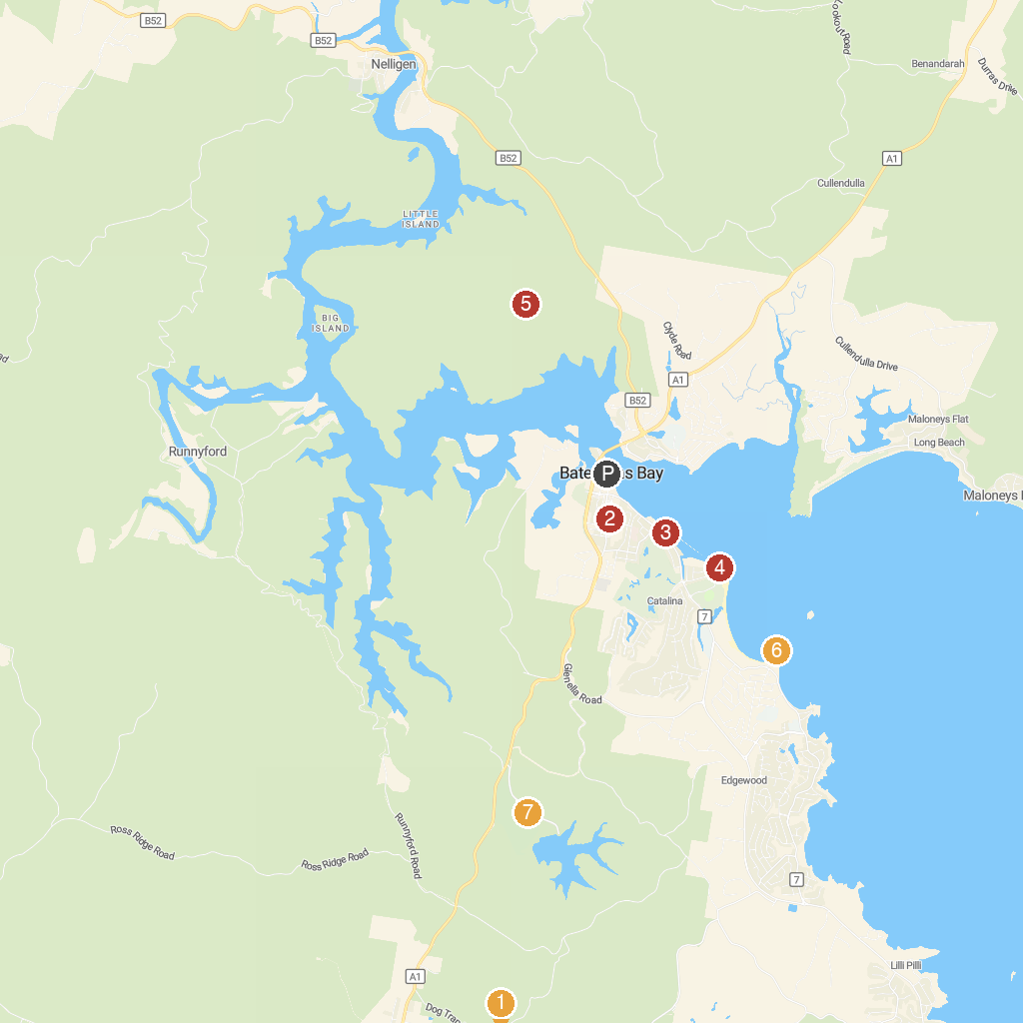
MAP KEY
1. Mogo Wildlife Park | 5. Holmes lookout
2. Batemans Bay Heritage Museum | 6. Observation Point Lookout
3. d'Albora Batemans Bay Marina | 7. Eurobodalla Regional Botanic Garden
4. Batemans Marine Park
P. Cruise port / terminal
Map © MapTiler © OpenStreetMap contributors · cruiseports.org

