Bastia, Corsica, France
Corsica's lived-in capital rewards walkers with a Genoese citadel above a pastel old port, an enormous café-terrace square, and the dramatic peninsula of Cap Corse beckoning just north.
⚓ Docked (most ships); tender for very large vessels · 🕒 Typical call: 7-9 hrs · 💶 Euro (€) · 🗣️ French / Corsican
✍️ MY DAY IN PORT (FILL IN)
Ship / Date
In port | arrive ______ · all aboard ______
Booked excursion
Notes / meeting point
GETTING ASHORE
- Docking: Commercial pier (Port de Commerce) adjacent to city centre; ~500 m to Place Saint-Nicolas
- Walk to centre: 5–10 min flat walk to Place Saint-Nicolas; 20 min to Old Port & Citadel
- Best For: History, café culture, scenic coastal drives, Corsican food & wine
- Don't Miss: Terra Nova Citadel and the Aldilonda clifftop walkway above the sea
GETTING AROUND
- 🚕 Taxi: €7–€10 — Taxis wait near the port entrance. Metered fares to the city center run €7–€10; expect a 20% surcharge on Sundays, eveni
- 📱 Rideshare: ✅ Uber
TOP THINGS TO DO
- Terra Nova Citadel & Musée de Bastia — Climb into the Genoese citadel quarter whose fortified lanes and governors' palace have dominated Bastia's skyline for centuries.
- Cap Corse Coastal Drive — The wild finger of Cap Corse stretches 40 km north of Bastia, lined with Genoese towers, fishing villages like Erbalunga and…
- Patrimonio Wine Tasting — Patrimonio, about 18 km northwest of Bastia toward Saint-Florent, is Corsica's oldest AOC wine region, producing benchmark…
- Aldilonda Clifftop Walkway — A suspended pedestrian path carved into the cliffs below the Citadel, the Aldilonda hugs the sea with views across to the Tuscan…
- Place Saint-Nicolas Market & Café Culture — One of France's largest squares, Place Saint-Nicolas is lined with plane trees, café terraces, and a bandstand.
BEST WALKS
- Old Town Loop: Place Saint-Nicolas to Citadel & Back: 3–4 km · 1.5–2 hrs · Moderate (hilly return) — Start at Place Saint-Nicolas and walk south along the quays to the Vieux Port.
- Waterfront Promenade to Erbalunga: ~10 km round-trip · 2.5 hrs · Easy-Moderate — From the pier follow the coast road north through the marina district and along the bay to the…
WEATHER · DAYLIGHT · MONEY
Month | High °F | Low °F | Rainy days
May | 69 | 58 | 9
Jul | 84 | 72 | 3
Sep | 78 | 67 | 8
Daylight: May 6:00AM–8:37PM · Jul 5:58AM–8:57PM · Sep 7:02AM–7:31PM
cruiseports.org/bastia · Confirm terminal & all-aboard time with your ship

Bastia, Corsica, France — Port Map
Red = walkable sights · Amber = excursions farther out · P = cruise terminal
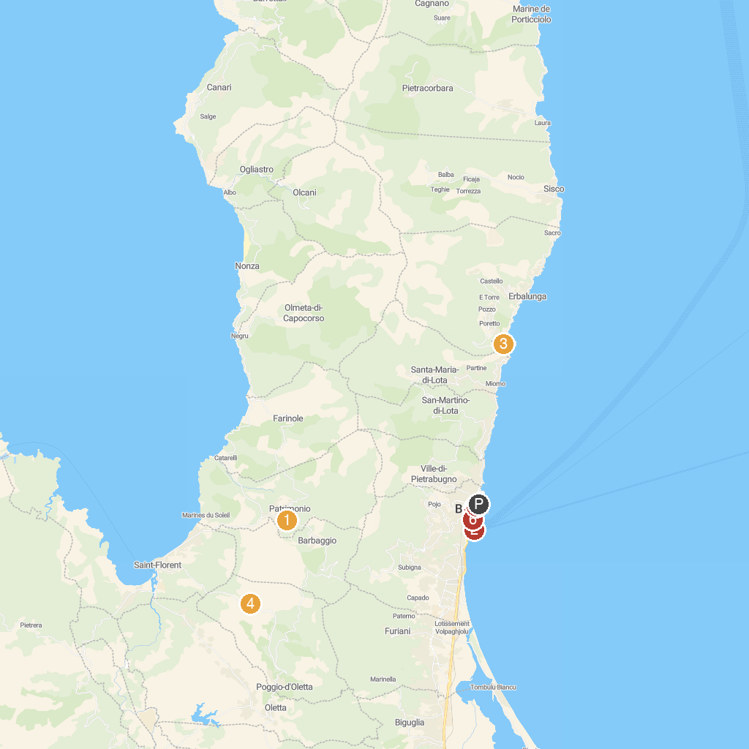
MAP KEY
1. Clos de Bernardi | 5. Place Saint Nicolas
2. Palais des Gouverneurs | 6. Église Saint Jean-Baptiste
3. Sanctuaire - Église Notre-Dame de Lavasina par Brando | 7. Le Petit Train de Bastia
4. VIGNOBLE YVES LECCIA
P. Cruise port / terminal
Map © MapTiler © OpenStreetMap contributors · cruiseports.org

