Basseterre, St. Kitts, Caribbean
St. Kitts punches well above its size — a UNESCO fortress, a one-of-a-kind sugar-cane railway, and a walkable Georgian capital all compete for a single shore day.
⚓ Docked at Port Zante · 🕒 Typical call: 7–9 hrs · 💵 EC Dollar / USD widely accepted · 🗣️ English · 🌴 Caribbean island
✍️ MY DAY IN PORT (FILL IN)
Ship / Date
In port | arrive ______ · all aboard ______
Booked excursion
Notes / meeting point
GETTING ASHORE
- Docking: Pier-side at Port Zante — no tender required
- Walk to center: ~10 min on foot to The Circus / downtown
- Best For: History buffs, scenic railway fans, beach seekers
- Don't Miss: Brimstone Hill Fortress (UNESCO) and the St. Kitts Scenic Railway
GETTING AROUND
- 🚕 Taxi: USD 5–12 — Fixed-rate taxis wait just outside Port Zante cruise terminal. Short trips within Basseterre run USD 5–8; confirm fare b
TOP THINGS TO DO
- Brimstone Hill Fortress — This UNESCO World Heritage Site is one of the best-preserved colonial fortresses in the Americas.
- St. Kitts Scenic Railway — The last remaining railway in the Caribbean rides a narrow-gauge track built in the 1920s for sugar cane.
- South Friar's Bay Beach — The most popular beach day for cruisers — calm Caribbean waters, golden sand, and a string of beach bars.
- Rainforest Zipline at Wingfield Estate — Sky Safari runs zip lines over the historic Wingfield Estate rainforest, with views down to the coast.
- Romney Manor & Caribelle Batik — An elegant 17th-century plantation estate surrounded by botanical gardens, home to Caribelle Batik where artisans hand-print…
BEST WALKS
- Basseterre City Loop: 1.5 miles · ~45 min · Easy — From Port Zante, walk into town to The Circus — Basseterre's colonial roundabout modeled after…
- Timothy Hill Viewpoint Drive (taxi): ~20 min drive each way · Short walk at top — Timothy Hill sits at the island's narrowest point and offers a panorama where the Atlantic Ocean…
WEATHER · DAYLIGHT · MONEY
Month | High °F | Low °F | Rainy days
May | 83 | 77 | 16
Jul | 84 | 79 | 18
Sep | 85 | 79 | 20
Daylight: May 5:39AM–6:35PM · Jul 5:45AM–6:48PM · Sep 5:59AM–6:12PM
cruiseports.org/basseterre-st-kitts · Confirm terminal & all-aboard time with your ship

Basseterre, St. Kitts, Caribbean — Port Map
Red = walkable sights · Amber = excursions farther out · P = cruise terminal
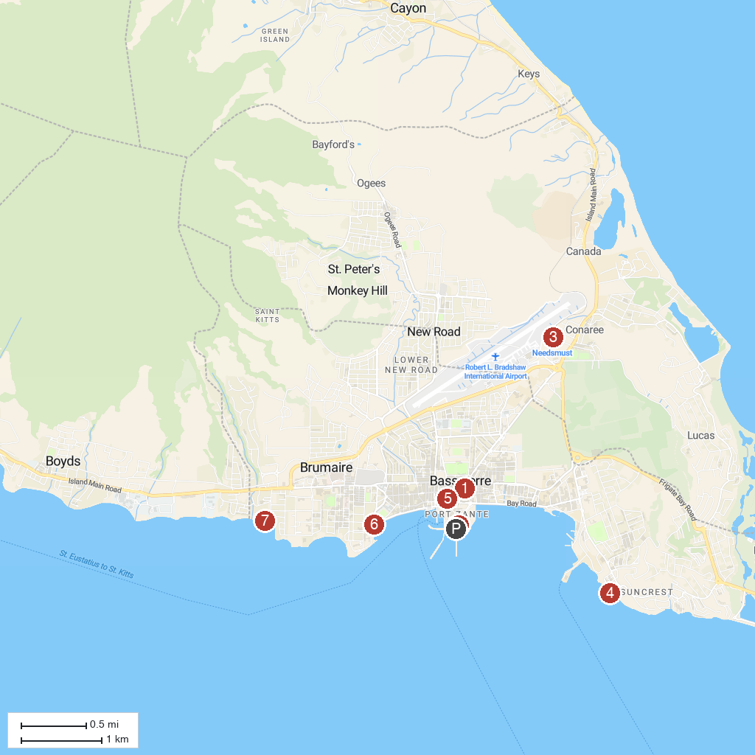
MAP KEY
1. Immaculate Conception Catholic Co-Cathedral | 5. Berkeley Memorial
2. MaPau St Kitts Casino & Entertainment Centre | 6. The War Memorial
3. St. Kitts Scenic Railway | 7. Sea Glass Beach
4. Dolphin Discovery St Kitts
P. Cruise port / terminal
Map © MapTiler © OpenStreetMap contributors · cruiseports.org

