Basse-Terre, Guadeloupe, French Caribbean
The administrative capital of Guadeloupe is dominated by an active volcano and draped in rainforest — a rare Caribbean port where serious nature adventures sit minutes from the pier.
⚓ Docked (pier) · 🕒 Typical call: 7-9 hrs · 💶 Currency: Euro · 🗣️ Language: French / Creole
✍️ MY DAY IN PORT (FILL IN)
Ship / Date
In port | arrive ______ · all aboard ______
Booked excursion
Notes / meeting point
GETTING ASHORE
- Docking: Pier-docked on the northern waterfront; ~10-min walk to city center
- Best For: Volcano hikes, waterfalls, rainforest, snorkeling (Cousteau Reserve)
- Don't Miss: La Soufrière summit hike or Les Chutes du Carbet waterfall trail
- Currency Tip: Euros only; ATMs in town. Cards accepted at larger businesses.
GETTING AROUND
- 🚕 Taxi: ~€5–€15 minimum fare — Government-regulated taxis wait at the port. Cash (euros) preferred; credit cards not always accepted. Fares increase ~4
- 📱 Rideshare: ❌ not available
TOP THINGS TO DO
- La Soufrière Volcano Hike — Hike to the 1,467 m summit of Guadeloupe's active volcano through mossy rainforest and sulfurous fumarole fields.
- Les Chutes du Carbet (Carbet Falls) — Three spectacular waterfalls inside Guadeloupe National Park.
- Cousteau Marine Reserve Snorkel & Dive — Jacques Cousteau called the Ilets Pigeon off Malendure Beach one of the world's best diving sites.
- Fort Delgrès & Basse-Terre City Walk — Explore the 17th-century Fort Delgrès, a significant landmark in Caribbean resistance history, then stroll Basse-Terre's colonial…
- Deshaies Botanical Garden — A lush 7-hectare tropical garden in Deshaies showcasing over 1,000 species of exotic flowers, trees, and wildlife — including…
BEST WALKS
- Basse-Terre Colonial City Loop: 1.5 km · ~45 min · Easy — From the cruise pier, walk south along the waterfront to Fort Delgrès, then loop through the…
- Cascade aux Écrevisses Forest Walk: 1 km · ~30 min · Easy — A short, well-marked jungle path off the Route de la Traversée leads to this lovely waterfall with…
WEATHER · DAYLIGHT · MONEY
Month | High °F | Low °F | Rainy days
May | 83 | 77 | 20
Jul | 84 | 78 | 23
Sep | 85 | 79 | 21
Daylight: May 5:37AM–6:29PM · Jul 5:43AM–6:42PM · Sep 5:55AM–6:08PM
cruiseports.org/basse-terre · Confirm terminal & all-aboard time with your ship

Basse-Terre, Guadeloupe, French Caribbean — Port Map
Red = walkable sights · Amber = excursions farther out · P = cruise terminal
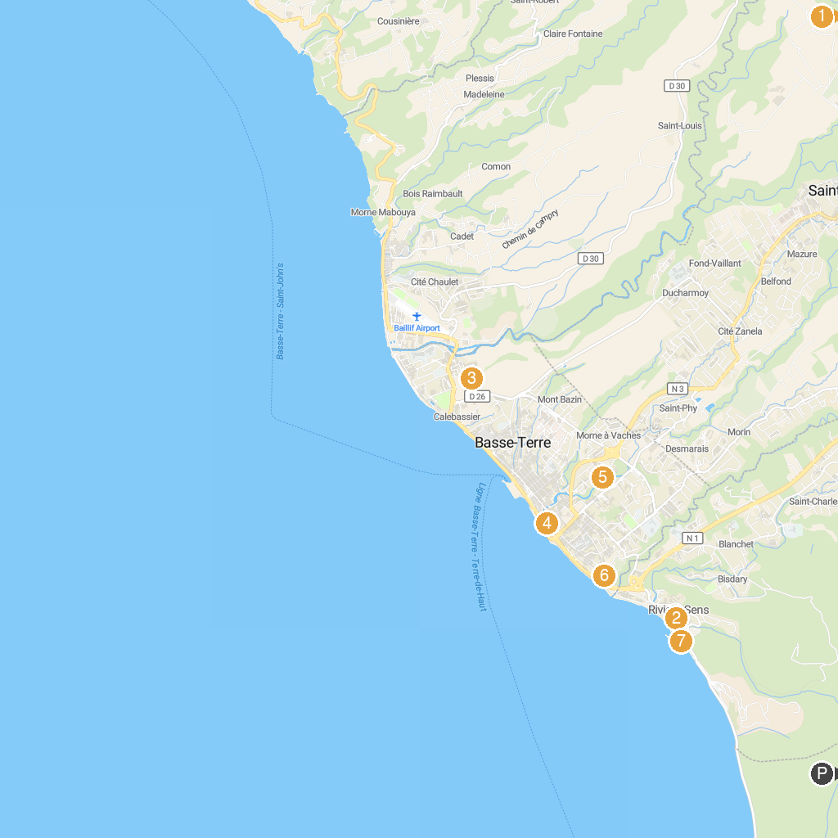
MAP KEY
1. 1ère chute du Carbet | 5. de Basse Terre Botanical Garden
2. Rêve de Nav’ Croisière | 6. Fort Delgrès
3. Rum Distillery Bologne | 7. Plage de Rivière-Sens
4. Marché de Basse-Terre
P. Cruise port / terminal
Map © MapTiler © OpenStreetMap contributors · cruiseports.org

