Basel, Basel-Stadt, Switzerland
Where Switzerland, Germany, and France meet at a bend in the Rhine — Basel rewards river cruisers with Gothic spires, world-class art, and one of the most walkable old towns in Europe.
⚓ Docked (river pier) · 🕒 Typical call: 8–10 hrs · 💵 Swiss Franc (CHF) · 🗣️ German (English widely spoken)
✍️ MY DAY IN PORT (FILL IN)
Ship / Date
In port | arrive ______ · all aboard ______
Booked excursion
Notes / meeting point
GETTING ASHORE
- Docking: River piers at St. Johann, Klybeck, or Dreiländereck — exact pier confirmed close to arrival
- Walk to center: 10–15 min on foot from St. Johann; tram from Klybeck/Dreiländereck
- Best For: Art & culture lovers, Old Town strolls, Rhine river experiences
- Don't Miss: Basler Münster terrace view, a motorless Fähri river ferry crossing
GETTING AROUND
- 🚕 Taxi: CHF 20–40 — Taxis are metered and readily available near the port. Short in-city rides run CHF 20–40; pre-booked private transfers t
- 📱 Rideshare: ✅ Uber, Bolt
- 🚌 Hop-on hop-off: ✅
TOP THINGS TO DO
- Basel Old Town (Altstadt) Walk — Wander cobblestone lanes to the vivid red 16th-century Rathaus on Marktplatz, then climb to the Pfalz terrace at Basel Minster…
- Basler Münster — Basel's great Gothic cathedral dominates the Rhine skyline.
- Kunstmuseum Basel — One of Europe's oldest and finest public art collections, spanning Old Masters to contemporary works.
- Tinguely Museum — Jean Tinguely's whimsical, noise-making kinetic sculptures fill a purpose-built riverside museum designed by Mario Botta — a…
- Rhine Fähri Ferry Crossing — Ride one of Basel's four traditional motorless Fähri boats across the Rhine — they use only the river's current and a cable.
BEST WALKS
- Rhine Promenade & Old Town Loop: 3–4 km · 1.5–2 hrs · Flat — Follow the Rhine north from St.
- Dreiländereck (Three-Country Corner): Easy stroll · 30 min from pier · Flat — From the Dreiländereck pier, walk to the obelisk monument marking where Switzerland, Germany, and…
WEATHER · DAYLIGHT · MONEY
Month | High °F | Low °F | Rainy days
May | 66 | 48 | 15
Jul | 79 | 60 | 13
Sep | 71 | 53 | 11
Daylight: May 5:52AM–9:00PM · Jul 5:48AM–9:22PM · Sep 7:07AM–7:41PM
cruiseports.org/basel · Confirm terminal & all-aboard time with your ship

Basel, Basel-Stadt, Switzerland — Port Map
Red = walkable sights · Amber = excursions farther out · P = cruise terminal
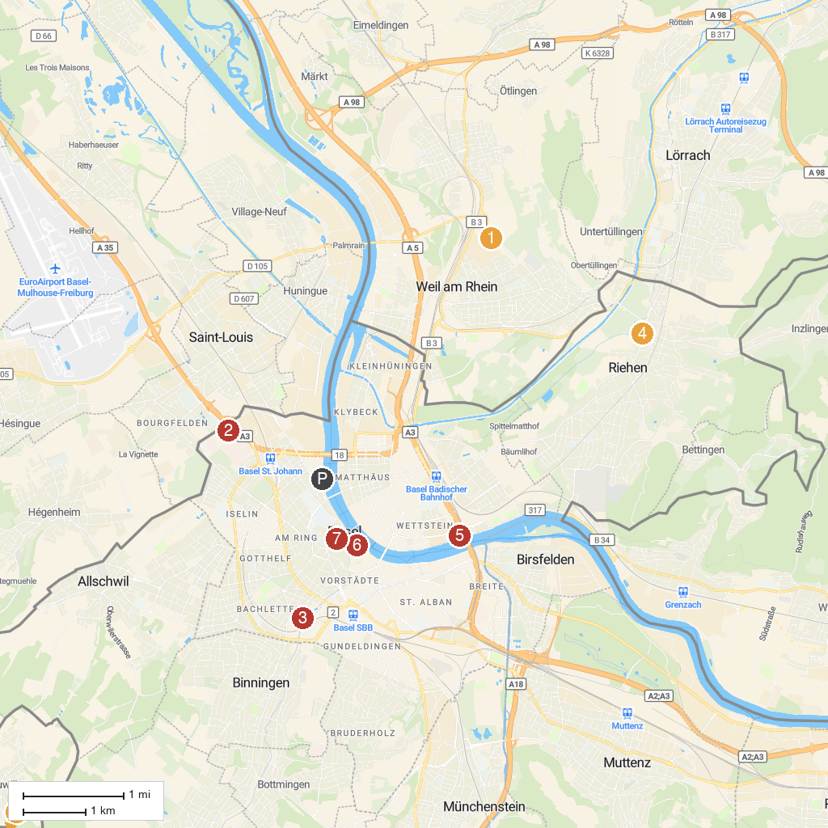
MAP KEY
1. Vitra Design Museum | 5. Museum Tinguely
2. Grand Casino Basel | 6. Museum of Natural History Basel
3. Zoo Basel | 7. Pharmacy Museum of the University of Basel
4. Fondation Beyeler | 8. Mariastein Abbey
P. Cruise port / terminal
Map © MapTiler © OpenStreetMap contributors · cruiseports.org

