Utqiaġvik (Barrow), Alaska, USA
The northernmost community in the United States, Utqiaġvik sits where the Chukchi and Beaufort Seas meet — a place of polar light, Iñupiat tradition, and rare Arctic wildlife that few cruise passengers ever reach.
⚓ Tender port (no pier) · 🕒 Typical call: 5–7 hrs · 💵 USD · 🗣️ English / Iñupiaq · 🧊 Expedition ships only
✍️ MY DAY IN PORT (FILL IN)
Ship / Date
In port | arrive ______ · all aboard ______
Booked excursion
Notes / meeting point
GETTING ASHORE
- Docking: Tender only — ships anchor offshore; no deep-water pier
- Walk to center: ~10 min from tender landing to Whale Bone Arch / downtown
- Best For: Arctic culture, wildlife, bucket-list geography
- Don't Miss: Iñupiat Heritage Center and the Whale Bone Arch
GETTING AROUND
- 🚕 Taxi: $8 flat rate (within town); +$2/person extra — The City of Utqiaġvik operates licensed taxis with a flat $8 fare for single-party or shared rides within the Barrow or
- 📱 Rideshare: ❌ not available
TOP THINGS TO DO
- Iñupiat Heritage Center Tour — The Iñupiat Heritage Center is the cultural heart of Utqiaġvik, with exhibits on language, traditional crafts, whaling history…
- Whale Bone Arch & Arctic Ocean — Walk to the iconic arch made from bowhead whale jawbones overlooking the Arctic Ocean — a symbol of Iñupiat whaling tradition.
- Point Barrow — Northernmost USA — A full excursion to Point Barrow, the northernmost tip of the United States, passing tundra landscape and the ancient Nuvuk…
- Arctic Wildlife & Tundra — Guided tundra excursions look for polar bears, ringed seals, walrus, caribou, and over 100 species of migratory birds.
- Will Rogers & Wiley Post Memorial + Historic Sites — Visit the monument commemorating pilot Wiley Post and entertainer Will Rogers, who died in a 1935 crash near Barrow.
BEST WALKS
- Downtown to Whale Bone Arch & Arctic Ocean: 1 km · Easy · 15–20 min — From the tender landing, walk along the seafront road to the Whale Bone Arch and the Arctic Ocean…
- Heritage Center & Town Walk: 1.5 km · Easy · 30 min — Walk from the town center past the Will Rogers and Wiley Post Monument to the Iñupiat Heritage…
WEATHER · DAYLIGHT · MONEY
Month | High °F | Low °F | Rainy days
May | 30 | 23 | 4
Jul | 48 | 38 | 9
Sep | 38 | 33 | 9
Daylight: Sep 7:39AM–9:02PM
cruiseports.org/barrow-ak · Confirm terminal & all-aboard time with your ship

Utqiaġvik (Barrow), Alaska, USA — Port Map
Red = walkable sights · Amber = excursions farther out · P = cruise terminal
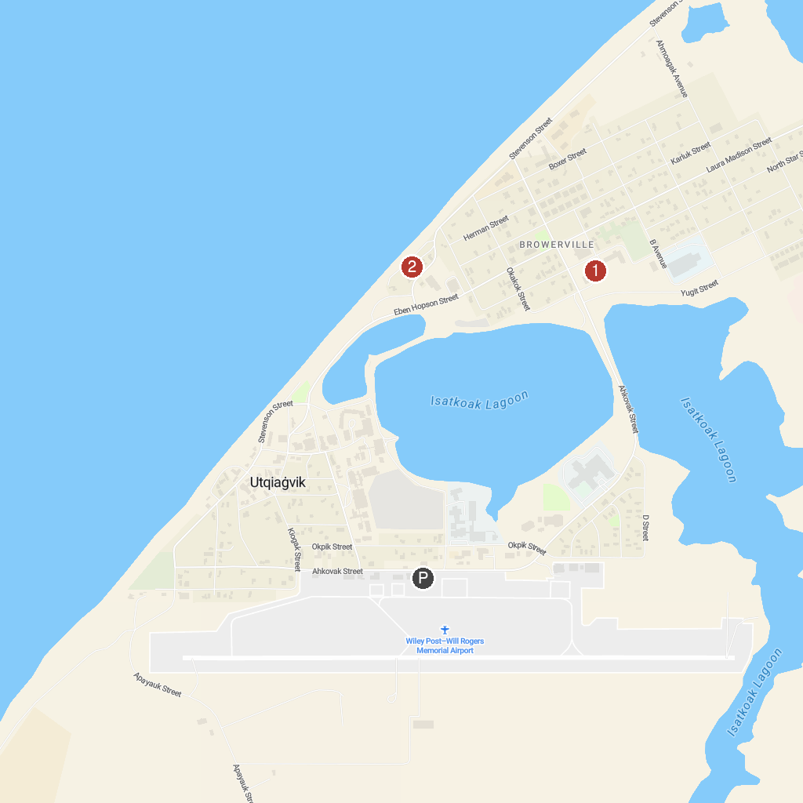
MAP KEY
1. Iñupiat Heritage Center | 2. Utqiagvik Whale Bone Arch
P. Cruise port / terminal
Map © MapTiler © OpenStreetMap contributors · cruiseports.org

