Barranquilla, Atlántico, Colombia
Colombia's Caribbean capital pulses with carnival energy, vibrant street art, and the mighty Magdalena River meeting the sea. Barranquilla rewards the curious traveler with authentic coastal culture far off the usual cruise trail.
⚓ Docked (commercial pier) · 🕒 Typical call: 8–10 hrs · 💵 Colombian Peso (COP) · 🗣️ Spanish
✍️ MY DAY IN PORT (FILL IN)
Ship / Date
In port | arrive ______ · all aboard ______
Booked excursion
Notes / meeting point
GETTING ASHORE
- Docking: Pier at Sociedad Portuaria Regional de Barranquilla, ~3 km from city center
- Walk to Center: Not walkable — taxis or arranged transfers recommended
- Best For: Culture, street art, Carnival history, Magdalena River delta
- Don't Miss: Gran Malecón del Río, Bocas de Cenizas, Carnival Museum
GETTING AROUND
- 🚕 Taxi: COP 30,000–50,000 (~$8–$14 USD) — Taxis are the most common transport from the port. Agree on a fixed fare before getting in — drivers do not always use m
- 📱 Rideshare: ✅ Uber
TOP THINGS TO DO
- Carnival Museum & Barrio Abajo Street Art — Dive into the world's second-largest carnival at the Museo del Carnaval de Barranquilla, then walk Barrio Abajo's vivid murals…
- Bocas de Cenizas — Where River Meets Sea — Journey north to the dramatic delta where the chocolate-brown Magdalena River flows into the turquoise Caribbean.
- Gran Malecón del Río & Shakira Statue — Stroll Barranquilla's signature waterfront promenade along the Magdalena River, passing the golden Shakira statue, Ventana al…
- El Prado Neighborhood & Plaza de San Nicolás — Explore Barranquilla's elegant early-20th-century district of El Prado, then visit the Gothic-influenced St.
- Puerto Colombia Beach Day — A 20-minute drive west leads to Puerto Colombia, a historic coastal village with a ruined 19th-century pier and calm Caribbean…
BEST WALKS
- Gran Malecón Waterfront Stroll: 2 km | Easy | 45–60 min — Follow the Magdalena River promenade from the Shakira statue south through sports courts, food…
- El Prado Architecture Walk: 1.5 km | Easy | 45 min — A leisurely loop through the leafy El Prado district takes you past elegant early-20th-century…
WEATHER · DAYLIGHT · MONEY
Month | High °F | Low °F | Rainy days
May | 88 | 78 | 21
Jul | 87 | 79 | 18
Sep | 87 | 78 | 26
Daylight: May 5:36AM–6:14PM · Jul 5:44AM–6:26PM · Sep 5:48AM–5:59PM
cruiseports.org/barranquilla-colombia · Confirm terminal & all-aboard time with your ship

Barranquilla, Atlántico, Colombia — Port Map
Red = walkable sights · Amber = excursions farther out · P = cruise terminal
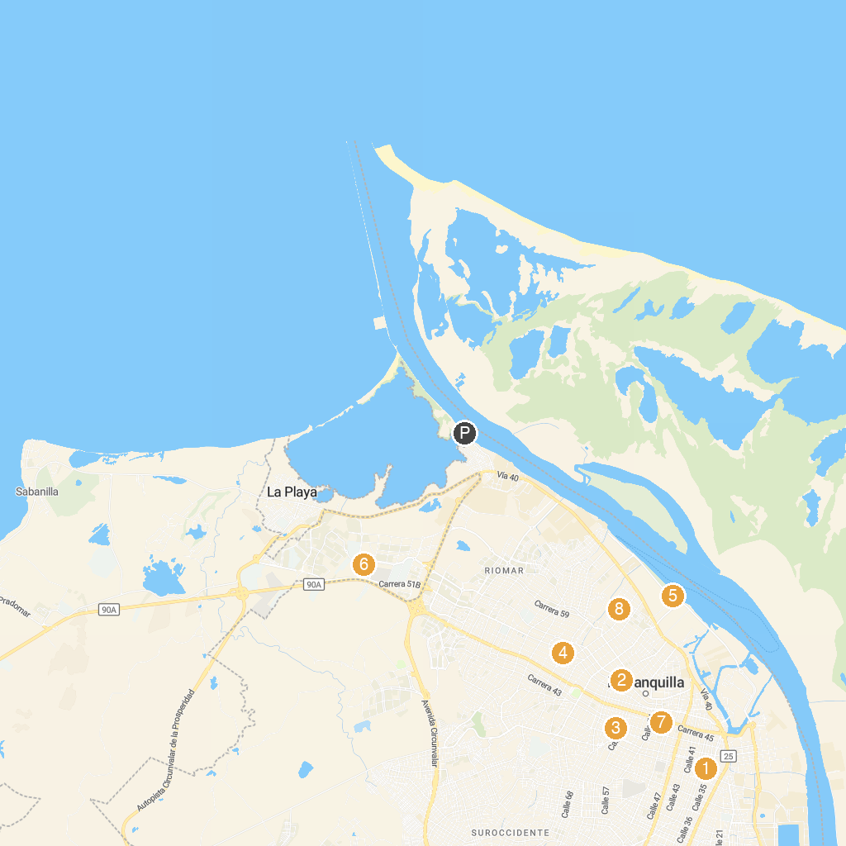
MAP KEY
1. Museo del Atlántico | 5. Malecón Tourist León Caridi
2. Bibliographical Museo Bolivariano | 6. Museo Mapuka
3. Combarranquilla Unidad Boston | 7. Plaza de la Paz - John Paul II
4. Sede principal / Flagship gallery | 8. Zoológico de Barranquilla
P. Cruise port / terminal
Map © MapTiler © OpenStreetMap contributors · cruiseports.org

