Bari, Puglia, Italy
Southern Italy's Adriatic gateway drops you steps from Bari Vecchia's sun-bleached lanes, where women roll orecchiette outside their doors and the bones of Saint Nicholas rest beneath a golden basilica.
⚓ Docked (pier) · 🕒 Typical call: 8–10 hrs · 💶 Euro (€) · 🗣️ Italian
✍️ MY DAY IN PORT (FILL IN)
Ship / Date
In port | arrive ______ · all aboard ______
Booked excursion
Notes / meeting point
GETTING ASHORE
- Docking: Ships dock at Molo San Vito cruise terminal in the New Port; ~2 km from the Old Town
- Walk to center: Old Town is ~2 km / 20–25 min on foot from the terminal
- Best For: Medieval architecture, Puglia cuisine, day trips to Alberobello & Polignano a Mare
- Don't Miss: Basilica di San Nicola, Via delle Orecchiette, Castello Normanno-Svevo
GETTING AROUND
- 🚕 Taxi: €15–€20 — Metered taxis are available outside the terminal. The ride to Bari Centrale or the old town takes about 12 minutes; shar
- 📱 Rideshare: ✅ Uber
- 🚌 Hop-on hop-off: ✅
TOP THINGS TO DO
- Bari Vecchia Old Town Walk — Wander the labyrinthine medieval quarter, pause at the Basilica di San Nicola, and watch nonnas roll orecchiette by hand on Via…
- Alberobello Trulli Village — A UNESCO World Heritage Site an hour from Bari, Alberobello's conical-roofed stone trulli houses are unlike anything else in…
- Matera Sassi Cave City — One of the world's oldest continuously inhabited cities, Matera's ancient cave dwellings (Sassi) carved into a dramatic ravine…
- Polignano a Mare Cliffs — This photogenic coastal town perched on limestone cliffs is 35 km south of Bari — reachable by train in 30 minutes.
- Puglia Food & Pasta Experience — Join a market tour and hands-on orecchiette-making class in Bari Vecchia, then sit down to a full Pugliese lunch with burrata…
BEST WALKS
- Old Town Heart Walk: 2.5 km · 1–1.5 hrs · Easy — From the seafront, enter Bari Vecchia at Piazza del Ferrarese, walk to the Basilica di San Nicola…
- Castle & Lungomare Promenade: 3 km · 1 hr · Easy — Start at Castello Normanno-Svevo on the edge of the Old Town, then walk the scenic Lungomare Araldo…
WEATHER · DAYLIGHT · MONEY
Month | High °F | Low °F | Rainy days
May | 73 | 59 | 9
Jul | 87 | 72 | 4
Sep | 80 | 67 | 7
Daylight: May 5:34AM–8:03PM · Jul 5:33AM–8:23PM · Sep 6:33AM–7:01PM
cruiseports.org/bari · Confirm terminal & all-aboard time with your ship

Bari, Puglia, Italy — Port Map
Red = walkable sights · Amber = excursions farther out · P = cruise terminal
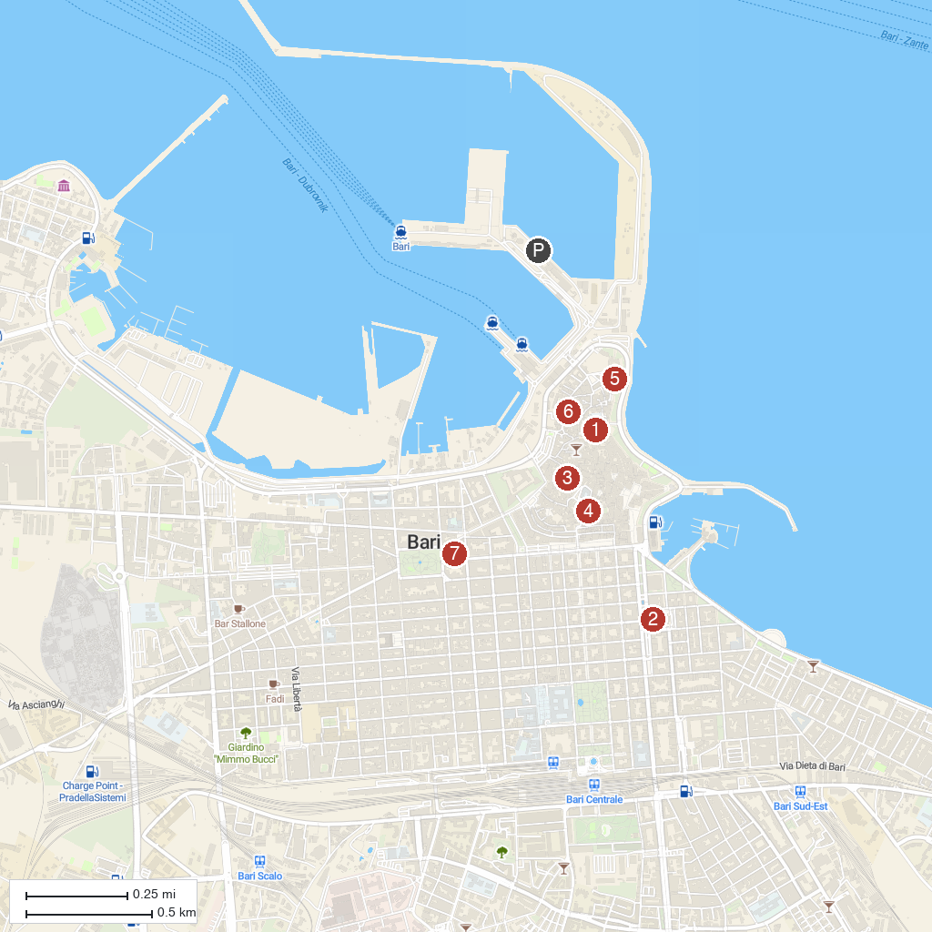
MAP KEY
1. Basilica of St Nicholas | Bari | 5. Archaeological Museum of Santa Scolastica
2. Teatro Petruzzelli | 6. Regional Directorate of Museums
3. Cathedral of Saint Sabinus | 7. Palazzo Fizzarotti
4. Palazzo Simi (Simi Palace)
P. Cruise port / terminal
Map © MapTiler © OpenStreetMap contributors · cruiseports.org

