Barca d'Alva, Douro Valley, Portugal
At the eastern tip of Portugal's navigable Douro, Barca d'Alva is where river cruises turn around — a sleepy village pressed between terraced vineyards and Spain, with some of the valley's most dramatic scenery at its doorstep.
⚓ Docked at riverside pier · 🕒 Typical call: 5-8 hrs · 💶 Currency: Euro (€) · 🗣️ Language: Portuguese · 🍷 River cruise only
✍️ MY DAY IN PORT (FILL IN)
Ship / Date
In port | arrive ______ · all aboard ______
Booked excursion
Notes / meeting point
GETTING ASHORE
- Docking: Tied alongside a small riverside quay; most ships dock directly — no tender required
- Walk to centre: Village is right at the pier — about 2 min walk, but facilities are very limited
- Best For: Wine estate visits, day trip to Salamanca, dramatic Douro gorge scenery
- Don't Miss: The Almirante Sarmento Rodrigues Bridge viewpoint over the gorge
GETTING AROUND
- 🚕 Taxi: €40–€50 to Pocinho — Taxis can be arranged to reach Pocinho (32 km away), the nearest town with a train station. Meters are rarely used for r
TOP THINGS TO DO
- Salamanca, Spain — Full-Day UNESCO City — One of Europe's finest historic cities, about 2 hours by bus (≈122 km).
- Castelo Rodrigo Hilltop Village — This fortified medieval village perches on a crag above the Douro Superior plain, with crumbling castle ruins, old stone lanes…
- Alto Douro Quinta Wine Estate Visit — The UNESCO Alto Douro Wine Region surrounds Barca d'Alva.
- Douro International Natural Park Walk — Barca d'Alva sits within the Douro International Natural Park, a cross-border protected area renowned for birds of prey including…
- Côa Valley Archaeological Park — About 30km downstream, the Côa Valley Palaeolithic Rock Art Site is a UNESCO World Heritage Site with open-air engravings dating…
BEST WALKS
- Village Stroll & Bridge Viewpoint: ~1 km | 20-30 min | Easy | River views — From the quay, walk up into the village centre, then continue to the Almirante Sarmento Rodrigues…
WEATHER · DAYLIGHT · MONEY
Month | High °F | Low °F | Rainy days
May | 71 | 52 | 8
Jul | 84 | 60 | 2
Sep | 77 | 58 | 6
Daylight: May 6:10AM–8:39PM · Jul 6:09AM–8:58PM · Sep 7:09AM–7:37PM
cruiseports.org/barca-dalva · Confirm terminal & all-aboard time with your ship

Barca d'Alva, Douro Valley, Portugal — Port Map
Red = walkable sights · Amber = excursions farther out · P = cruise terminal
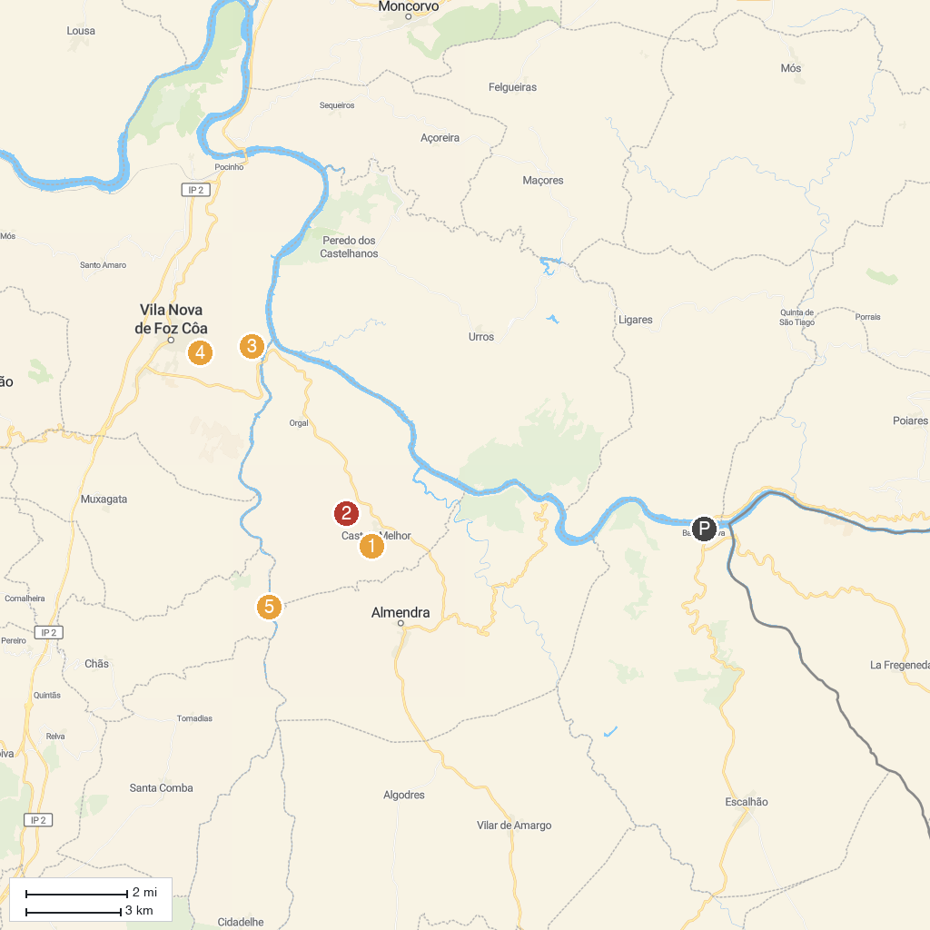
MAP KEY
1. Castelo Melhor's Castle | 5. Museu das gravuras de Foz do Côa
2. Estação Arqueológica do Prazo | 6. Miradouro de Santa Bárbara
3. Faia Brava | 7. Penascosa Prehistoric Rock-Art Site (UNESCO World Heritage)
4. Miradouro de São Gabriel
P. Cruise port / terminal
Map © MapTiler © OpenStreetMap contributors · cruiseports.org

