Bar Harbor, Maine, USA
Anchored in Frenchman Bay and tendered ashore to the foot of Main Street, Bar Harbor punches well above its size — a compact, walkable New England town with Acadia National Park as its backyard.
⚓ Tender port (no pier) · 🕒 Typical call: 7-9 hrs · 💵 USD · 🗣️ English · 🦞 Lobster country
✍️ MY DAY IN PORT (FILL IN)
Ship / Date
In port | arrive ______ · all aboard ______
Booked excursion
Notes / meeting point
GETTING ASHORE
- Docking: Tender from Frenchman Bay to Town Pier (Ells Pier), ~10-15 min
- Walk to center: 30 seconds — Town Pier is at the foot of Main Street
- Best For: Acadia hiking, whale watching, lobster, scenic coastal walks
- Don't Miss: Cadillac Mountain sunrise/summit, Shore Path, Bar Island at low tide
GETTING AROUND
- 🚕 Taxi: $15–$25 — Local cabs (Bar Harbor Taxi, Point to Point) wait near the Village Green. Short town hops or trailhead drop-offs run $15
TOP THINGS TO DO
- Acadia National Park & Cadillac Mountain — Drive or shuttle the Park Loop Road to Thunder Hole, Sand Beach, and the summit of Cadillac Mountain — highest point on the US…
- Whale Watching Cruise — Head out into the Gulf of Maine with naturalist guides to spot humpbacks, finbacks, and minkes.
- Carriage Road Biking — Acadia's 45 miles of carriage roads are car-free and perfectly graded — rent bikes downtown and roll through old-growth forest…
- Frenchman Bay Schooner Sail — Board a traditional Maine windjammer schooner for a narrated sail around Frenchman Bay, with views of the Porcupine Islands and…
- Abbe Museum & Downtown Walk — The Abbe Museum on Mount Desert Street tells the story of Maine's Wabanaki people through impressive collections and rotating…
BEST WALKS
- Shore Path: 1.5 miles round-trip · Easy · 30-45 min — Starting just east of Agamont Park, this paved coastal path hugs the rocky shoreline past Gilded…
- Bar Island at Low Tide: 1 mile round-trip · Easy · 1-1.5 hrs — At low tide, a natural gravel bar emerges from Bridge Street, letting you walk dry-shod to Bar…
- Downtown Bar Harbor Loop: 0.75 miles · Easy · 30 min — From the Town Pier, walk up Main Street past shops and restaurants, turn on Cottage Street to the…
WEATHER · DAYLIGHT · MONEY
Month | High °F | Low °F | Rainy days
May | 58 | 45 | 10
Jul | 73 | 62 | 11
Sep | 67 | 57 | 8
Daylight: May 5:05AM–7:53PM · Jul 5:03AM–8:14PM · Sep 6:12AM–6:42PM
cruiseports.org/bar-harbor · Confirm terminal & all-aboard time with your ship

Bar Harbor, Maine, USA — Port Map
Red = walkable sights · Amber = excursions farther out · P = cruise terminal
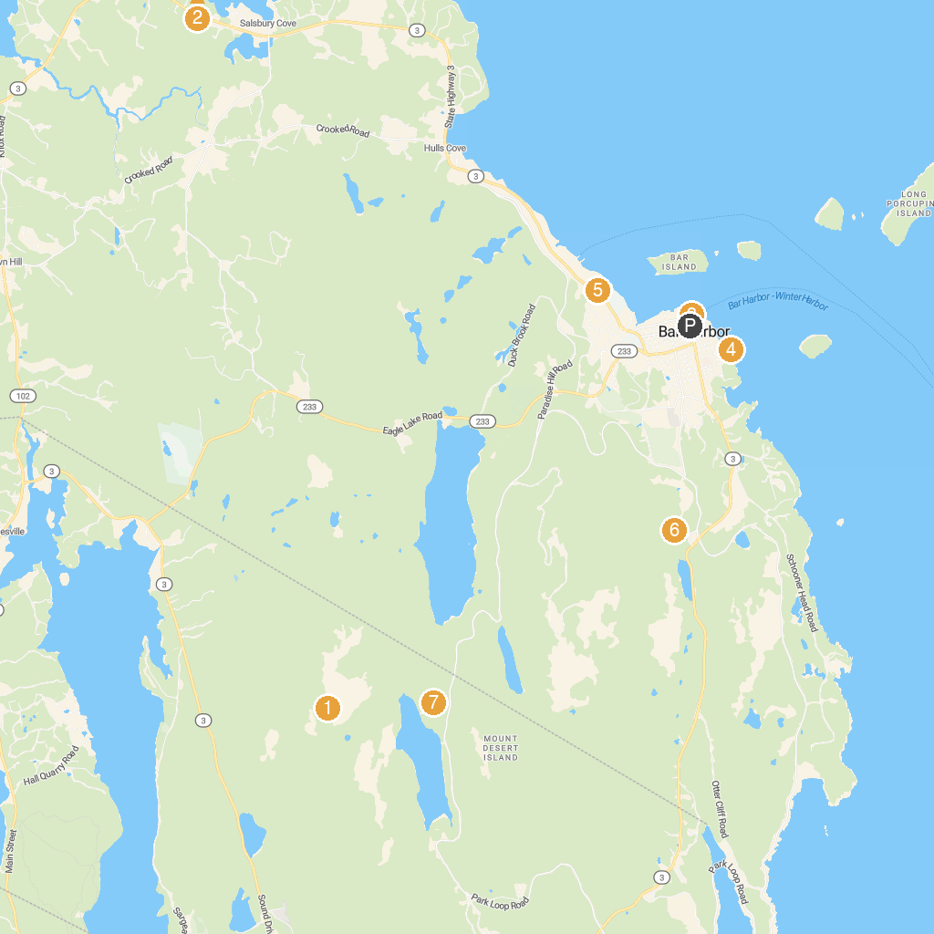
MAP KEY
1. Acadia National Park | 5. George B. Dorr Museum of Natural History
2. Lamoine State Park | 6. Wild Gardens of Acadia
3. Bar Harbor Whale Watch Co | 7. Bubble Rock
4. Bar Harbor Shore path
P. Cruise port / terminal
Map © MapTiler © OpenStreetMap contributors · cruiseports.org

