Bangor, County Down, Northern Ireland
A Victorian seaside town on Belfast Lough, Bangor punches above its size: the marina is steps from the pier, Belfast is 30 minutes by train, and the Giant's Causeway lies an easy coach ride along one of Europe's most scenic coasts.
⚓ Docked (Eisenhower Pier) · 🕒 Typical call: 7-10 hrs · 💷 Currency: GBP (British Pounds) · 🗣️ Language: English
✍️ MY DAY IN PORT (FILL IN)
Ship / Date
In port | arrive ______ · all aboard ______
Booked excursion
Notes / meeting point
GETTING ASHORE
- Docking: Eisenhower Pier — smaller ships berth pier-side; larger vessels may anchor and tender
- Walk to centre: 5–10 min from pier to Main Street and marina promenade
- Best For: Belfast day trips, Giant's Causeway, Titanic history, coastal walks
- Don't Miss: Titanic Belfast museum and the WWII mosaics on Eisenhower Pier
GETTING AROUND
- 🚕 Taxi: £4–£8 — Metered taxis are available at the pier. Day rate starts at £3.20 for the first ~800 yards then £1.80/mile; night rates
- 📱 Rideshare: ✅ Uber
TOP THINGS TO DO
- Titanic Belfast & Titanic Quarter — The world's largest Titanic visitor experience, built on the slipway where RMS Titanic was constructed.
- Giant's Causeway & Antrim Coast — Northern Ireland's only UNESCO World Heritage Site — 40,000 interlocking basalt columns sculpted by ancient volcanism.
- Belfast Black Cab & Murals Tour — Private black cab tours cover the Peace Walls, Falls Road and Shankill Road murals, and the story of The Troubles in a way no…
- Carrick-a-Rede Rope Bridge — A rope bridge spanning a 20-metre chasm and suspended around 30 metres above the rocks, leading to a tiny island off the Antrim…
- Game of Thrones Studio Tour — Located in Banbridge, less than an hour from Belfast, this immersive tour takes fans through original sets, props, costumes, and…
BEST WALKS
- Pier to Pickie Seafront Stroll: 1.5 km · 20 min · Easy · Flat — Walk from Eisenhower Pier along the marina promenade past the 'Pasty Supper' sculpture and the…
- North Down Coastal Path to Groomsport: 4 km one way · 1 hr · Easy · Coastal — Head east from the pier along the North Down Coastal Path with views over Belfast Lough and the…
- Town Centre & Bangor Castle Loop: 2 km · 30 min · Easy — From the pier walk up to Main Street, then into Castle Park to see Bangor Castle and the Walled…
WEATHER · DAYLIGHT · MONEY
Month | High °F | Low °F | Rainy days
May | 64 | 45 | 10
Jul | 79 | 62 | 11
Sep | 71 | 55 | 8
Daylight: May 5:06AM–7:57PM · Jul 5:04AM–8:17PM · Sep 6:14AM–6:45PM
cruiseports.org/bangor-uk · Confirm terminal & all-aboard time with your ship

Bangor, County Down, Northern Ireland — Port Map
Red = walkable sights · Amber = excursions farther out · P = cruise terminal
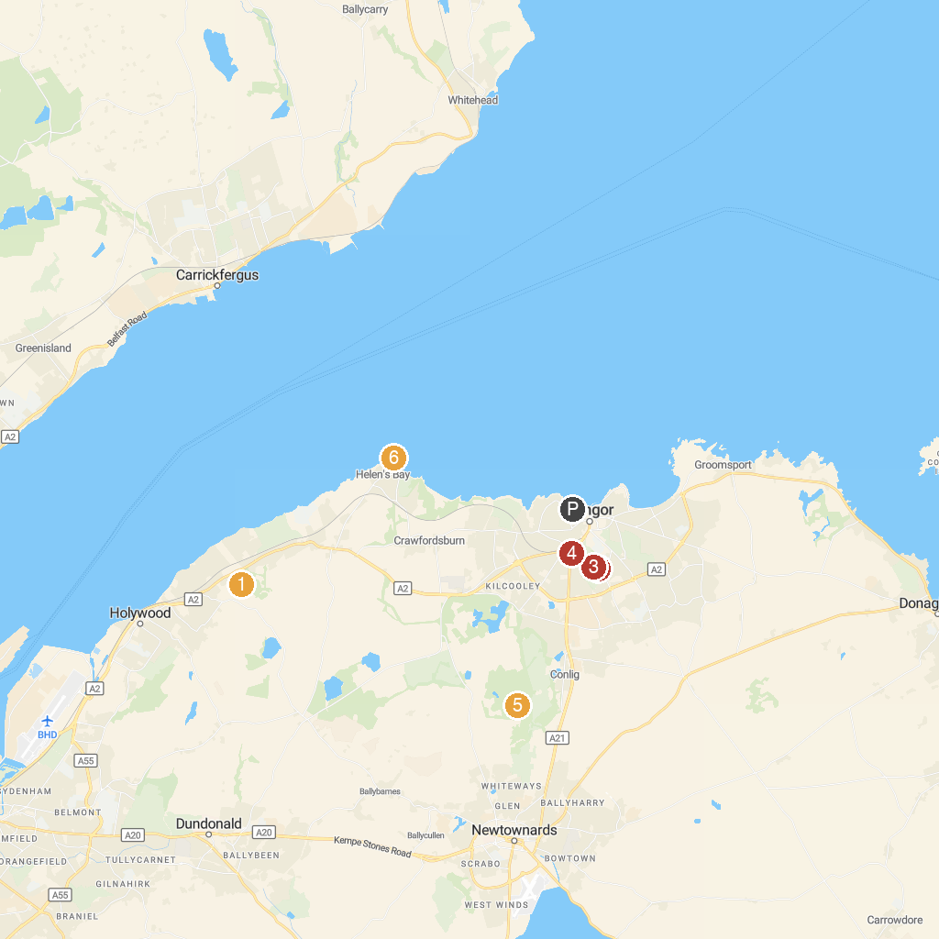
MAP KEY
1. Ulster Folk Museum | 5. Bangor Castle Walled Garden
2. Dundonald International Ice Bowl | 6. Bangor Abbey
3. Bangor Aurora Aquatic & Leisure Complex | 7. Helen's Tower
4. National Trust - Mount Stewart | 8. Grey Point Fort
P. Cruise port / terminal
Map © MapTiler © OpenStreetMap contributors · cruiseports.org

