Bandol, Provence, France
A Provençal gem where vines tumble toward the sea — tender ashore into a town where world-class rosé, sandy coves, and a scenic coastal path fill the day effortlessly.
⚓ Tender port · 🕒 Typical call: 6-8 hrs · 💶 Euro (€) · 🗣️ French
✍️ MY DAY IN PORT (FILL IN)
Ship / Date
In port | arrive ______ · all aboard ______
Booked excursion
Notes / meeting point
GETTING ASHORE
- Docking: Tender to quayside; ~30 m from town center
- Walk to center: Immediate — tender drops at the port quay
- Best For: Wine lovers, beach days, coastal hiking
- Don't Miss: AOC Bandol wine tasting & Île de Bendor boat trip
GETTING AROUND
- 🚕 Taxi: €5–€15 (local) — Taxis queue outside the terminal. Fares within Bandol are short and relatively inexpensive; longer trips to Toulon run ~
- 📱 Rideshare: ✅ Uber
TOP THINGS TO DO
- AOC Bandol Winery Tour & Tasting — The Bandol appellation — France's smallest and most prestigious for Mourvèdre — produces structured reds and acclaimed rosés.
- Sentier du Littoral Coastal Walk — Bandol's Sentier du Littoral hugs the rocky shoreline from the port past dramatic headlands — Pointe Grenier, Pointe Fauconnière…
- Île de Bendor Boat Trip — A 7-minute ferry hops to this 7-hectare private island, 300 m offshore, once the playground of Salvador Dalí and the French jet…
- Plage de Renécros Beach Day — Bandol's finest public beach — a sheltered, Blue Flag sandy cove a short stroll from the tender dock.
- Calanques of Cassis Boat Trip — Head by organised boat excursion to the iconic limestone calanques of Cassis, just along the coast.
BEST WALKS
- Harbour & Town Stroll: 1 km loop · 20 min · Easy — Walk the animated port quay, browse the Tuesday morning Provençal market (local produce and…
- Sentier du Littoral: Port to Renécros & Beyond: 3-6 km one way · 1-3 hrs · Moderate — Pick up the coastal path from the port and follow it past Plage de Renécros, along clifftop…
WEATHER · DAYLIGHT · MONEY
Month | High °F | Low °F | Rainy days
May | 71 | 57 | 8
Jul | 85 | 70 | 2
Sep | 78 | 65 | 6
Daylight: May 6:13AM–8:53PM · Jul 6:11AM–9:14PM · Sep 7:16AM–7:46PM
cruiseports.org/bandol · Confirm terminal & all-aboard time with your ship

Bandol, Provence, France — Port Map
Red = walkable sights · Amber = excursions farther out · P = cruise terminal
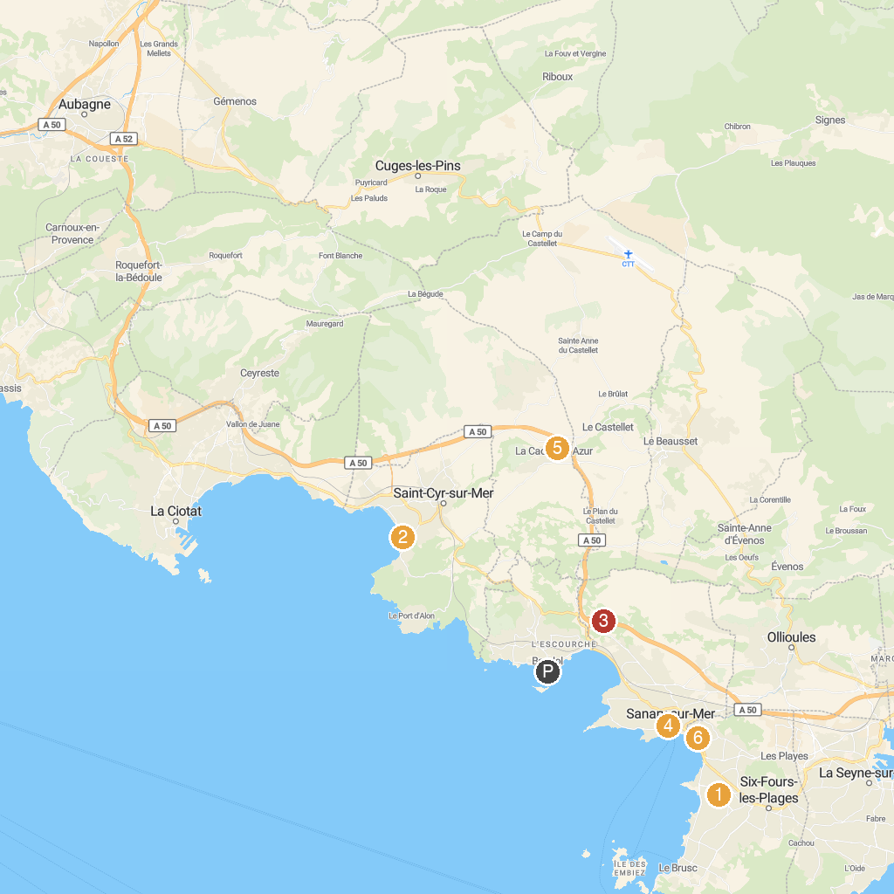
MAP KEY
1. Coudou Parc | 5. Musée Frédéric Dumas
2. Museum Tauroentum | 6. Eglise Saint André
3. Musée National de la Marine | 7. Parc paysager des nuraghes
4. ZOA Parc
P. Cruise port / terminal
Map © MapTiler © OpenStreetMap contributors · cruiseports.org

