Baltiysk, Kaliningrad Oblast, Russia
Russia's westernmost port is the gateway to Kaliningrad — the one-time Prussian capital of Königsberg — where amber washes ashore, Gothic cathedrals echo centuries of history, and sand dunes tower over a UNESCO-listed spit.
⚓ Docked (Baltiysk naval pier) · 🕒 Typical call: 8-10 hrs · 💵 Russian Ruble (RUB) · 🗣️ Russian · 🛂 Visa required / tour-only disembark
✍️ MY DAY IN PORT (FILL IN)
Ship / Date
In port | arrive ______ · all aboard ______
Booked excursion
Notes / meeting point
GETTING ASHORE
- Docking: Alongside at Baltiysk naval commercial pier; buses transfer passengers ~50 km to Kaliningrad
- Walk to Center: Baltiysk town center ~15 min walk; Kaliningrad requires bus transfer (~1 hr each way)
- Best For: History buffs, amber collectors, Baltic nature lovers
- Don't Miss: Kant Island & Königsberg Cathedral, Amber Museum, Curonian Spit
GETTING AROUND
- 🚕 Taxi: 500–1,500 RUB to city center — Local taxis operate in Baltiysk. A ride from the sea terminal to Baltiysk bus station takes about 10–15 minutes. Negotia
TOP THINGS TO DO
- Königsberg Cathedral & Kant Island — The Gothic Königsberg Cathedral (founded 1333), miraculously surviving WWII bombing, anchors Kneiphof Island (now Kant Island) in…
- Amber Museum, Kaliningrad — Housed in a 19th-century Prussian tower, the Amber Museum holds over 14,000 pieces including rare inclusions, Soviet amber art…
- Curonian Spit (UNESCO World Heritage) — A 98 km sand-dune peninsula shared with Lithuania, the Curonian Spit features the "Dancing Forest" (bizarrely twisted pines)…
- Vistula Spit Ferry & Cycling — A quick ferry from Baltiysk harbour lands you on the Baltic Spit where abandoned WWII German airfields, coastal dunes, and quiet…
- Pillau Citadel, Baltiysk — This 17th-century Swedish-built star-shaped fortress — historically known as Pillau — contains a naval museum and underground…
BEST WALKS
- Baltiysk Waterfront Walk: 3 km · ~45 min · Easy · Flat — From the pier, stroll along Marine Boulevard to the Baltic Lighthouse (one of the oldest on the…
- Königsberg Cathedral & Fishing Village, Kaliningrad: 2 km loop · 1-2 hrs · Easy · Flat city walk — From the bus drop-off near the Pregolya River, cross to Kant Island and the Cathedral, then walk…
WEATHER · DAYLIGHT · MONEY
Month | High °F | Low °F | Rainy days
May | 61 | 48 | 10
Jul | 71 | 61 | 14
Sep | 65 | 55 | 12
Daylight: May 4:34AM–8:40PM · Jul 4:24AM–9:07PM · Sep 6:13AM–6:56PM
cruiseports.org/baltiysk-kaliningrad · Confirm terminal & all-aboard time with your ship

Baltiysk, Kaliningrad Oblast, Russia — Port Map
Red = walkable sights · Amber = excursions farther out · P = cruise terminal
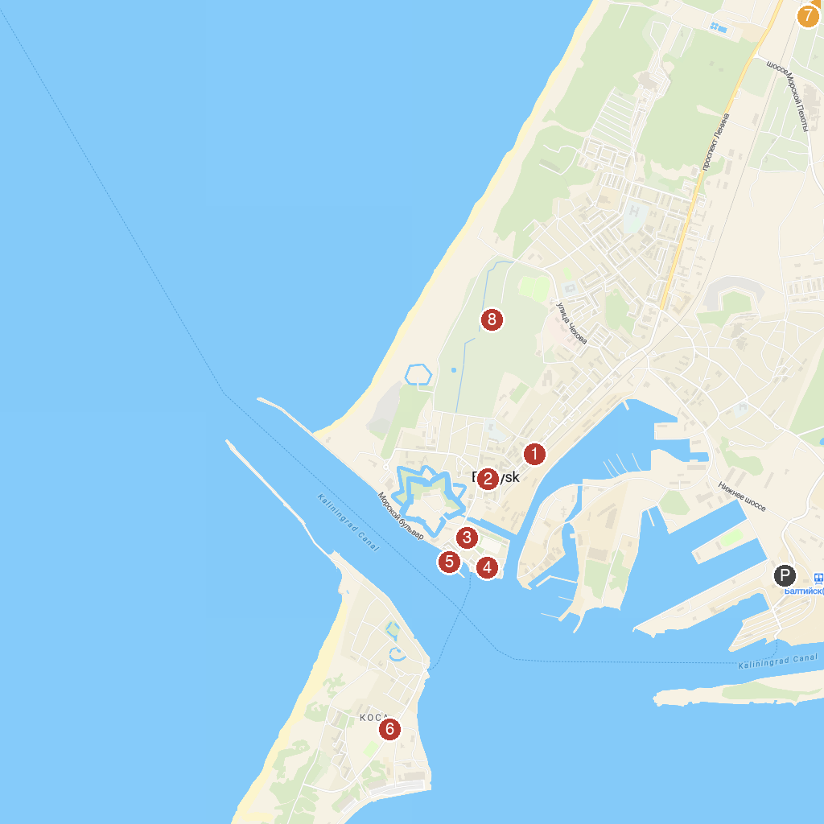
MAP KEY
1. Railway water tower Pillau | 5. Lotsmanskaya Bashnya Pillau
2. Pekhotnyye Kazarmy | 6. Mass grave of Soviet soldiers
3. Muzey Baltiyskogo Flota | 7. Villa Porro
4. Lighthouse Pillau | 8. Park im. A.Golovko
P. Cruise port / terminal
Map © MapTiler © OpenStreetMap contributors · cruiseports.org

