Baltimore, Maryland, USA
Where the Star-Spangled Banner was born — Baltimore blends maritime history, waterfront dining, and easy access to the nation's capital into one of the East Coast's most rewarding port days.
⚓ Docked (Cruise Maryland Terminal) · 🕒 Typical call: 8–10 hrs · 💵 US Dollar · 🗣️ English
✍️ MY DAY IN PORT (FILL IN)
Ship / Date
In port | arrive ______ · all aboard ______
Booked excursion
Notes / meeting point
GETTING ASHORE
- Docking: Cruise Maryland Terminal, 2001 E McComas St — ships dock pierside, no tender
- To Inner Harbor: ~3 miles / 10–15 min by taxi or rideshare; area around terminal is industrial
- Best For: History buffs, seafood lovers, families, D.C. day-trippers
- Don't Miss: Fort McHenry, National Aquarium, Fells Point waterfront, crab cakes
GETTING AROUND
- 🚕 Taxi: $10–$20 — Metered taxis are available outside the terminal. The Inner Harbor is roughly 10 minutes away; flat rates to the World T
- 📱 Rideshare: ✅ Uber, Lyft
TOP THINGS TO DO
- Fort McHenry & the Star-Spangled Banner — Tour the star-shaped fort that withstood British bombardment in 1814, inspiring Francis Scott Key to write the national anthem.
- National Aquarium — One of the country's top aquariums, home to sharks, rays, dolphins, Australian lungfish, and over 17,000 animals across immersive…
- Washington D.C. Day Trip — Baltimore's proximity to D.C.
- Historic Ships in Baltimore — Explore floating museums at the Inner Harbor: USS Constellation (Civil War sloop), USS Torsk (WWII submarine), the Lightship…
- Fells Point Food & History Walk — Baltimore's oldest neighborhood is a cobblestoned waterfront district packed with colonial-era taverns, independent restaurants…
BEST WALKS
- Inner Harbor Waterfront Loop: 2 miles • Easy • 45–60 min — Circle the Inner Harbor from the Visitor Center at Light Street past the National Aquarium…
- Inner Harbor to Fells Point Waterfront Promenade: 1.5 miles one-way • Easy • 30 min — Follow the paved Waterfront Promenade east from the Inner Harbor through Little Italy to Fells…
WEATHER · DAYLIGHT · MONEY
Month | High °F | Low °F | Rainy days
May | 73 | 55 | 14
Jul | 86 | 70 | 15
Sep | 78 | 63 | 10
Daylight: May 5:52AM–8:13PM · Jul 5:52AM–8:31PM · Sep 6:48AM–7:14PM
cruiseports.org/baltimore · Confirm terminal & all-aboard time with your ship

Baltimore, Maryland, USA — Port Map
Red = walkable sights · Amber = excursions farther out · P = cruise terminal
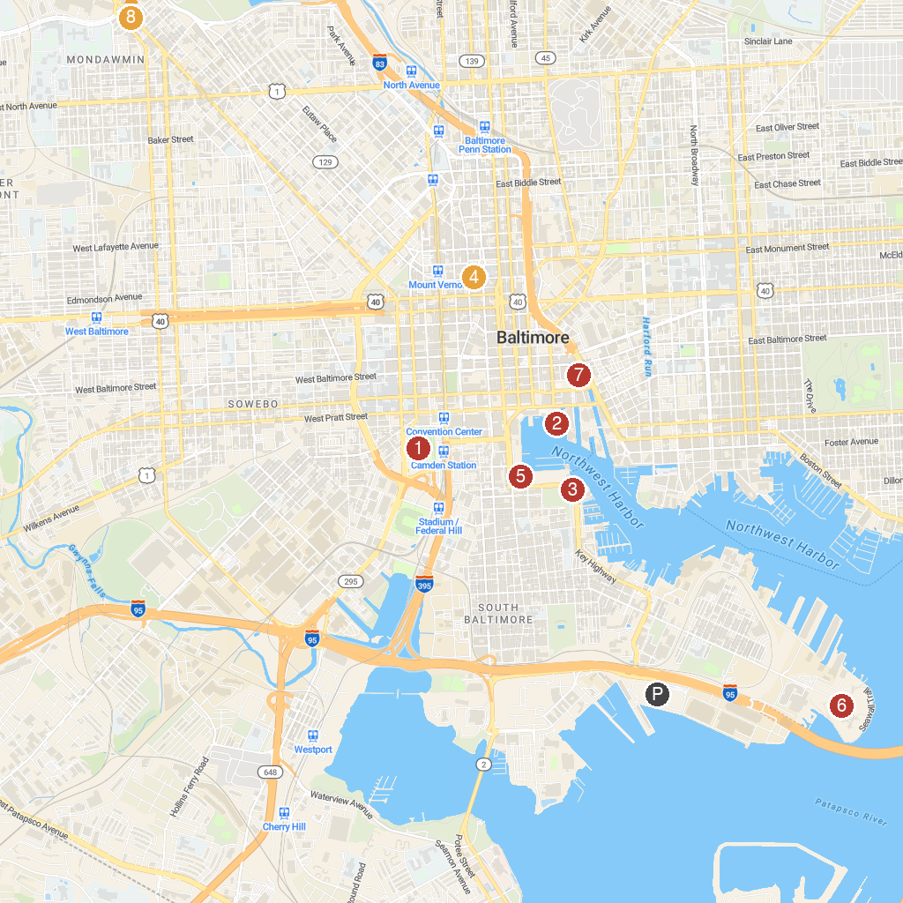
MAP KEY
1. Oriole Park at Camden Yards | 5. Maryland Science Center
2. National Aquarium | 6. Fort McHenry National Monument and Historic Shrine
3. American Visionary Art Museum | 7. Port Discovery Children's Museum
4. The Walters Art Museum | 8. The Maryland Zoo in Baltimore
P. Cruise port / terminal
Map © MapTiler © OpenStreetMap contributors · cruiseports.org

